Lec:8 prosthodontics د.حكمت

**Support for the Distal Extension Denture Base**

**Support**: resistance to vertical components of masticatory force in a direction toward the basal seat

All partial dentures have two things in common:

1. They must be supported by oral structures and
2. They must be retained against reasonable dislodging forces.

Support can be classified according to **Cradock**:

1. Dental support

2. Mucosal support

3. Mixed: dental and mucosal/ mucosal and dental support

**Designing Support**

**a**- Tooth ***support***: When abutment teeth available at both ends of the denture base (bounded saddle). It most commonly obtained by occlusal rests.

**b**- Mucosa ***support***: (mucoperiosteum covering residual alveolar bone). It allows varying degree of displacement.

*The amount of displacement (tissue ward movement) will depend on:*

1. The amount of pressure applied.

2- The nature of the mucosa (thickness).

3- Area covered by the denture (the wider the area the less the displacement).

4- Fit of the denture base.

5- Type of impression (anatomical, functional, or selective pressure).

**c**-***Tooth-mucosa support:*** (Bilateral free end saddle). Posterior tissue support, and anterior tooth support. In the class III PD three components are necessary, support provided by rests, the connectors (stabilizing components) and the retainers. An anatomical impression is the only needed to record the anatomic form of the teeth and residual ridge in tooth born RPD.

*The distal extensions PD does not have the advantage of total tooth supported because one or more bases are extensions covering the residual ridge distal to the last abutment, but in this situation, the support comes from both the teeth and the underlying ridge tissues rather than from teeth alone.

*This is a composite support, and the prostheses must be fabricated so that the resilient support provided by the edentulous ridge is coordinated with the more stable support offered by the abutment teeth.

*The distal extension removable partial denture must depend on the residual ridge for some sup­port, stability, and retention. Indirect retention, to prevent the denture from lifting away from the residual ridge, should also be incorporated in the design.

***In addition provision must be made for three other factors:***

1. Best support must be obtained from the resilient tissues that cover the edentulous ridges. This is accomplished by the impression technique more than by the PD design. The area covered by the pd base is a factor in such support.
2. The method of direct retention must take into account the inevitable tissueward movement of distal extension base(s) under the stress of mastication and occlusion. Direct retainers must be designed so that the occlusal loading will result in the direct transmission of this load to the long axis of the abutment teeth.
3. The PD, with one or more distal extension denture bases, must be designed so that movement of the unsupported and un retained end away from the tissues will be prevented by indirect retainer.

***The main problems which might occur in tooth-tissue support are:***

1. Mucosa is resilient and displaceable and can lead to unstable prostheses.
2. Difficult to record mucosa at resting and at displaced condition simultaneously.
3. In distal ERPD under function compresses the mucosa and act as class I lever thus it cause damaging to the abutment teeth, the solution is to record tissue in the functional form so the denture not exert additional stress to the abutment teeth. 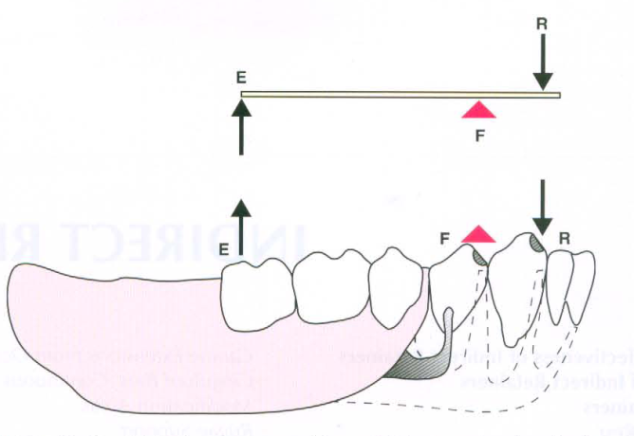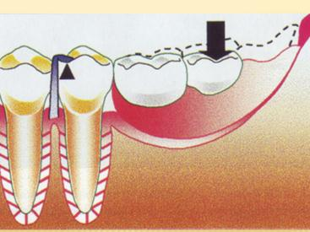

***Factors infuencing the support of a distal extension denture base***

***1- Quality of the residual ridge.***

***2- Extent of residual ridge coverage by the denture base.***

***3- Type and accuracy of impression registration.***

***4- Accuracy of denture base.***

***5- Design of the the partial frame work.***

***6- Total occlusal load applied,***

**1-Quality of the residual ridge for good support**.

* The ideal residual ridge to support a denture base would consist of cortical bone that covers relatively dense cancellouse bone with abroad rounded crest and high vertical slopes, and covered by firm, dense fibrous connective tissue.
* Buccal self-area (bounded by the external oblique line and crest of alveolar ridge) in the lower ridge as primary stress bearing area, because it is covered by relatively firm, dense, fibrous connective tissue supported by cortical bone, while the crest is mostly cancellous not good for support. While in maxillary ridge the crest is primary stress bearing area.
* Slopes of the ridge can resist horizontal forces.

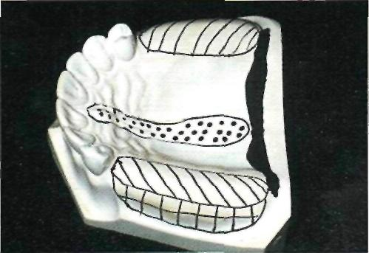

Crest of maxillary residual ridge *(diagonal lines/* is primary supporting region for maxillary distal extension denture base. Buccal and palatal slopes may furnish limited vertical support to denture base. It seems logical that their primary role is to counteract horizontal rotational tendencies of denture base. *Dotted portion* out­lines incisive papilla and median palatal raphe. Relief must be provided for these regions, especially if tissues covering palatal raphe are less displaceable than those covering crest of residual ridge.

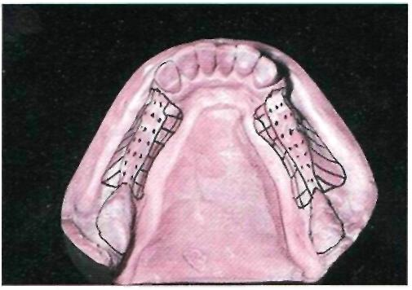

*Dotted portion* outlines cresi of residual ridge, which should be recorded in its anatomic form in impression procedures. Similarly, retromolar pads should not be dis­placed by impression. Buccal shelf regions *(diagonal lines'* serve as primary support and therefore additional pressures may be placed on these regions for vertical support of den­ture base. Lingual slopes of residual ridge *tcross-hatched)* may furnish some vertical support to restoration; however, these regions principally resist horizontal rotational tenden­cies of denture base and should be recorded by impression in undisplaced form.

***2- Extent of residual ridge coverage by the denture base.***

The broader the residual ridge coverage the greater the distribution of the load, which results in less load per unit area. A denture base should cover as much of the residual ridge as possible and be extended the maximum amount within the physi­ological tolerance of the limiting border structures or tissue lead to better distribution of load and better withstanding of vertical and horizontal forces.

The longer the edentulous area covered by the denture base, the greater the potential lever action on the abutment teeth.

* Flat ridge will provide good support, poor stability.
* Sharp spiny ridge will provide poor support, poor to fair stability.
* Displaceable tissue on ridge will provide poor support and poor stability.

The DERPD derives its support from the residual ridge with its fibrous connective tissue covering. The length and contour of residual ridge significantly influence the amount of available support and stability.

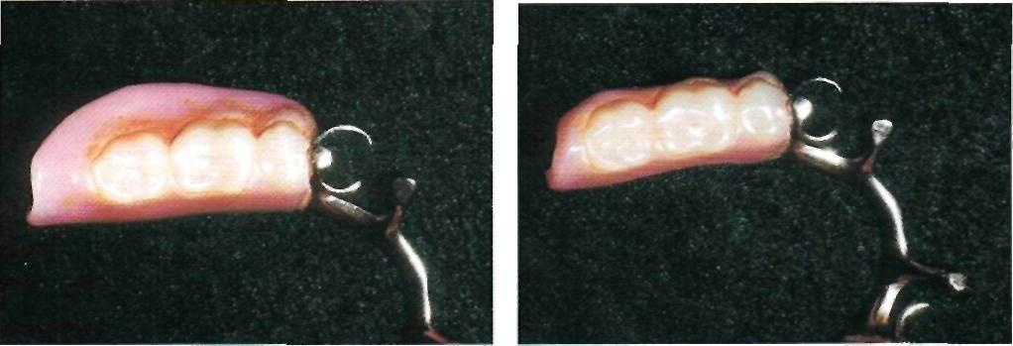

Comparison of two removable partial dentures for same patient. A, A distal extension base that is adequately extended, as it covers both the buccal shelf and retromolar pad. B, Underextension of this base results in less support to the prosthesis from the residual ridge, which can cause increased instability of the prosthesis.

***3-Type and accuracy of impression registration.***

The residual ridge may be said to have two forms:

* 1. The anatomic form: The anatomic form is the surface contour of the ridge when it is not supporting an occlusal load. The anatomic form and the relationship of the remaining teeth in the dental arches, as well as the surrounding soft tissue, must be recorded accurately so that the denture will not exert pressure on those structures.
  2. The functional form of the residual ridge is the surface contour of the ridge when it is supporting a functional load. The support form of the soft tissues underlying the DE base of the PD should be recorded so that firm areas are used as primary stress- bearing areas and readily displaceable tissues are not over loaded, only in this way can maximum support of the PD base be obtained.

*McLean and others recognized the need to record the tissue that supports a distal extension removable partial denture base in its functional form, or support­ing state, and then relate them to the remainder of the arch by means of a secondary impression. This was called ***a functional impression***because it recorded the ridge relation under simulated function.

Many of the requirements and advantages that are associated with the distributed stress denture apply equally well to the functionally or physiologi­cally based denture. Some of these requirements are:

(1) Positive occlusal rests; (2) an all-rigid, nonflexible framework; (3) indirect retainers to acid stability; and (4) well-adapted, broad coverage bases.

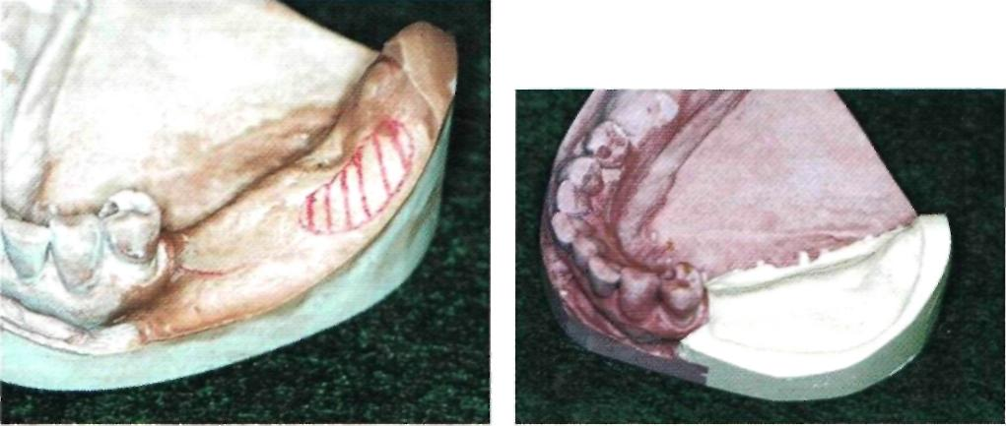

Comparison of anatomic and functional ridge forms. A, Original mandibular cast showing left residual ridge area recorded in its anatomic form. Buccal shelf region is outlined. B, Same cast after left residual ridge area has been repoured to its functional form as recorded by secondary impression.

1. ***accuracy of denture base.***

* Distal extension base is enhanced by intimacy of contact of the tissue surface of the base and the tissue that covers the residual ridge. The tis­sue surface of the denture base must optimally rep­resent a true negative of the basal seat regions of the master cast.
* In addition, the denture base must be related to the removable partial denture framework in the same manner as the basal seat tissue was related to the abutment teeth when the impression was made. Every precaution must be taken to ensure this rela­tionship when the altered cast technique of making a master cast is used.

1. ***Design of the the partial frame work.***

*Some rotation movement of a distal extension base at the distal abutment is inevitable under functional loading.

*The greatest movement takes place at the most posterior extent of the denture base, the retromolar pad region of the mandibular residual ridge and the tuberosity region of the maxillary resid­ual ridge therefore are subjected to the greatest movement of the denture base

*use of more anterior or mesial rest is suggested as it allow vertical ridge loading,

Permit greater ridge area for support, transfer stress to anterior abutment.

*Incorporation of indirect retainer.

*Incorporation of RPI system in free end suddle which make stress release.

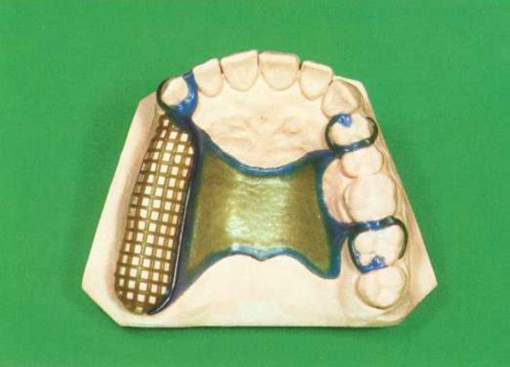

A typical framework for restoring a unilaterally shortened maxillary arch. A maximally extended denture base combined with a wide palatal strap helps resist rotation.

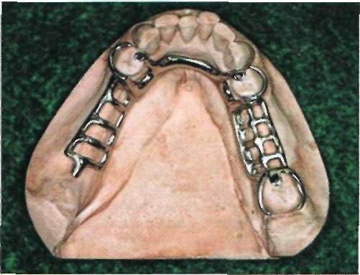

Occlusal rest is placed on mesioocclusal surface of left mandibular first premolar, which will move point of rotation anterior to conventionally placed disto-occlusal rest if contact of proximal minor connector on distal guiding plane is designed to release under function. Occlusal rest is connected to lingual bar by minor connector, which contacts small mesiolingual prepared guiding plane.

***6. Total occlusal load applied,***

* Patients with distal extension removable partial den­tures generally orient the food bolus over natural teeth rather than prosthetic teeth, because of: 1- ) the more stable nature of the natural den­tition. 2- ) The proprioceptive feedback they provide for chewing, and 3-) the possible nociceptive feedback from the supporting mucosa.
* This has an effect on the direction and magnitude of the occlusal load to the removable partial denture, and thus on the load transferred to the abutments.
* The support from the residual ridge should be optimized and shared appropriately with the remaining natural dentition.
* The ***number*** of artificial teeth, the ***width*** of their occlusal surfaces, and their ***occlusal efficiency*** influ­ence the ***total occlusal load*** applied to the removable partial denture.
* The ***reduction of the size of the occlusal table*** ***reduces the vertical and horizontal forces*** that act on the remov­able partial dentures and lessens the stress on the abutment teeth and supporting tissue. 
* **ANATOMIC FORM IMPRESSION**

* The anatomic form impression is a one-stage impression method using an elastic impression material that will produce a cast that does not repre­sent a functional relationship between the various supporting structures of the partially edentulous mouth. It will only represent the hard and soft tissue at rest.

* With the removable partial denture in posi­tion in the dental arch, the occlusal rest(s) will fit the rest seat(s) of the abutment teeth, whereas the den­ture base(s) will fit the surface of the mucosa at rest.

* When a masticatory load is applied to the extension base(s) with a food bolus, the rest(s) will act as a defi­nite stop, which will limit the part of the base near the abutment tooth from transmitting the load to the underlying anatomic structures.

* The distal end of the base(s) that is able to move more freely, however, will transmit more of the masticatory load to the underlying extension base tissue and will transmit more torque to the abutment teeth through the rigid removable partial denture framework.

* A removable partial denture fabricated from a one-stage impression, which only records the anatomic form of basal seat tissue, places more of the mastica­tory load on the abutment teeth and that part of the bone that underlies the distal end of the extension base.

***METHODS FOR OBTAINING FUNCTIONAL SUPPORT FOR THE DISTAL EXTENSION BASE***

The objective of any functional impression tech­nique is to provide maximum support for the remov­able partial denture bases.

* This allows for the maintenance of occlusal contact between both natu­ral and artificial dentition.
* Minimum movement of the base, which would cre­ate leverage on the abutment teeth.
* Some tissueward movement of the distal extension base is unpreventable and dependent on the six factors listed previously, it can be minimized by providing the best possible support for the denture base.
* No single impression mate­rial can record both the anatomic form of the teeth and tissue in the dental arch and, at the same time. The functional Form of the residual ridge. Therefore some secondary or corrected impression method must be used.
* Methods for obtaining functional support for either should satisfy the two requirements for providing adequate support to the distal extension removable partial denture base. These are (1) that it records and relates the sup­porting soft tissue under some loading and (2) that it distributes the load over as large an area as possible.

**Selective Tissue Placement Impression Method**

* Soft tissue that covers basal seat areas may be placed, displaced, or recorded in their resting or anatomical form. Placed and displaced tissue differs in the degree of alteration from their resting form and in their physiological reaction to the amount of displacement. For example, the palatal tissue in the vicinity of the vibrating line can be slightly displaced to develop a posterior palatal seal for the maxillary complete denture and will remain in a healthy state for extended periods. On the other hand, this tissue develops an immediate inflammatory response when it has been overly displaced in developing the posterior palatal seal.
* Oral tissues that have been overly displaced or distorted attempt to regain their anatomic form. When they are not permitted to do this by the den­ture bases, the tissues become inflamed and their physiological functions become impaired, accompa­nied by bone resorption. Tissues that are minimally displaced (placed) by impression procedures for definitive border control respond favorably to the additional pressures placed on them by the resultant denture bases if these pressures are intermittent rather than continuous.
* ***The selective tissue placement impression method*** *is based on these* ***clinical observations****:*

**\*** The histologi­cal nature of tissue that covers the residual alveolar bone.

* The nature of the residual ridge bone.

* And its positional relationship to die direction of stresses that will be placed on it.

It is further believed that by use of specially designed individual trays for impressions, denture bases can be developed that will use those portions of the residual ridge that can withstand additional stress and at the same time relieve the tis­sue of the residual ridge that cannot withstand func­tional loading and remain healthy.