5thclass Prosthodontic Dr. Thekra Ismael

Over Denture (Continue)
Attachments in over denture

Attachments are small mechanical devices, they are incorporated to provide retention and support, one part is connected to a root, tooth or implant (male part) and other part to a prosthesis (female part)

Function of attachment
1- Securing the prosthesis against forces that tend to lift it.
2- Providing periodontal support for the prosthesis.
3- Transferring the forces of the muscles of mastication from the prosthesis to the periodontium in as nearly axial direction as possible
4- Distributing shearing forces.
5-Stabilizing and/or splinting the abutment teeth

Factors affecting attachment selection
1. Available inter-arch space.
2. Crown root ratio and alignment of the roots.
3. Type of coping.
4. Vertical space available.
5. Number of teeth present.
6. Amount of bone support.
7. Location of abutments.
8. Location of the strongest abutments.
9. Whether the overdenture is a tooth supported or toothtissue-supported.
10. The type of the opposing dentition whether it is complete denture, overdenture, fixed appliance or natural dentition.
11. The maintenance problems and the cost.
12. Clinical experience and personal preference.

Retentive Mechanism
It is achieved by either:
1- Active retention provided by springs that fit into recesses.
2- Friction between the components.
3- Magnetic anchorage
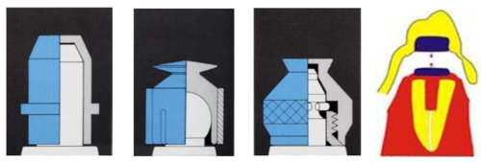

Classification of Attachments
- Rigid attachments
A retentive attachment is considered to be rigid if it is grasps the abutment tooth bodily and permits no movement between anchor and prosthesis except for rotation around the long axis of the element in case of a single tooth. Even with rigid attachment there is a minimal amount of movement, which can increase when the attachment wear.
Advantages:
1- Reduction of the load on the edentulous ridge during function and parafunction.
2- Minimum tipping of the abutment teeth when subjected to lateral forces.
Disadvantages:
Applied forces and movements of the denture are transmitted almost entirely to the abutment teeth

- Non rigid attachments
Non rigid attachment permits rotational movements of the denture around the anchor in one or more planes, or vertical body movement's .The greater the number of the non-rigid attachments used in the same denture, the more limited will be movement of each.
Advantage: Reduced effect of tipping force on the abutment teeth.
Disadvantage:
-Greater stress on the tissues supporting the denture (Ridge resorption)

Non rigid attachments may be indicated under the following conditions:
1- When the geometric distribution of the remaining teeth is unfavorable for the stability of the denture. This can give rise to undesirable tipping and rocking movements especially if the soft tissue support is more resilient and/or less expanded than normal.
2- When only a short dowel (post) can be used to anchor the coping. If a rigid attachment were used over a short dowel, uncontrolled movement of the denture might loosen the dowel from the root
Types of attachments
A-Stud attachments: (2 types):-
- Intra radicular attachments. (E.g. Zest anchor attachment).

- Extra radicular attachments. (E.g. Ceka Revax attachment).

B- Bar attachments: (2 types):-
- Bar units.
- Bar joints.

C-Magnet attachments.

Stud attachment
•Male stud –soldered to the base which is a coping covering the prepared tooth stump
•Female housing –this is embedded in the acrylic of the OD or it is soldered to substructure in the OD
•Male and female attachments may be either resilient or non resilient

There are many systems of stud attachments:
1. Zest anchor (intraradicular attachment)
- Post prep is made within the root and the female sleeve is cemented into place
- Male portion consists of a nylon post and a ball head attachment to the overdenture as a chair side procedure
- Ideal for interim overdenture

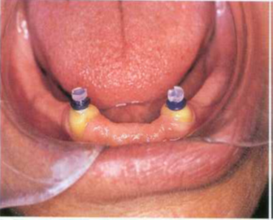
.

Advantage
1. Overcomes any space problem since the attachment is within the root structure.
2. Leverage to the abutment tooth is reduced
3. Attachment procedure is simple
4. Parallelism is not necessary if more than one tooth is used due to the flexibility of the nylon
5. No casting is required
Disadvantage
1. Caries susceptibility as no coping placed
2. Nylon stud can bend preventing seating (To correct this frequent recall ( visits are necessary
3. When eating foods without the OD can cause food to stagnate in the female part.

2-Ceka Attachment (extra radicular attachment)
• Male part fixed to the tooth and has a rounded shape wider at the top and split vertically into 4 sections. They are flexible and can be compressed
• Female housing fits over this
• The attachment can also be constructed with a different type of retention male that has a space between the parts to allow both rotational and vertical movement

3-Dalbo attachment
• Rigid, resilient or the stress breaker type
• Male part is soldered to the tooth and the housing to the base
• The rigid type has a cylindrical male unit with a rounded head
• The resilient is the smallest and the most commonly used.
• Rotational and vertical movement possible because of relief spacers between the units
• Retention in this is by the flexible arms of the female unit fitting over the undercut head of the male unit

Bar attachment
• The purposes of using bars are: – Splinting of abutment teeth – Retention and support of the prosthetic appliance.
• There are 2 types:
– Bar units : which are the rigid type, no movement between bar and overlying sleeve, transmits occlusal stress totally to abutments.

– Bar joints: which allow some movement of the rotational type. Utilizes the residual ridge for support .

There are many systems of bar attachment such as:
- 1- Hader Bar
- This bar can serve either as a bar joint or a bar unit or as stud .It consist of preformed plastic bars and clips .The bar is attached to the coping wax-up and is casted with the coping. The plastic clips can be imbedded in the denture base to gain retention.
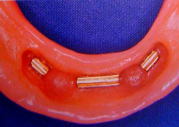
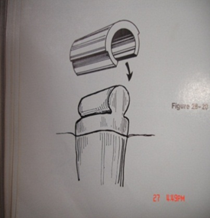
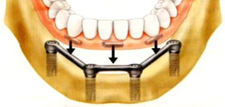
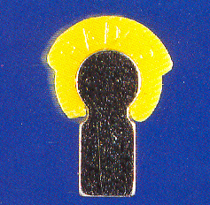

2-Ackerman clip and C.M. clip
It consists of a round bar soldered to the post copings and the clip fits over the bar, It in addition has retention wings for engagement of the clip into the resin in the overdenture, spacer is supplied, so that the clip does not rest directly on the bar providing both rotational and vertical movement.
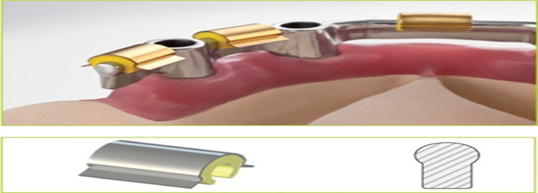
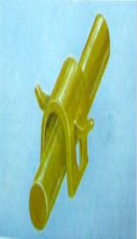

3- Dolder bar
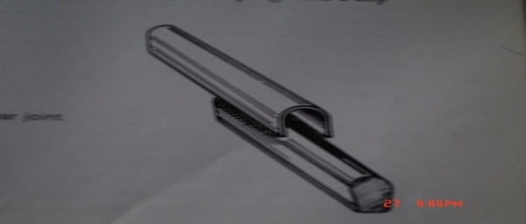
• Bar unit: preformed bar with parallel sides and rounded top soldered to the coping , Sleeve is present in the denture bases , Retention is due to friction ,If the post of the copings cannot be made parallel to seat the soldered bar then a schubiger unit is used . Because of the parallel walls and close adaptation rotation is not possible

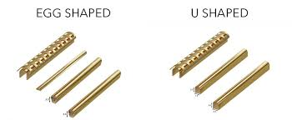
• Bar joint: – Egg shaped bar with a spacer. This allows some movement – Difficult to adapt to tissue contour and bulky.
C-Magnet Attachments
Magnet system of cobalt - samarium magnet built into the denture base and a magnetisable dowel -coping or keeper plate of palladium cobalt- nickel alloy into the abutment teeth
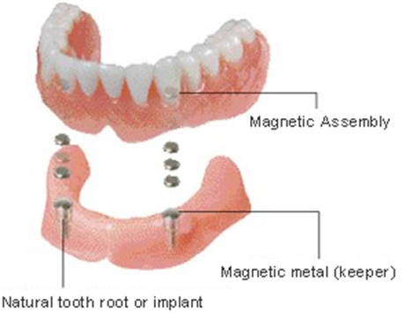

O-Ring attachment
They are doughnut shaped, synthetic polymer objects that possess ability to bend with resistance and then return back to their original shap.The
O-ring attaches to a post with a groove or undercut area.
Advantage
- Ease in changing the attachment.
- Wide range of movement.
- Low cost.
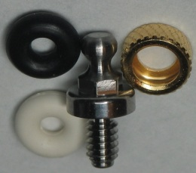
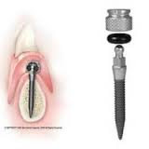
- Elimination of time &cost of a superstructure of prosthesis.

Oral Hygiene Instructions
- Motivating and instructing the patient in the care of the overdenture is of the extreme importance for its long term success
- Learned during the preliminary treatment phase, the oral hygiene procedures practiced by the patient following placement of the overdenture should be an uninterrupted continuation of the home care measures.
Overdenture care
- 1- Ordinary toothbrush or a special denture brush.
- 2- Tooth pastes with low abrasiveness and non-alkaline soaps.
- 3- Denture cleansers (mostly peroxide based) are a useful adjunct.
- Candidacies can be treated by immersing the denture in a 0.2%chlorhexidine solution for 10-15 minutes every day

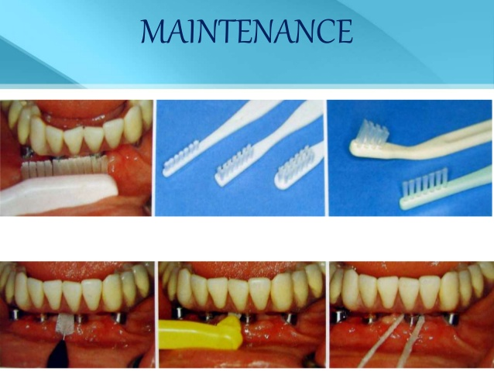

Care of abutment
A-mechanical aid
- All abutment teeth with or without root coping must be cleaned on all sides.
- All exposed root surfaces and gingival area should be brush again with an inter proximal brush.
- Dental floss is used only to clean under interdental bars and beneath root coping that are solder together.

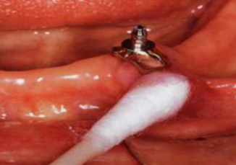
B-chemical aid
Fluoride in gel
Fluoride in a 0.025% solution can also be
used as a daily rinse.

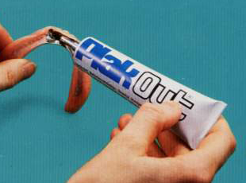
Chlorhexidine:
0.1-0.2% solution as a daily rinse
gel to be applied inside the
denture base or the female attachment.
Prosthodontics follow up care: - to correct
- Occlusion (remounting records).
-Base (relining).
-Pressure spots.
-Bar (loose screws).
-Bar clips (broken, loose).
-Female retainers and clips remounted with acrylic resin.
-Signs of wear

