**5thclass  *Prosthodontic***  **Dr. Thekra Ismael**

**Lec. No. *Over denture***

The overdenture: is any removable dental prosthesis that covers and rests on one or more remaining natural teeth, the roots of natural teeth, and/or dental implants; a dental prosthesis that covers and is partially supported by natural teeth, natural tooth roots, and/or dental implants. (GPT. 9, 2017). The overdenture is also called overlay denture, overlay prosthesis or super imposed prosthesis.

***The important goals of overdenture:***

1-Maintains teeth as part of the residual ridge

* More support
* Withstands more occlusal load.
* Retention improve

2-Decrease in the rate of bone resorption. Alveolar bone exists as a support for teeth.

3- Retaining the proprioception.

4- An increase in the patient's manipulative skills in handling the denture.

***Indications of Overdenture.***

1-few remaining teeth unsuitable for fixed or removable partial dentures.

2- Remaining teeth present with unhealthy periodontal condition.

3- Patients with class II or class III Angle's classification - Esthetics & masticatory function improved.

4- Patients presenting abnormal jaw size large maxillary or mandibular bone defects.

5- The construction of over-denture is an alternative line of treatment to single dentures opposing few natural teeth.

6- Patients presenting congenitally missing teeth and congenital defects as cleft palate, microdontia, amelogenesis or dentinogenesis imperfecta or partial anodontia.

***Contraindications of Overdenture:***

1. Poor oral hygiene.
2. Inter-arch space inadequate to accept the denture and the abutments.
3. Mentally and \or physically handicapped.
4. Cost and time considerations.
5. When other treatment modalities promise superior results.
6. Lack of patient acceptance.

***Advantages of overdenture prosthesis***  
 1. Preserving the remaining residual ridge by decreasing the rate of bone resorption.

2- Preservation the abutments as part of residual ridge to gain support.

3. Preserving the response of proprioceptive exist in the periodontal membrane of the abutment tooth.

4- The modified teeth provide a definite vertical stop for the denture base

5-Horizontal and torque forces are minimized.

6-Stability and support are increased

7-Patient acceptance and Psychological Benefits

8-A Simple Approach to the Problem Patient.

9-fewer post insertion problems

10- Convertibility& effective management.

11-Periodontal Maintenance.(by distributing the applied forces over the remaining teeth) physiological stimulation.

12- Provide retention through the attachments.

***Disadvantage of overdenture****:*

1. The susceptibility of the overlaid teeth to caries is high.

2. Periodontal disease of the retained teeth.

3. Bony undercuts of the alveolar ridge are often found adjacent to retained teeth over contoured (bulky denture) or under contoured flanges especially in canine eminence.

4. Encroachment interocclusal distance beyond the denture space.

5- Overdenture construction is time consumingand expensive.

**Overdenture Classification:** *Overdentures can be classified into:*

**1-tooth supported**

A complete or partial removable denture supported by tooth or retained roots that is intended to provide improve support, stability and tactile and proprioceptive sensation and to reduce ridge resorption. The tooth -supported over denture is also called overlay denture, telescopes denture and biological denture are among the many terms used to define the tooth-supported complete denture.

**2-implant supported**

The denture appears like traditional prosthesis. However, that part of the denture overlying implants is modified to retain various attachments that receive implant extentions projecting above the gum.

**Classification of tooth supported overdenture Based on the method of abutment preparation:**

**1. Non coping abutment**

* The tooth is reduced to a coronal height of 2 to 3 mm.
* The crown is contoured to a convex or dome shape.
* The tooth is endodontically treated and filled with amalgam or composite restoration.

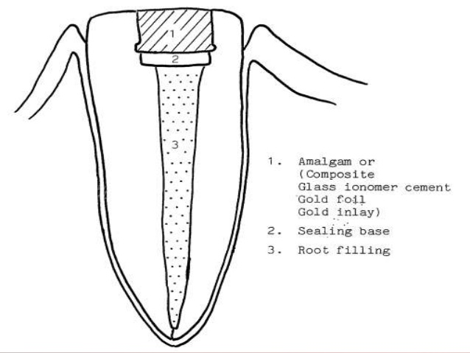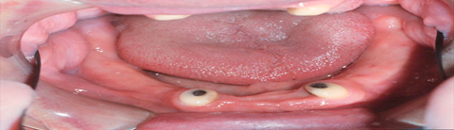

**2. Abutment with coping preparation**

* A coping is a cover for the exposed tooth surface.
* 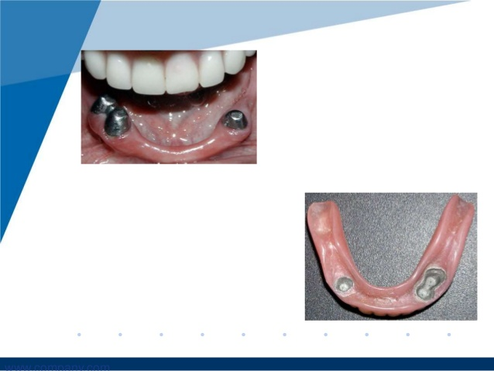Cast metal copings with a dome shaped surface and a chamfer finish line at the gingival margin.

**There are two types of copings:**

A. Short copings

B. Long copings

A- Short cast copings

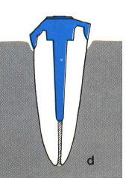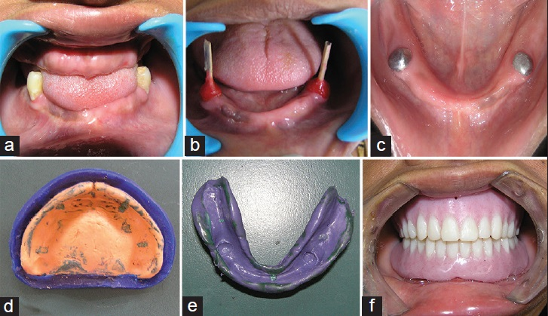2 to 3 mm long (cast coping has a post is fitted to endodontically treated canal).

B-Long cast copings

* 5 to 8 mm long abutment
* Endodontic treatment is not a must (abutment is prepared

Conservatively to prevent pulp involvement to receive the cast)

* 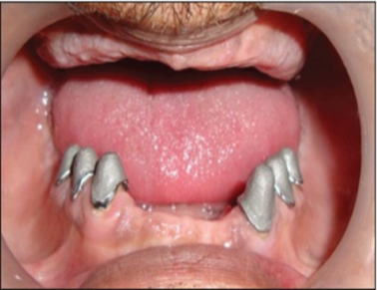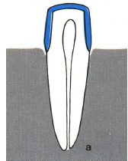Greater level of osseous support.

**3- Abutments with attachment**

* Attachment is small precision device
* Most attachment are secured to the abutment by cast coping.
* Objective to improve retention of denture base.
* Consisting of 2 parts
* Male
* Female

**4. Submerged Vital Roots**

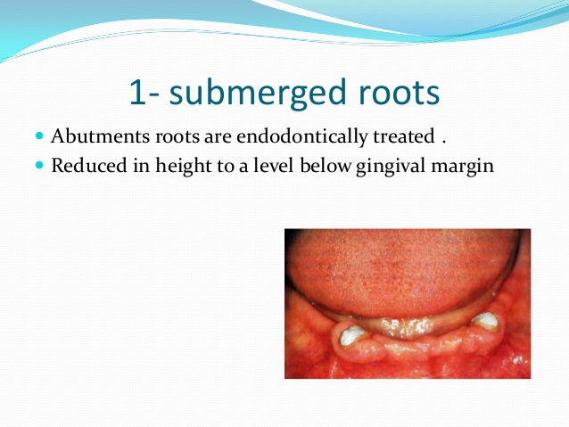This additional abutment category, this method is innovative attempt to overcome some problems associated with the more conventional overdenture abutments included caries, gingivitis, periodontitis and the need for endodontic therapy. This method included vital roots are transected and reduced to 2mm below the crestal bone and covered by mucoperiosteal flap. The disadvantage of these method dehiscences over the retained roots and pulp pathosis.

**5-Abutments with telescopic crown**

* Abutment teeth are either vital or endodontically treated &contoured to tapered configuration.
* Tapered metal copings constructed &cemented over abutments
* Denture constructed with metal crowns having veneered facings.
* Indicated 1) unparalleled abutment 2) uneven spaces between abutments 3) useful for obturators
* Advantage increased retention and stability
* Disadvantages bulky crowns.

**Classification of over denture based on the type of the over denture**

**1. Immediate overdenture**

The remaining teeth are reduced to accept the overdenture (on the cast), the overdenture are constructed prior to the preparation of abutment teeth and is inserted after the preparation.

**2- Transitional or intermediate overdenture**

Used for patient in transition or preparation phase until permanent overdenture constructed or patient with old partial denture and add new artificial teeth using self-cure acrylic resin.

**3-definitive overdenture**

Conventional complete over denture constructed over one or more abutment teeth. Could be made entirely of acrylic resin or in conjunction with metal bases.

**Uses of overdenture concept in other areas**

The overdenture approach has applications besides the obvious replacement of complete denture therapy or extensive restorative dentistry

**Congenital and acquired defects**:

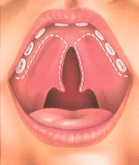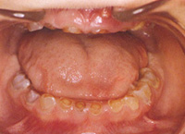Patients presenting with such anomalies as cleft palate microdontia, amelogenesis imperfecta etc…the overdenture application can afford a very workable and relatively simple solution to patients with selected problems. The important benefit is that the technique is totally reversible.

**Partial overdenture**

The use of an overlaid tooth that might otherwise be extracted to give posterior support to distal extension base or to provide anterior support for a large anterior supply on a partial denture renders obvious support advantage.

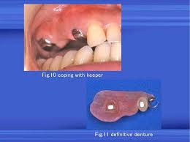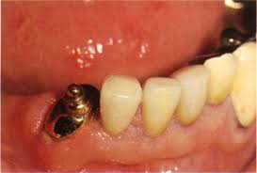

**Sequence of Treatment of Patient Who Need an Overdenture**

**A-Assessment of the patient**

1. History (general and oral).
2. Clinical examination (visual and digital examination, radiographic examination and study model of the arch).
3. **B-Treatment plan**

Evaluation the abutments

1-Periodontal status.

2-Endodontic considerations

3-The number and position of abutment teeth in the arch

1-periodental status

* Minimum mobility.
* Have acceptable bone support, 5-7mm.
* Amenable to periodontal therapy.

2-endodontic consideration

The tooth must be treated endodontically to allow for sufficient reduction of clinical crown, ideally patient with single rooted teeth with only one canal are the best candidate although multirooted teeth can also be used.

3-the number and position of the abutment teeth in the arch

In maxillary arch incisors are used, at least one tooth per quadrant should be present, ideal is 2 teeth per quadrant. The stress is distributed over a rectangular area, A tripod approach can also be used, most commonly used teeth in the mandible for abutment Canine, reasons – Position, Large surface area, The Canine response, Time period of retention of the tooth, less susceptibility to periodontal breakdown, fewer anatomical and positional difficulties

**periodontal treatment includes:**

1. Initial therapy.
2. Surgical therapy.
3. Root planning with direct visual access.
4. Surgical reduction of periodontal pockets by gingivectomy and /or flap procedures.
5. Surgical crown lengthening.
6. Widening of the attached gingiva through mucogingival surgery.

**Abutment Preparation**

1-Simple Tooth Modification and Reduction

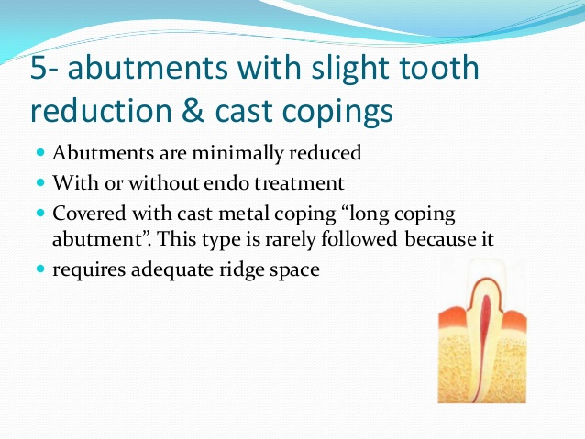The teeth are reshaped to eliminate undercuts and to reduce the vertical height. This technique is often used in partially anandontic patient or in patient with sever abrasion of teeth.

**Indication:**

1. Good oral hygiene with low caries index
2. Vital pulp.
3. Partially anandontic patient.
4. Sever abrasion of teeth.
5. Sufficient interocclusal distance.

**2- Tooth Reduction and Cast Coping**

Cast copings are made after reducing the teeth to prevent sensitivity or as caries control. Endodontic is not done on these teeth; this technique is used when there is adequate bony support and good periodontal prognosis.

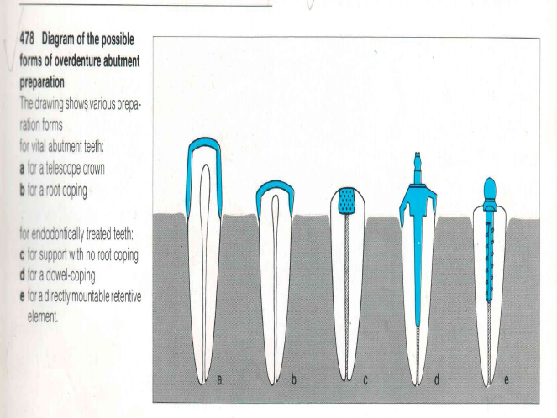

**Indication:**

1. Adequate bony support
2. Good periodontal prognosis
3. Adequate interocclusal distance.

**3-Endodontic Therapy and Amalgam Plug**

It is indicated when there is normal coronal height to the teeth and normal interocclusal distance with little or no loss of vertical dimension, endodontic therapy to the abutment then reduced (1-2) mm at gingival level to receive an amalgam type restoration.

**4-Endodontic Therapy and Cast Coping**

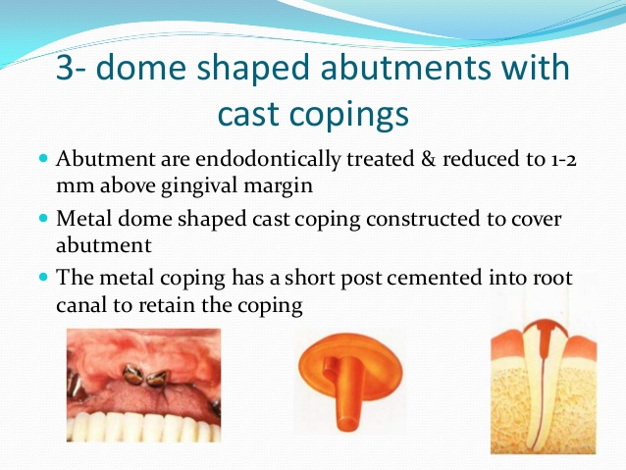Shallow dome shape with the margin slightly supra-gingival. Recurrent decay on the exposed dentin when there is a history of carious involvement. The retention is gained from a short post that is placed within the root canal.

**5- Endodontic Therapy with cast coping utilizing some form of attachment**

Over denture retained by attachments offer the patient the idea of a fixed removable bridge instead of a denture. The abutments are prepared as in short-coping but with long intraradicular post to prevent root-coping dislodgment. Two attachments are enough to retain a denture, third attachment add unnecessary complexity and weakens the denture.

**6-Endodontic treated tooth with prefabricated retentive element**

It is a simple and inexpensive way to temporary fixation of overdenture.

(Spherical retentive element attached to a threaded post).

Ex. (Dalbo-Rotex system).

The disadvantage of this type is that the omission of a protective coping increases the risk of carious destruction and root fracture.

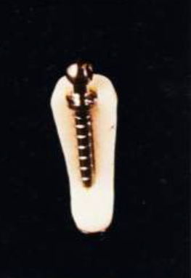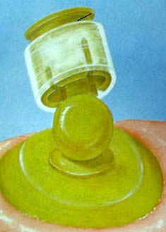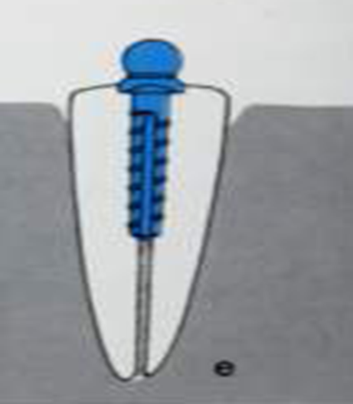

**Impressions of the Abutment Teeth**

**One –stage technique with supporting element**

For designs that rest on abutment teeth without root copings, the full-arch impression is made as soon as the abutments are prepared. When root copings without retentive elements, the impression is made after final cementation of the copings, the full arch impression is made in a custom tray similar to one for conventional complete denture. It covers the entire ridge except for any undercut areas near the abutment teeth that could not be utilize for the future denture base any way. The impression is made using Zinc oxide-eugenol paste or elastomer in the same manner as in the edentulous arch.

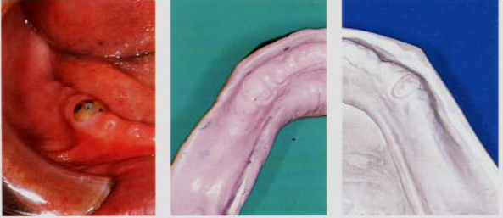

**One -stage technique with existing retentive element**

A single step full arch impression in Zinc oxide-eugenol paste or elastomer the materials used for overdenture that will rest on Pre-existing retentive elements Transfer matrices are set in place on the involved retentive elements and picked up in the impression. this is make it possible to incorporate retentive elements analogs in the working cast, used custom tray similar to these used for complete denture, the tray must touch neither the root coping nor the transfer matrices.

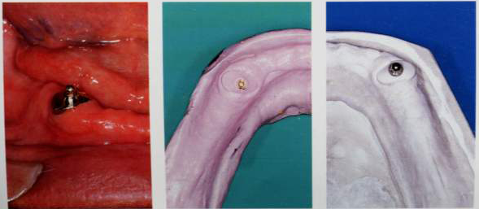

**Record base**

The only difference in the construction of the record bases for tooth –supported overdenture and conventional dentures is the incorporation of the metal bearing in the record base. The shape of the record base must correspond to that of the future overdenture, i.e., it should not cover the facial marginal gingiva in the abutment region.

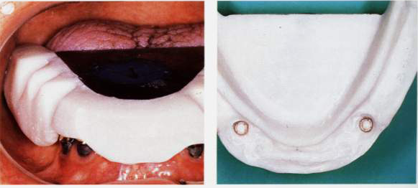

**Denture Base designing**

Criteria for Designing the Base

* Not unnecessarily promote plaque accumulation.
* Not mechanically traumatize the marginal gingival.
* Not impede the performance of good oral hygiene.
* Not interfere with normal function of the tongue, lips and cheeks.
* Not interfere with esthetics or speech

**Designs that leave the periodontium uncovered**

* The base does not cover the gingiva, and the artificial teeth are prepared to fit directly upon the roots or the dowel copings

1- Bases that are circumdentally open

2- Bases that is facially and proximally open.

* Temperatures in the gingival sulcus are significantly higher under closed bases that cover the gingival margin than with open designs. Gingival reaction was always most severe where the denture base covered the gingival margin and least severe in uncovered gingival margins.

**Basic rules of overdenture base design**

1. Cover as little of the marginal gingiva as possible
2. Border the proximal spaces with metal.
3. The greater the number of abutment teeth and the better their prognosis, the more open the construction may be.

**Advantages of a base designed that it does not cover the gingiva**

1. precludes direct mechanical trauma.
2. Reduce plaque retention around the abutments.
3. it possible to clean the proximal surfaces of the root coping with interproximal brushes with the prosthesis in place.
4. prevents a suction effect combined with inadequate coping shape and poor oral hygiene, would lead to hyperplasic proliferation (suction hyperplasia).
5. prevents undesirable vacuum retention in maxillary overdentures with retentive attachment.

**Disadvantages**

1. increased risk of fracture of the base
2. Unfavourable spatial relationships that do not permit extensive proximal openings
3. Esthetic considerations
4. increased food impaction in the open proximal spaces
5. Speech problems such as sigmatism
6. Poor prognosis for the abutment teeth, making probable an early conversion to a complete denture

**Circumdentally opened design**

**Advantages**

1. Possible to clean the abutments without removing the denture.
2. The base cannot traumatize the gingiva around the abutments.
3. minimal extension of the base

**Disadvantages**

1. very complex
2. The risk of fracture is greater
3. The possibilities are limited for modifying and adding to the denture when abutment teeth are lost.

**Indications**

* abundant space over the abutments
* a good prognosis

**Facially and proximally open design**

Have enough rigidity only if they incorporate custom cast reinforcing frameworks.

**Advantages**

* less involved technical construction,
* the reduced risk of fracture.
* the ease of modification when an abutment is seldom causes any problem with phonation or food retention.

**Disadvantage**

1. difficulty in cleaning
2. 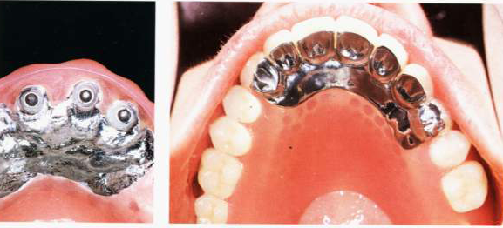The greater extension of the denture base (psychological disadvantage)

**Indications**

* Poor prognosis
* speech problems
* extensive tissue loss in the anterior region
* unfavorable spatial relations

**2-Implant supported overdenture**

An implant retained overdenture is an alternative form of treatment to the fixed‐implant prosthesis. The denture may attach on a cast bar fixed to abutments, or it may attach to individual abutments. Patient can remove the overdenture for cleaning. Due to an increased awareness of the variety of clinical situations, bone density, biomechanics, and patient’s desires, and an ever growing number of patients benefit from additional retention and support through the help of implant supported overdentures.

**Type of implant overdenture**

**1-implant-retained and tissue-born overdenture**

It depends primarily on residual alveolar ridge for support. The implants will provide support in the area of the arch in which they are placed when loading is directed over them, this type need less number of implant (depending on the quality and quantity of the bone for maxilla and mandible)

* 2-4 implants -------for mandible
* 3-4 implants------for maxilla

**2-implant –retained and implant –born overdenture**

It does not depend on tissue support but depended on implant to bear the total occlusal loading. This type requires the use of sufficient number of implants to accommodate the load placed on the prosthesis.

The minimum number of implant required:

* 4 implants ------------- for mandible
* 6-8 implants------------for maxilla

***Indication of Implant supported overdenture.***

1. The patient’s general health allows only a short surgical procedure.
2. Atrophic ridge, therefore objective improvement cannot be expected by fabrication of new conventional dentures.
3. Patient has worn removable dentures previously.
4. Edentulous patients who are no longer able to wear complete dentures.
5. The patient is basically satisfied with complete dentures but wants the security of increased retention.
6. Economics: the patient is either unwilling or unable to bear the expense of a fixed reconstruct.

***Contraindication:***

1. Systemic conditions.
2. Inadequate bone substance for placement of at least two implants.
3. Unrealistic patient expectation.
4. Mental disorders.
5. Pregnancy
6. radiation to the implant site
7. Improper patient motivation

**Consideration that determine the type of implant supported overdenture**

1- Patients desire.

2- The quality and quantity of the bone in the arch.

3- The opposing occlusion.

4- The amount of inter-arch distance.

5- Economic considerations.

**Advantages of implant supported over denture:**

1. Prevent bone loss.

2. Maintain facial esthetics.

3. Reduce or eliminate prosthesis movement.

4. Create reproducible centric relation occlusion.

5. Eliminate soft tissue abrasions.

6. Improve prosthesis retention.

7. Increase occlusal force.

8. Improve prosthesis retention.

9. Improve chewing efficiency.

10. Improve speech compared with dentures.

**Disadvantages of implant supported over denture:**

1. Eliminate bone grafting or implants with poor prognosis for fixed restorations.

2. Some patients want implants primarily because they do not want to be able to remove the prosthesis. This would not satisfy the psychological needs of these patients to feel that the prosthesis is part of their body.

3. Lack of sufficient inter-arch space makes an overdenture system more difficult to fabricate than a porcelain fused to metal fixed prosthesis and more prone to component fatigue and failure.

**Requirments** **of implants** **used**:

•Distance between bar‐connected implants must be no less than 8 to 10mm, so that the lengths of the bar segments between implants are sufficient for proper placement of the retention clips.

•Arrangement of the implants should be as symmetrical as possible.

•Points of emergence of all implants should lie at the same height.

•In mandible, two implants may be sufficient.

•In maxilla, more than two implants recommended.

***The removable implant supported denture may present certain advantages over fixed implant prosthesis such as:***

1. Decreased costs associated with fewer implants.
2. Easier access for oral hygiene procedures.
3. Improved facial support via denture flanges.
4. Improved esthetics and phonetics, particularly in the maxillary arch.

**5thclass  *Prosthodontic***  **Dr. Thekra Ismael**

**Over Denture *(Continue)***

**Attachments in over denture**

Attachments are small mechanical devices, they are incorporated to provide retention and support, one part is connected to a root, tooth or implant (male part) and other part to a prosthesis (female part)

**Function of attachment**

1- Securing the prosthesis against forces that tend to lift it.

2- Providing periodontal support for the prosthesis.

3- Transferring the forces of the muscles of mastication from the prosthesis to the periodontium in as nearly axial direction as possible

4- Distributing shearing forces.

5-Stabilizing and/or splinting the abutment teeth

**Factors affecting attachment selection**

1. Available inter-arch space.

2. Crown root ratio and alignment of the roots.

3. Type of coping.

4. Vertical space available.

5. Number of teeth present.

6. Amount of bone support.

7. Location of abutments.

8. Location of the strongest abutments.

9. Whether the overdenture is a tooth supported or toothtissue-supported.

10. The type of the opposing dentition whether it is complete denture, overdenture, fixed appliance or natural dentition.

11. The maintenance problems and the cost.

12. Clinical experience and personal preference.

***Retentive Mechanism***

It is achieved by either:

1- Active retention provided by springs that fit into recesses.

2- Friction between the components.

3- Magnetic anchorage

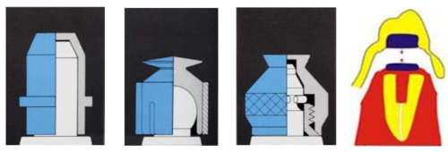

**Classification of Attachments**

1. **Rigid attachments**

A retentive attachment is considered to be rigid if it is grasps the abutment tooth bodily and permits no movement between anchor and prosthesis except for rotation around the long axis of the element in case of a single tooth. Even with rigid attachment there is a minimal amount of movement, which can increase when the attachment wear.

**Advantages:**

1- Reduction of the load on the edentulous ridge during function and parafunction.

2- Minimum tipping of the abutment teeth when subjected to lateral forces.

**Disadvantages:**

Applied forces and movements of the denture are transmitted almost entirely to the abutment teeth

1. **Non rigid attachments**

Non rigid attachment permits rotational movements of the denture around the anchor in one or more planes, or vertical body movement's .The greater the number of the non-rigid attachments used in the same denture, the more limited will be movement of each.

**Advantage:** Reduced effect of tipping force on the abutment teeth.

**Disadvantage**:

-Greater stress on the tissues supporting the denture (Ridge resorption)

**Non rigid attachments may be indicated under the following conditions:**

1- When the geometric distribution of the remaining teeth is unfavorable for the stability of the denture. This can give rise to undesirable tipping and rocking movements especially if the soft tissue support is more resilient and/or less expanded than normal.

2- When only a short dowel (post) can be used to anchor the coping. If a rigid attachment were used over a short dowel, uncontrolled movement of the denture might loosen the dowel from the root

**Types of attachments**

***A-Stud attachments: (2 types):-***

1. Intra radicular attachments. (E.g. Zest anchor attachment).

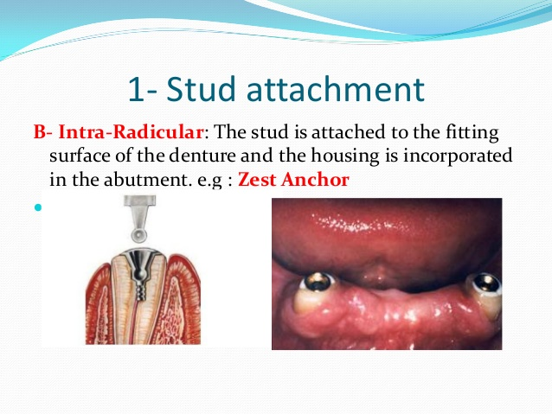

1. Extra radicular attachments. (E.g. Ceka Revax attachment).

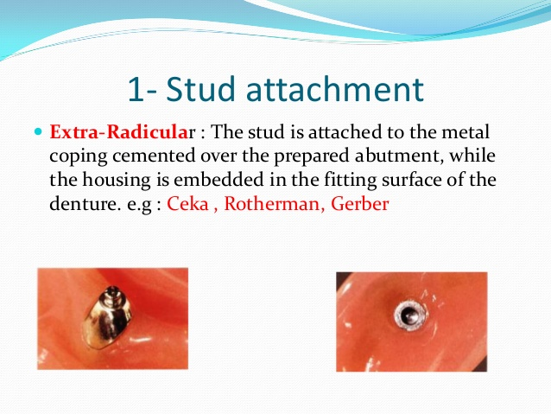

***B- Bar attachments: (2 types):-***

1. Bar units.
2. Bar joints.

***C-Magnet attachments.***

***Stud attachment***

•Male stud –soldered to the base which is a coping covering the prepared tooth stump

•Female housing –this is embedded in the acrylic of the OD or it is soldered to substructure in the OD

•Male and female attachments may be either resilient or non resilient

There are many systems of stud attachments*:*

**1. Zest anchor (intraradicular attachment)**

* Post prep is made within the root and the female sleeve is cemented into plac*e*
* Male portion consists of a nylon post and a ball head attachment to the overdenture as a chair side procedure
* Ideal for interim overdenture

*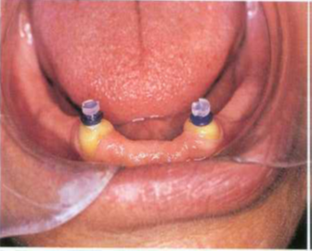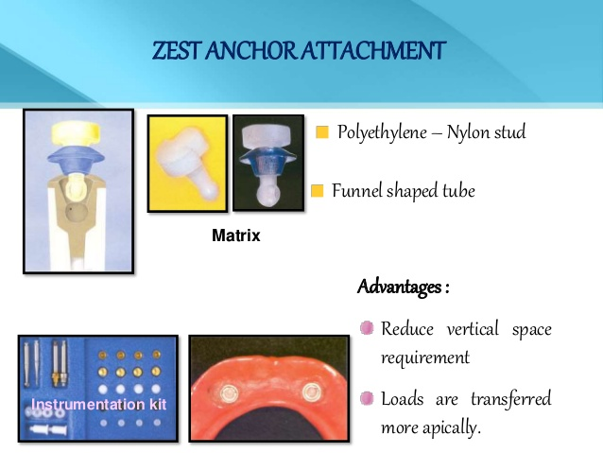.*

**Advantage**

1. Overcomes any space problem since the attachment is within the root structure.

2. Leverage to the abutment tooth is reduced

3. Attachment procedure is simple

4. Parallelism is not necessary if more than one tooth is used due to the flexibility of the nylon

5. No casting is required

**Disadvantage**

1. Caries susceptibility as no coping placed

2. Nylon stud can bend preventing seating (To correct this frequent recall ( visits are necessary

3. When eating foods without the OD can cause food to stagnate in the female part.

**2-Ceka Attachment (extra radicular attachment)**

• Male part fixed to the tooth and has a rounded shape wider at the top and split vertically into 4 sections. They are flexible and can be compressed

• Female housing fits over this

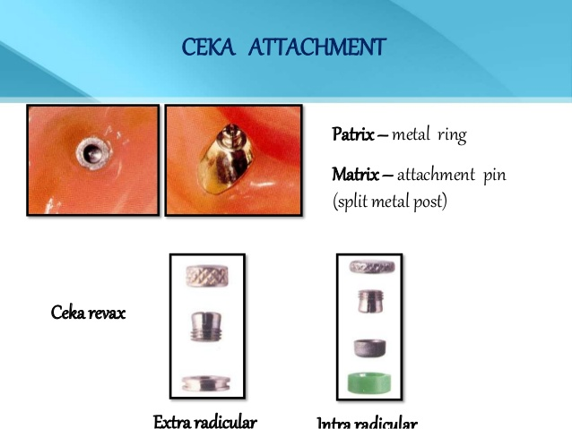 • The attachment can also be constructed with a different type of retention male that has a space between the parts to allow both rotational and vertical movement

3-Dalbo attachment

• Rigid, resilient or the stress breaker type

• Male part is soldered to the tooth and the housing to the base

• The rigid type has a cylindrical male unit with a rounded head

• The resilient is the smallest and the most commonly used.

• Rotational and vertical movement possible because of relief spacers between the units

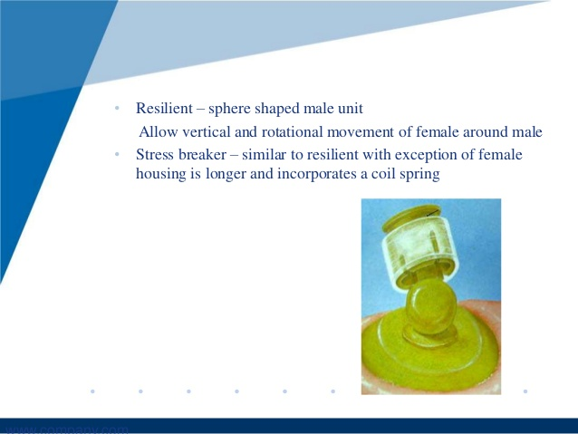 • Retention in this is by the flexible arms of the female unit fitting over the undercut head of the male unit

**Bar attachment**

• The purposes of using bars are: – Splinting of abutment teeth – Retention and support of the prosthetic appliance.

• There are 2 types:

**– Bar units** : which are the rigid type, no movement between bar and overlying sleeve, transmits occlusal stress totally to abutments.

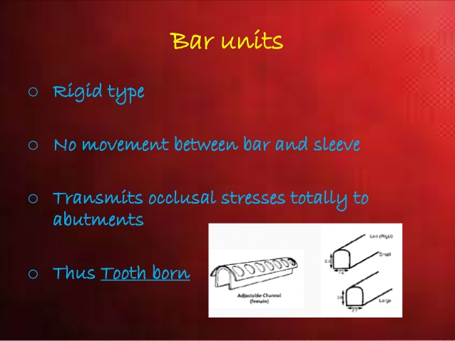

**– Bar joints**: which allow some movement of the rotational type. Utilizes the residual ridge for support .

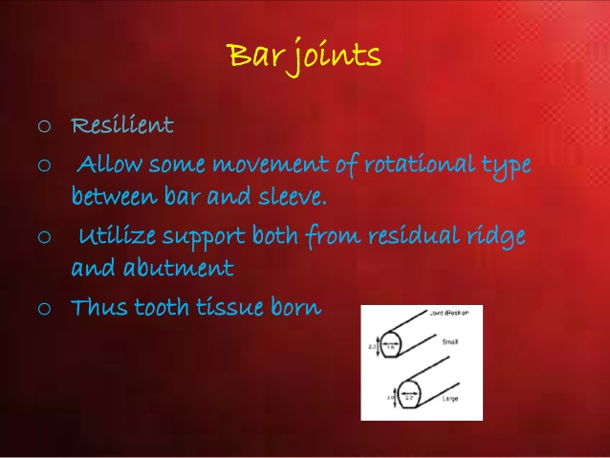

**There are many systems of bar attachment such as:**

* **1- Hader Bar**
* This bar can serve either as a bar joint or a bar unit or as stud .It consist of preformed plastic bars and clips .The bar is attached to the coping wax-up and is casted with the coping. The plastic clips can be imbedded in the denture base to gain retention.

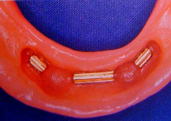

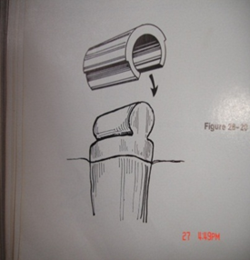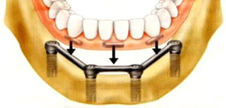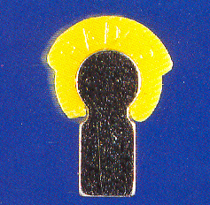

**2-Ackerman clip and C.M. clip**

It consists of a round bar soldered to the post copings and the clip fits over the bar, It in addition has retention wings for engagement of the clip into the resin in the overdenture, spacer is supplied, so that the clip does not rest directly on the bar providing both rotational and vertical movement.

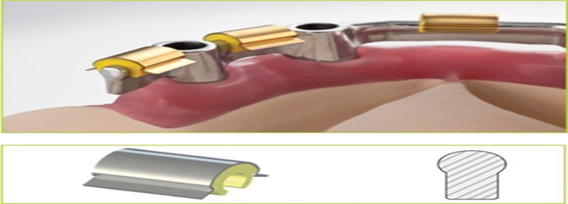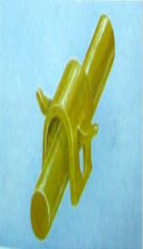

**3- Dolder bar**

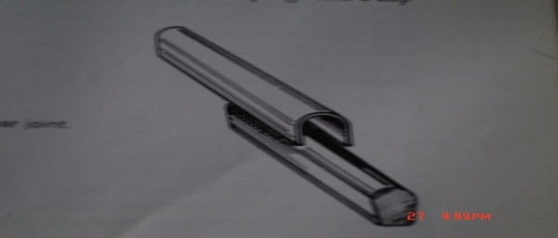• Bar unit: preformed bar with parallel sides and rounded top soldered to the coping , Sleeve is present in the denture bases , Retention is due to friction ,If the post of the copings cannot be made parallel to seat the soldered bar then a schubiger unit is used . Because of the parallel walls and close adaptation rotation is not possible

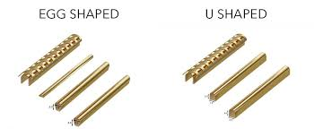• Bar joint: – Egg shaped bar with a spacer. This allows some movement – Difficult to adapt to tissue contour and bulky.

**C-Magnet Attachments**

Magnet system of cobalt - samarium magnet built into the denture base and a magnetisable dowel -coping or keeper plate of palladium cobalt- nickel alloy into the abutment teeth

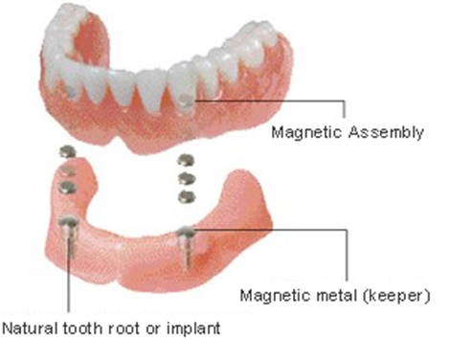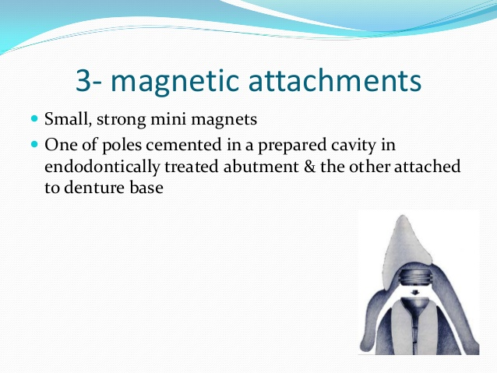

**O-Ring attachment**

They are doughnut shaped, synthetic polymer objects that possess ability to bend with resistance and then return back to their original shap.The

O-ring attaches to a post with a groove or undercut area.

Advantage

* Ease in changing the attachment.
* Wide range of movement.
* Low cost.
* 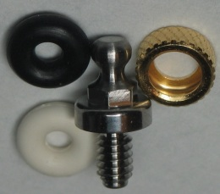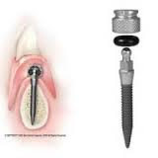Elimination of time &cost of a superstructure of prosthesis.

**Oral Hygiene Instructions**

* Motivating and instructing the patient in the care of the overdenture is of the extreme importance for its long term success
* Learned during the preliminary treatment phase, the oral hygiene procedures practiced by the patient following placement of the overdenture should be an uninterrupted continuation of the home care measures.

**Overdenture care**

* 1- Ordinary toothbrush or a special denture brush*.*
* 2- Tooth pastes with low abrasiveness and non-alkaline soaps.
* 3- Denture cleansers (mostly peroxide based) are a useful adjunct.
* Candidacies can be treated by immersing the denture in a 0.2%chlorhexidine solution for 10-15 minutes every day

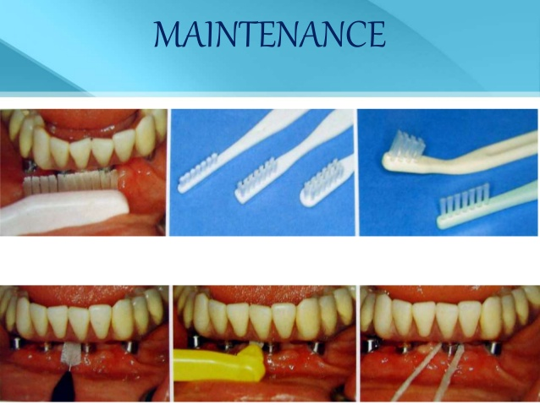

**Care of abutment**

**A-mechanical aid**

* All abutment teeth with or without root coping must be cleaned on all sides.
* All exposed root surfaces and gingival area should be brush again with an inter proximal brush.
* Dental floss is used only to clean under interdental bars and beneath root coping that are solder together.

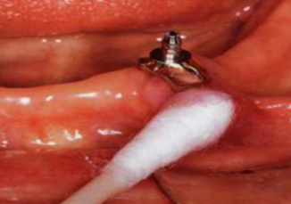**B-chemical aid**

Fluoride in gel

Fluoride in a 0.025% solution can also be

used as a daily rinse.

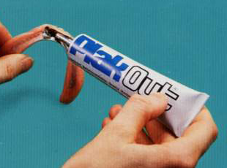

Chlorhexidine:

0.1-0.2% solution as a daily rinse

gel to be applied inside the

denture base or the female attachment.

**Prosthodontics follow up care:- to correct**

- Occlusion (remounting records).

-Base (relining).

-Pressure spots.

-Bar (loose screws).

-Bar clips (broken, loose).

-Female retainers and clips remounted with acrylic resin.

-Signs of wear