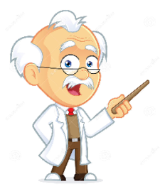**The following materials must go into Sharps Bin**

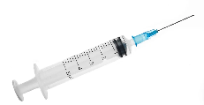

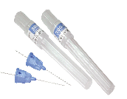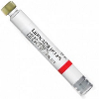 **Disposable irrigation syringe**

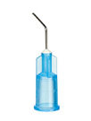 **Local anesthesia cartridge with their needles**

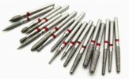 **Empty acid etch tips with their syringe**

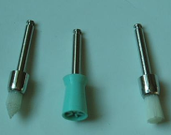 **Dental burs**

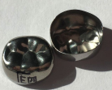 **Prophy brushes and rubber cups**

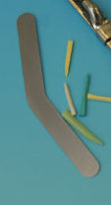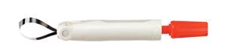 **Stainless steel crown**

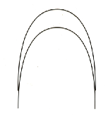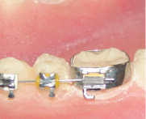 **Retainers, disposable retainers and wedges**

**Orthodontic brackets, bands and wires**

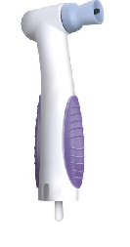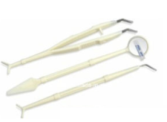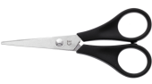 **Disposable mirror, probes and tweezers**

**Disposable scissors**

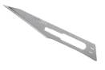 **Disposable handpiece**

**Scalpels and other blades**

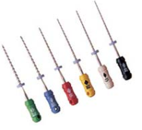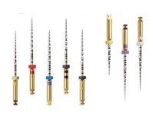 **Files and other rotary endodontic instruments and barbed broaches**

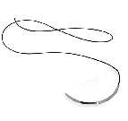

**Surgical sutures**

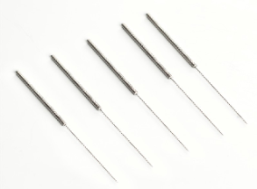 **Slides and cover slides** 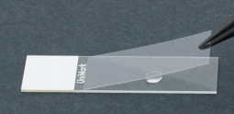

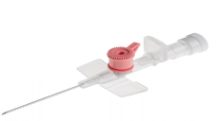 **Acupuncture needles**

**Cannula**

**Any other sharp instrument that might cause skin prick or cuts.**

**By MK Salih**