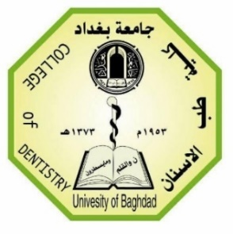
Republic of Iraq
Ministry of Higher Education & Scientific Research
University of Baghdad
College of Dentistry

Advanced Treatment Materials and Techniques for Dentin Hypersensitivity

BY
Abdulrahman Nawfel
Supervised by
Asst. prof. Dr. Lamis A. AL-Taee
B.D.S., M.Sc., Ph.D

Department of Restorative & Esthetic Dentistry
2021-2022

Certification of the Supervisor

I certify that this undergraduate dissertation entitled "Advanced Treatment Materials and Techniques for Dentin Hypersensitivity" was prepared by Abdulrahman Nawfel under my supervision at the College of Dentistry / University of Baghdad in partial fulfillment of the requirements for B.D.S degree.

Signature
Asst. prof. Dr. Lamis A. Al-Taee
(The Supervisor)

Dedication

To my parents, who never stop giving of themselves in countless ways.
To my second family in college.
To my supervisor for her guidance, encouragement, help & support.

Acknowledgment

In the Name of Allah, the Most Merciful, the Most Compassionate all praise be to Allah, the Lord of the worlds; and prayers and peace be upon Mohamed His ervant and messenger.
First and foremost, I must acknowledge my limitless thanks to Allah, the Ever-Magnificent; the Ever-Thankful, for His help and bless.
I owe a deep debt of gratitude to our university for giving us an opportunity to complete this work.
My sincere appreciation is to my supervisor Asst. prof. Dr. Lamis A. Al-Taee for her thoughtful guidance, suggestion, criticism, invaluable help & advice in planning and conducting this research.

List of Contents
Subject | Page No.
Introduction | 1
Structure of dentin | 2
Sound dentin VS hypersensitivity dentin | 3
Etiology and predisposing factors | 4
Treatment materials and Techniques | 7
Oral hygiene instruction for DHS prevention | 8
Behavioral control and elimination of predisposing factors | 8
Non-invasive treatments for pain relief | 9
Nerve desensitizing agent | 12
Desensitizing Agents that precipitate salivary protein | 12
Desensitizing Agents\techniques that precipitates dentin like minerals | 14
Anti-inflammatory Desensitizing agents | 18
Desensitizing Agents that lead to precipitation of calcium and phosphates | 18
New agents for management of hypersensitivity | 20
Heal Ozone treatment | 20
Laser application | 20
Restorative materials | 25
Conclusion | 28
References | 28

List of figures
Figure No. | Figure Title | Page No.
1 | Scanning electron micrograph of dentin with open dentinal tubules | 3
2 | A summary of the etiological factors contributing to DH | 6
3 | strategies for managements of dentin hypersensitivity (DHS) | 7
4 | Prevention procedures for dentin hypersensitivity | 9
5 | Treatment materials & techniques | 11

Introduction:
Dentin hypersensitivity is often defined as the pain arising from chemical, tactile, thermal, osmotic or evaporative stimulus whereby the dentin surface is exposed to the oral environment (Dababneh et al., 1999). There are many reasons for dentin involvement in the oral cavity, such as attrition, abrasion and erosion, cervical caries, gingival recession and excessive brushing (Bartold, 2006). There have been many theories about the mode of neural transmission within the dentinal tubule but the most widely accepted mechanism is the hydrodynamic theory. This theory was first introduced by John Neill in 1838, resurfaced by Alfred Gysi in 1900 and more recently by Martin Brännström in 1963. According to Brännström the disruption of dentinal fluid within patent and exposed tubules can stimulate the nerve plexus in the pulp (Brännström, 1963). Dentin hypersensitivity is usually encountered among people aged 20-50 yrs. (Miglani et al., 2010). The older population rarely encounters hypersensitivity problems, this can be ascribed to the reparative properties of dentine, fibrosis within the pulp and sclerosis of the tubules (West, 2000). Some studies conclude that DH occurs more in females than males (Cunha-Cruz et al., 2013) and other studies showed cold stimulus is the most common stimulus that caused DH (Chabanski, et al., 1996). Teeth that were most affected by DH were premolars and molars (Wang, et al., 2012). One systematic review, however, reported that premolars and incisors were mostly like affected by DH (Shiau, H.J, 2012). In terms of age, many studies conceded that DH occurs most frequently between the third and fourth decade and gradually declines thereafter (Rees and Addy, 2004). Root Dentinal hypersensitivity is managed through disturbing the neural response to pain stimulus or blocking fluid flow by occluding the tubule. Non-invasive measures as desensitizers, dentin adhesive sealers, laser application and ozone heal therapy proved efficacy in relieving dentinal hypersensitivity, with desensitizers being the most commonly used, probably due to ease of usage and low cost, it was applied at-home in toothpastes and mouthwashes in low concentrations and in-office as pastes at high concentrations, Furthermore, current advances as nano-technology were applied successfully with promising results, However, it require at least two weeks and the long term outcome is questionable, combinations of lasers with desensitizers and dental adhesives are suggested for optimum results. Nevertheless, when indications are met, invasive therapies including restorations as Glass ionomer cement and resin composites showed superior long-term outcome.

Structure of dentin:
Dentin is composed of minerals made up of apatite crystallites about 70% in weight, 40-45% in volume, organic matrix 20% in weight, 30% in volume and water 10% in weight, 20-25% in volume (Nanci, 2003). It is considered a complex hydrated structure composed from four elements: oriented tubules surrounded by a highly mineralized peritubular zone, embedded in an inter-tubular matrix consisting largely of type one collagen with embedded apatite crystals, and dentinal fluid ( Bulter, 1992). About 56% of the mineral phase is inside the collagen, which makes dentin slightly harder than the bone, yet softer than enamel. Throughout life, a layer of nonmineralized dentin, known as predentin, separates the odontoblasts from the mineralized regions. Predentin–dentin interface has an irregular-scalloped appearance. This is due to the occurrence of mineralized dentin with a spheroidal morphology. All of the dental tissues are deposited incrementally, and unlike bone, dental tissues are rarely remodeled (Arola et al., 2009). Odontoblasts produce non-collagenous proteins that play an important role in the dentin mineralization. These are present between the dentinal tubules and are assembled along the dentinal tubule walls (Orsini et al., 2009). Cytoplasmic extension of odontoblast associated with nerve endings extend into dentinal tubules and making the odontoblast which resides in the pulp responsible for dentin hypersensitivity (Mjor et al., 2001). According to formation phases, dentin can be divided into five different types: DEJ, mantle dentin, primary dentin, secondary dentin, and tertiary dentin. This classification reflects the changes in the basic components of the structure as defined by changes in their arrangement, interrelationships, or chemistry (Marshall et al., 1997).
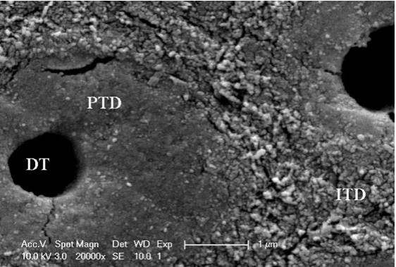

Figure 1: Scanning electron micrograph of dentin with open dentinal tubules.

Sound dentin versus hypersensitivity dentin
Through the use of scanning electron-microscope, a study showed that teeth with DH approximately have eight times the number and two times the diameter of dentinal tubules in sound teeth (Absi et al., 1987). Furthermore, a study by Transmission Electron Microscopy clearly showed that the lumens of most of the tubules were occluded with mineral crystals in naturally desensitized areas, but such lumens were empty and surrounded with peritubular and inter-tubular dentin in hypersensitive areas (Yoshiyama et al., 1990). Moreover, electron-dense structures that lined peritubular dentin were observed in the empty lumens of dentinal tubules. In addition, the smear layer of dentinal tubules in teeth with DH were found to be thinner than those in sound teeth (Rimondini et al.,1995), hence exposure of dentinal tubules along with removal of smear layer will lead for development of dentin hypersensitivity. There are, several distinct structural differences between dentin of the crown and the root (West et al., 2013). However, there is no evidence to support differences in their pathogenesis.

Etiology and predisposing factors:
The etiology of dentinal hypersensitivity is multifactorial and ascribed mostly to denudation of root surface or wear of the enamel causing exposure of the dentinal tubules and subsequent stimulation of the nerve endings due to local or environmental irritant (Taani & Awartani, 2001). The etiology can be broadly divided into 2 processes: lesion localization and lesion initiation. Lesion localization starts due to dentin exposure due to either enamel loss or cement loss. The various factors attributed are gingival recession, attrition, abrasion, erosion, abfraction, improper instrumentation, and lack of overlap between enamel and cementum at cemento-enamel junction (CEl), (Cummins, 2010). Whilst, lesion Initiation process requires the opening of dentinal tubules. Toothpaste with abrasives, erosive agents, etc. lead to removal of smear layer after few minutes of exposure and causes bulk loss of dentin. The smear layer is composed of elements of protein and sediments derived from salivary calcium phosphate and seal the tubule inconsistently and transiently. Both mechanical and chemical exposure is required for loss of the smear layer (Borges et al., 2012). In a study, (Taani & Awartani, 2001), within dental hospital population showed that 53% of the patients reported hypersensitive teeth, presenting women with higher prevalence of hypersensitive teeth than men. The gingival recession played a major role in dentine hypersensitivity in approximately 20% of the patients. Another subset of 29% patients had periodontal disease and 3.9% patients reported of previous orthodontic treatment or rehabilitation for trauma from occlusion. A summary of the etiological factors contributing to DH is represented in Fig.2.

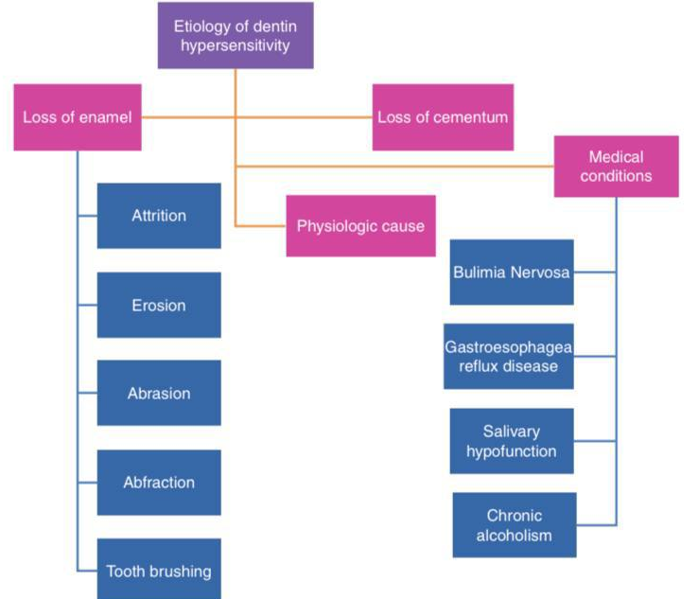

Figure 2: A summary of the etiological factors contributing to DH

Treatment materials and Techniques
Strategies for management and treatment of DHS includes:
- Oral hygiene education & brushing technique instructions.
- Behavioral control and elimination of predisposing factors for DHS.
- Non-invasive treatments for pain relief through occluding dentin tubules and blocking nociceptive transduction/transmission.
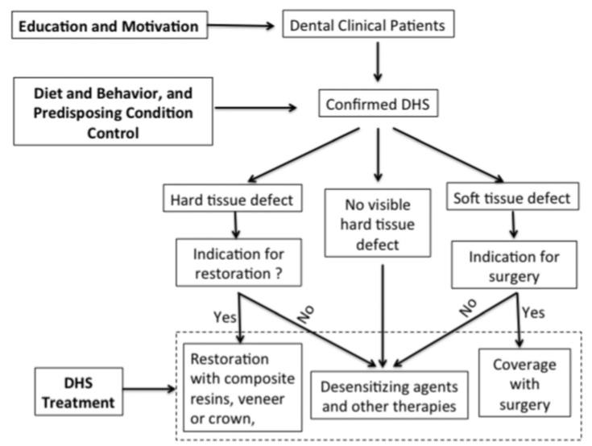
- Restoration for dental hard defects.

Fig.3 strategies for managements of dentin hypersensitivity (DHS) (Liu et al., 2020)

Oral hygiene instruction for DHS prevention
DHS is largely the result of erosive/abrasive tooth wear or gingival recession related dentin exposure, dental practitioners should employ preventive strategies directed at known predisposing etiological factors for DHS (Gillam, 2017). Education, instruction, and engagement in prevention of erosive and abrasive tooth wear and gingival recession should be routinely provided to dental patients. Since the acids from vinegar, fruit and fruit juices, as well as soft drinks (e.g. citric, malic, and phosphoric acid) are the major cause for dental erosion, consumption of the acidic food or beverages should be regulated in patients prone to the development of DHS (Malik et al. , 2010). Patients must be aware that other foods or beverages, although non-acidic, can contribute to lower pH in the oral cavity. These may contain various sugars or starches, which when broken down to their constituent sugars by salivary amylases, which can lead to bacterial production of acid (lactic for example). Consuming such foods or beverages before removal of the oral biofilm can thus elevate susceptibility of exposed dentin surfaces to mechanical abrasion, even from gentle tooth brushing Tooth brushing technique such as selection of soft bristle brush and non-abrasive toothpaste, and using vertical sweeping motion that minimize injury to dental soft and hard tissues should be emphasized (Addy, 2005).

Behavioral control and elimination of predisposing factors
It is essential to eliminate predisposing factors causing dentin exposure that will cause DHS. In cases with tooth wear caused by bruxism or compromised dentition, it is recommended that the use of an occlusal guard or restoration of the worn dentition and vertical dimension be done (Davari et al., 2013). Excessive frequency of brushing in the absence of acid-mediated softening of dentinal surfaces has also been noted in many subjects plagued by DHS (Addy, 2005). Medical and psychiatric conditions may contribute to dental erosion/abrasion and gingiva recession. Gastric reflux, the release into and the retention of gastric acids within the oral cavity, can erode both enamel and dentin aggressively leading to softening of surface dentin, thereby predisposing it to accelerated wear. In any case, medical and/or psychiatric causes of DHS must be identified and be treated or controlled (Mayhew, 1998).
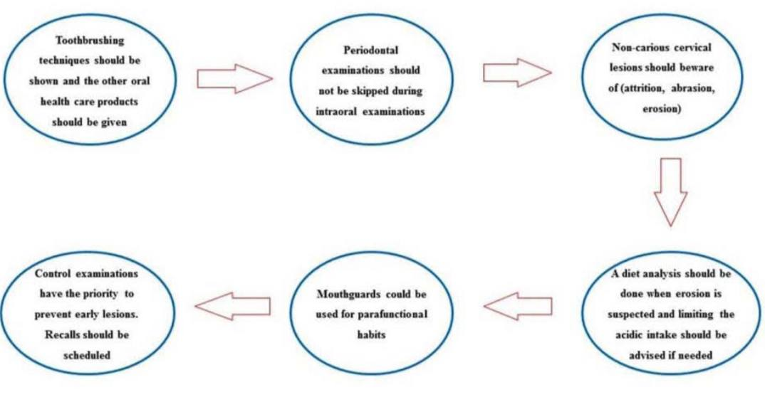

Fig. 4 Prevention procedures for dentin hypersensitivity.

Non-invasive treatments for pain relief
Application of desensitizing agents is the most frequently used non-invasive treatment for DHS. When self-care strategy fails to diminish root dentin hypersensitivity a professional is necessary, in which the treatment modalities are topical approaches (Lacevic et al., 2004). Treatment options is carried through two mechanisms; blockage of pulpal nerve activity which can be achieved through potassium salts (Haywood et al., 2001) occlusion of dentinal tubules which can be achieved by using agents that leads to precipitation of a dentin-like mineral (Hack & Thompson, 1994); through the application of products leading to formation of salivary protein precipitants in dentine tubule (Addy & Mostafa, 1988) by use of anti-inflammatory agents (Scherman & Jacobsen, 1992), through applying bioactive-glass that form an appetite layer which occludes the dentinal tubules (Forsback et al., 2004). By the application of adhesive resin materials which seal the dentine tubules by forming a hybrid layer and resinous tags (Orchardson, Gillam, 2006). While the use of Heal Ozone treatment where the ozone penetrates the exposed tubules eliminating bacterial contamination and allowing mineral ingress and subsequent sealing of the dentine tubules (Bubteina & Garoushi, 2015).
The application of dental lasers will promote recrystallization of dentin producing a glazed, nonporous surface that partially or totally obliterate dentine tubules, or by affecting the neural transmission through coagulation of proteins in the dentinal fluid and hence reduce permeability and block fluid movement (Bubteina & Garoushi, 2015). Kimura & Wilder-Smith (2007) supported the efficiency of those methods. Based on the mechanism of action, the most recently developed materials used in experiments are discussed below in regard to desensitizing measures which are divided into:

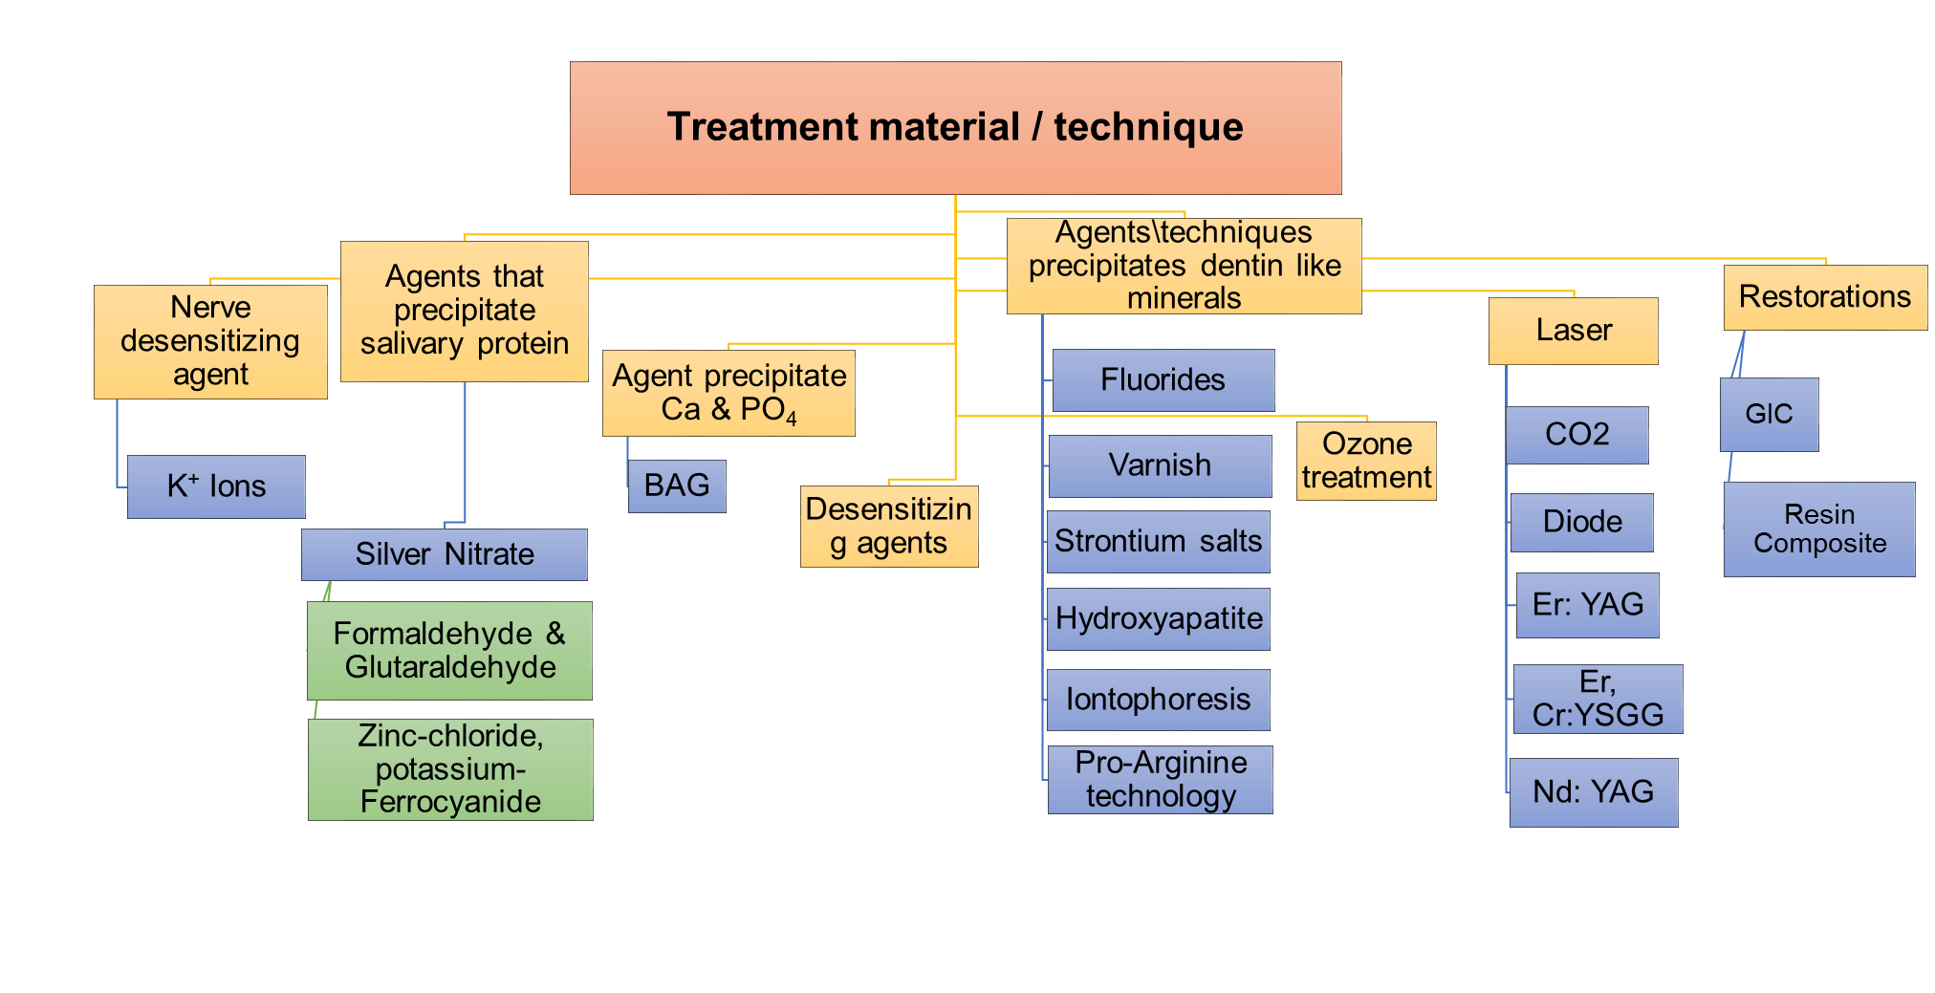
Figure 5. Treatment materials & techniques.

Nerve desensitizing agent
It is the primary therapeutic approaches to DHS, mainly carried by potassium ions which considered as the most favored material, it is applied in dentifrices containing potassium nitrate which are common, easy to use and accessible (Bamise & Esan, 2011). The mechanism of potassium salts (nitrate, chloride or citrate) reduce the DH by increasing the extracellular potassium ion level to depolarize the nerve. This ultimately prevents the nerve from repolarizing. This technique reduces DH by diminishing neural transmission from the nerve ending of the odontoblasts in the dentinal tubules (Shiau, 2012). Although it was widely used, it has challenging practically as patients use toothpaste twice a day and no sufficient increase in the concentration of potassium ions occurs in saliva in such short time. No strong support was found for using potassium containing dentifrices for managing dentinal hypersensitivity as many studies via meta-analysis indicated (Poulsen et al., 2006). Although studies showed no significance of potassium nitrate when used alone, a recent eight weeks randomized control trial concluded that combining potassium nitrate with 10% nanohydroxyapetite in a toothpaste is effective in relieving DHS symptoms when used at least twice daily (Amaechi, et al., 2021).
Desensitizing Agents that precipitate salivary protein:
1- Silver nitrate
A powerful protein precipitate which cause pulpal damage by coagulation or destroying the dentinal protoplasm, mainly affecting the protein constituent of odontoblastic processes (Burchard, 1898). Silver nitrate is not commonly utilized, according to Markowitz and Kim, because it permanently changes tooth color (Markowitz K and Kim., 1991). Although, silver nitrate is not used nowadays, however, silver particles (the active ingredient) have many applications recently, as an in-vitro study showed the occlusion of dentinal tubules along with silica under electron microscope, without blackening dentin. Furthermore, silver-containing mesoporous bioactive glass with a high specific surface area have antibacterial and remineralization abilities, in a study, silver nanoparticles were used to inhibit an S. mutans cultivated environment and reduce the degradation of collagen. Er:YAG laser irradiation improved the interaction between bioactive glass and dentin and enabled the formation of an intense crystalline layer, sponsoring the enhancement of mineralization and avoiding daily erosion (Kung et al., 2021).

2- Zinc-chloride, potassium-ferrocyanide:
Gottlieb developed the zinc chloride-potassium ferrocyanide impregnation method for controlling sensitivity due to exposed root surfaces and post-cavity preparation (Gottlieb, 1948). In this procedure, a 40% solution of aqueous zinc chloride was rubbed onto the surfaces of sensitive teeth and allowed to remain for 1 min, followed by vigorous rubbing with a 20% aqueous potassium ferrocyanide until an orange, curdy crystalline precipitate is formed covering the dentin. There are many applications for zinc salts in treating root-DH, as a novel in-vitro study applied nano-technology to produce nano-particle zinc salts incorporated in tooth-paste and has shown that in addition to occlude dentinal tubules, it enhanced the mechanical properties of the residual dental structure, therefore avoiding the loss of hard tissue produced by other toothpastes for non-carious cervical lesions. However, they should be considered as a treatment for patients suffering from root-DH only after performing clinical experimental studies (Toledano et al., 2021).
3- Formaldehyde and Glutaraldehyde:
A biological ﬁxatives that causes coagulation of plasma proteins and thus tubular blockage along with signiﬁcant pain relief following topical application to hypersensitive, glutaraldehyde is mainly applied in Gluma Desensitizer which is an aqueous solution of 5% glutaraldehyde (GA) and 35% 2-hydroxyethyl methacrylate (HEMA). A study resulted that application of Gluma showed better control in treatment of dentin hypersensitivity when compared to diode laser. Glutaraldehyde in Gluma desensitizers showed great effectiveness in treating root-DH, however, a study concluded that GA is safe when used alone, yet, when combined with HEMA as in Gluma desensitizer, the product becomes cytotoxic (Scheffel et al., 2015).
Desensitizing Agents\techniques that precipitate dentin like minerals:
1- Fluorides:
Fluoride ions prevent DH through occlusion of dentinal tubules or blocking of stimuli transmission (Orchardson & Gillam, 2006). Topical application of 1.23% sodium fluoride reduced sensitivity following bleaching in a randomized controlled clinical trial (Armenio, et al., 2008). Another type of fluoridated dentifrices, stannous fluoride have showed superiority in concentration of 0.45% over 1000 ppm sodium monofluorophosphate in decreasing DH at 4-8 weeks, despite the demonstration of near complete occlusion of dentinal tubules in the anhydrous version of stannous fluoride, it has a major disadvantage as it stains the teeth (West, et al., 2012) and ceramic materials (Artopoulou, et al., 2010), in addition for taking long onset to be effective.
2- Varnishes:
Fluoride varnish is a more concentrated form of fluoride that is not a permanent layer as it stays on a patient's teeth for several hours, allowing the fluoride to seep into and strengthen the teeth. It appeared with the most successful results of fluoride treatment methods; it can be accredited to the amplified retentiveness of the varnished surfaces compared with other procedure of fluoride treatment. A recent study showed disappointing results when using fluoride varnish in combination with other products as proven by A randomized, double-blind, placebo-controlled clinical study for determining the efficacy of a calcium-phosphate/fluoride varnish and ionomeric sealant on cervical dentin hypersensitivity which resulted in that Ca/PO⁴⁻/F⁻ varnish did not differ from placebo in reducing DH (Machado et al., 2022) whilst another split-mouth randomized double-blind clinical trial for long-term effectiveness of treating dentin hypersensitivity with fluoride varnish known as bifluoride 10 and adhesive known as futurabond which is a single dose dual curing universal adhesive has concluded that fluoride varnish is as effective as dental adhesives (futurabond) in treating DH.
3- Strontium salts:
Strontium salt has been known to reduce DH by utilizing its insoluble metal compound to occlude the dentinal tubules (Shiau, 2012). Some studies have reported no clinical efficiency from strontium (Cummins, 2010), although several in vitro studies have proven the efficiency of strontium-containing toothpastes Sensodyne Original and Sensodyne Rapid Relief (GlaxoSmithKline, Weybridge, UK) are available dentifrices that contain 8% strontium acetate in a silica base. Strontium might replace calcium ions within the hydroxyapatite and therefore strengthen the dentin (Banfield & Addy, 2004) is effective for pain relief in one minute after application in affected teeth, but still inferior to pro-arginine. Moreover, a combination of strontium and bioactive glass showed promising results keeping the decrease of hydraulic conductance about 90%, even after brushing (Arshad et al., 2021).
4- Oxalates:
Oxalate products are moderately insoluble in acid which make them more resistant to dissolution (Pereira et al, 2005). It was first introduced in the late 1970s and confirmed a decrease in hydraulic conductance in the dentinal tubules (Pashley & Galloway, 1985). Oxalates except 3% monohydrogen monopotassium oxalate, has not been proven to be more effective in treating DH than placebos as systematic review concluded (Cunha-Cruz, et al., 2011). Oxalate solutions have also been shown to be inferior to sodium chloride solutions in reducing DH (Cuenin, et al., 1991), gel form of potassium oxalate was investigated as in-vitro study showed great potential for tubule occlusion (Pereira et al., 2005).
5- Hydroxyapatites (HAp):
Hydroxyapatite is the most stable calcium phosphate compound under physiological conditions as temperature, pH and body fluids, it has biocompatible and biomimetic properties and able to reduce hypersensitivity along with enhanced remineralization. Effectiveness of synthetic HA in relieving root-DH is well documented in numerous clinical trials (Kalita et al., 2007). HAp is used alone or as synergistic agent in oral care products. It was successfully applied through the use of nano technology which enhanced its effect through small sized particles 200-400nm. Nano-HAP is able to occlude dentinal tubules, a randomized control trial showed that 20% nano-HAP dental cream is an effective method to promote the relief of DHS symptoms when applied daily (Amaechi et al., 2018). Another study comparing four groups according to the composition of desensitizing toothpaste: strontium acetate and calcium carbonate; calcium carbonate and arginine 8%, calcium phosphate nanoparticles; and a control toothpaste, resulted that the only immediate relief effect was from the paste containing calcium phosphate nanoparticles in the form of hydroxyapatite (Douglas de Oliveira et al., 2018).

6- Pro-arginine technology:
This technology is based on the interaction between Arginine, an amino acid positively charged at physiologic pH (6.5-7.5), Bicarbonate, a pH buffer, and insoluble calcium carbonate, a source of calcium (Panagakos et al., 2009) which infiltrates and blocks the dentinal tubules and prevent dentinal fluid flow, thus reducing dentin hypersensitivity. Usually, the effect lasts for a minimum of 28 days (Cummins, 2010). A recent randomized controlled trial concluded that dentifrices with Pro-arginine™ are effective for immediate pain relief from DH (Arshad et al., 2021). However, another study (Berg et al., 2021) comparing tubular occlusion by various treatments showed that arginine containing products are inferior to magnesium stabilized amorphous calcium phosphate-ACMP containing product in formation of a mineralized layer occluding exposed dentin tubules, and inferior to Bio-glass and Stannous fluoride in the resistance toward acid attacks.
7- Iontophoresis:
The use of an electric potential to transfer ions into the body for therapeutic purposes, where a chemical substance is applied on the tooth surface and current is passed through negative electrode using 0.5 mA current. The chemicals used are fluoride, oxalates, etc. This process increases the impregnation of the chemical by 2 to 6 times (Yadav et al., 2015), iontophoresis with 0.33% NaF gel produced partial occlusion of dentinal tubules that is comparable with diode laser when compared under scanning electron microscope, however it showed significantly less totally occluded tubules than diode laser showed (Patil et al., 2017).

Anti-inflammatory Desensitizing agents:
Corticosteroid Steroid application to exposed dentin increases peritubular dentin mineralization. Thus, the tubule lumen will be decreased, resulting in less dentinal tubular fluid movement, reducing the dentinal sensitivity. Although, corticosteroids are reasonably effective in reducing dentine hypersensitivity, but, still inferior to sodium fluoride and strontium chloride (Berman, 1984).

Desensitizing Agents that lead to precipitation of calcium and phosphates:
1- Bioactive glass:
A product mostly composed of silica. The mechanism of action starts with releasing Ca⁺² and PO₄⁻³ ions that continues as long as the material is exposed to the aqueous environment. A localized, transient increase in pH occurs during the initial material exposure due to the release of Na⁺ that helps to precipitate the Ca⁺² and PO₄ ⁻³ ions of the particle forming a layer of calcium phosphate Ca (PO₄)², which crystallizes into hydroxycarbonate apatite that is chemically and structurally equal to biological apatite. Physical occlusion of dentin tubules is carried out through the combination of residual particles and the newly formed apatite layer resulting in remission or pain reduction (Hench, 2006) due to the neoformation of a bioactive barrier on dentin surface. The use of bioactive materials is promising for DH as it occludes the dentinal tubules and form a mechanically strong layer of hydroxyapatite on the dentin surface, that resist degradation by repeated acid challenges (Bansal & Mahajan, 2017). A recent study (Hongal S. et al., 2019) under SEM showed that bioactive glass has the highest percentage of dentinal tubule occlusion followed by Pro-arginine and Strontium chloride while Potassium nitrate shows the least amount of dentinal tubule occlusion. Furthermore, the application of bioactive glass (BAG) irradiated by high-power laser could be promising effective and long-lasting method for managing dentin hypersensitivity. Despite the great advantages of BAG, it was suggested that toothpaste containing BAG is abrasive to enamel and may be a contributing factor in dentin hypersensitivity specially if combined with an erosive challenge. In order to overcome such drawback, it was found reducing the particle size would reduce abrasiveness (Mahmood et al., 2014). Moreover, drawbacks from independent use can be prevented through simultaneous application of silver-containing mesoporous bioactive glass MBG-Ag sealing and exposure for Er:YAG laser resulting in a superior outcome of treatment for dentin hypersensitivity (Kung et al., 2021).

New agents for management of hypersensitivity
The use of casein-phosphopeptide-amorphous calcium phosphate (CPP-ACP) for 6 weeks of topical application is recommended. It prevents the dissociation of calcium and phosphate ions and maintains their availability (Cai et al., 2003). The use of nanomaterials with a dimension less than 100 nm is also effective in treating DH. This occludes the tubule and lasts a minimum of 7 days. The agents from this group include nanostructure bioactive glass, and nanohydroxyapatite (Wang, et al., 2016).

Heal Ozone treatment
The ozone penetrates the exposed tubules eliminating bacterial contamination and allowing diffusion of calcium and phosphorus ions to the inner surface and subsequent sealing of the dentine tubules (Gupta & Mansi B, 2012). A study (Dähnhardt et al., 2008), showed that there was statistically no significant difference in pain reduction when ozone treatment was applied on hypersensitive teeth. However, another study (Azarpazhooh et al., 2009) proved that there was an average of 55% decrease of pain level of root dentinal hypersensitivity after ozone treatment. Although, ozone therapy provides no discomfort or pain and It reduces patient’s anxiety and stress level by reducing the treatment duration, but, there are limited useful role in treating root DH, not to mention the possible side effect that may go up to the respiratory tract. More studies are required to prove these speculations (Sen & Sen, 2020).

Laser application
The Laser therapy was first introduced as a potential method for treating dentinal hypersensitivity in 1985 (Matsumoto et al., 1985). The mechanisms involved in laser treatment of dentin hypersensitivity are relatively unknown (Kimura et al., 2000). The laser interacts with the tissue that causes different tissue reactions. This depends on its active medium, wavelength and power density and to the optical properties of the target tissue (Ladalardo et al., 2004). This occurs through the coagulation effect and protein precipitation of the plasma in the dentinal fluid or by alteration of the nerve fiber activity. A study of McCarthy et al. (1997) indicated that the reduction in DH could be the result of alteration of the root dentinal surface, physically occluding the dentinal tubules. The laser energy interferes with the sodium pump mechanism, changes the cell membrane permeability and/or temporarily alters the endings of the sensory axons (Kimura, et al., 2000). The immediate analgesic effect in the treatment of dentin hypersensitivity with diode laser was reported by Brugnera Júnior et al. (2001) based on this study the laser interaction with the dental pulp causes a photobiomodulating effect, which increases the cellular metabolic activity of the odontoblasts and obliterating the dentinal tubules with the intensification of tertiary dentine production (Brugnera Júnior et al., 2001)
The lasers used for the treatment of dentine hypersensitivity are divided into two groups:
- Low output power (low-level) lasers: diode laser
- Middle output power (Carbon Dioxide Laser (CO2), neodymium- or erbium-doped yttriumaluminum garnet (Nd:YAG, Er:YAG lasers) and erbium, chromium doped: yttrium, scandium, gallium and garnet (Er,Cr:YSGG) lasers) (Kimura et al., 2000)
Desensitization seems to depend mostly on the type of laser therapy adopted (Aranha & Eduardo, 2012).
1- Diode laser
The first use of this laser in dentin hypersensitivity treatment was reported by Matsumoto et al., (1985) which utilized three wavelengths (780, 830, and 900 nm) of diode for the treatment of dentin hypersensitivity. The laser tip has to be placed as close as possible to the tooth surface in noncontact mode. It is assumed that this type of low output power lasers mediates an analgesic effect related to depressed nerve transmission. According to physiological experiments using the diode laser at 830 nm, this effect is caused by blocking the depolarization of C-fiber afferents. The treatment effectiveness rates range from 53.3%-94.2% for the diode laser at 1month follow-up (Kimura, et al., 2000).
2- CO2 laser
This laser was first used for the treatment of dentine hypersensitivity by (Moritz et al. 1996) using output powers of 1 to 2 W with CW or pulse mode. The laser tip has to be kept on the tooth or gingival surface at a distance of 10-20 cm and has to be scanned as quickly as possible on the tooth or gingival surface (Matsumoto & Kimura, 2007) in order to avoid thermal damage to the tooth or gingival surface. The effectiveness ranges from 59.8 to 100%. CO2 laser effects on dentin hypersensitivity are due to the occlusion or narrowing of dentinal tubules. There have been no reports on nerve analgesia by CO2 laser irradiation. Using the CO2 laser at moderate energy densities, mainly sealing of dentinal tubules is achieved, as well as a reduction of permeability (Matsumoto & Kimura, 2007).
3- Neodymium: yttrium-aluminum-garnet (Nd: YAG) laser
The first use of this laser for treating the dentine hypersensitivity was reported by Matsumoto et al. (1985). A power output from 0.3 to 2 W is usually used. Continuous or pulsed wavelength is used and the number of the pulses is from 10-20 Hz (Kimura, et al., 2000). The use of Chinese black ink as an absorption enhancer is recommended, to prevent deep penetration of the Nd:YAG laser beam through the enamel and dentin and excessive effects in the pulp. Without using this ink, the laser tip has to be held over the tooth surface at a distance of approximately 10-20 cm. When Chinese black ink is used, the laser tip has to be kept close to the tooth or gingival surface in noncontact mode, and has to be scanned as quickly as possible over the tooth or gingival surface in order to avoid thermal damage to the tooth or gingival surface (Matsumoto & Kimura, 2007). The effectiveness ranged from 5.2 to 100%. The mechanism of Nd:YAG laser effects on dentin hypersensitivity is thought to be the laser-induced occlusion or narrowing of dentinal tubules ( Lan & Lui, 1996) as well as direct nerve analgesia (Whitters, 1995). Nd:YAG and CO2 lasers effectively cause occlusion of dentinal tubules (Kimura, et al., 2000).
4- Er: YAG Laser
This type of laser is suitable for caries treatment but endodontic and periodontic applications have also been studied. It was first used for DH therapy by (Schwarz et al., 2002). The parameters of Er:YAG laser irradiation for DH therapy are 1 W and 10-12 Hz for less than 60 s. In order to prevent damage to the tooth and gingival surface, the distance of the laser tip to tooth surface has to be kept more than 10 cm. The laser tip has to be quickly scanned across the tooth or gingival surface to prevent laser damage on the tooth or gingival surface (Matsumoto & Kimura, 2007). The reduction in DH after 6 months with the Er:YAG laser reportedly ranges from 38.2%-47% (Whitters, et al 1995). However there are a lot of ambiguous points in mechanism of Er:YAG, as this laser is absorbed by hydroxyapatite’s water molecules, which can cause dentin surface ablation and is opposite to the sealing of the dentinal tubules (Borges et al., 2012). According to Kimura, Nd:YAG laser is more effective than Er:YAG laser (Matsumoto & Kimura, 2007).
5- Er, Cr:YSGG Lasers
The Er, Cr:YSGG laser has been shown to be effective for soft-tissue surgery as well as for cutting enamel, dentine and bone. However, there is limited knowledge on the effects of this laser on DH and few studies have been published concerning the clinical aspects of the desensitizing effect obtained with the Er,Cr:YSGG laser. The output power used for DH therapy varies from 0.25 to 0.5 W (Aranha & Eduardo, 2012). (Yilmaz et al. 2011) demonstrated that the single application of Er,Cr:YSGG laser has shown efficacy in rapid DH reduction compared with placebo treatment. This effect has become apparent immediately, and it remained stable for a 3-month examination period. Based on the results of a Short-term clinical evaluation which compared the effects of Er:YAG and Er,Cr:YSGG lasers on DH, the Er,Cr:YSGG laser at a power of 0.25 W showed the best performance in the clinical evaluations (Aranha & Eduardo, 2012).
Although in-office root-DH laser treatment has some disadvantages as high cost, complexity of equipment, decreasing effectiveness over time and the possibility of hazard exposure, however, combination of laser treatment with chemical agents as sodium fluoride and stannous fluoride can enhance treatment effectiveness by more than 20% over that of laser treatment alone, hence achieving promising results that out-weights the disadvantages (Lan, & Lui,, 1996). The combination of Nd: YAG laser and 5% NaF varnish showed an impressive efficacy (Kumar & Mehta, 2005). In addition, CO2 laser irradiation through a layer of stannous fluoride causes a highly resistant layer on sensitized dentin. This layer induced by physical and chemical bonding mechanisms, providing a superior defense against external stimuli (Goharkhay et al., 2007).

Restorative materials
The use of direct restorations for hard tissue defects provide an alternative treatment for the DHS. For the erosion or abrasion related DHS, it is believed that direct restoration with resin based composite or glass ionomer cement and indirect restorations with a crown or a veneer provide effective long-lasting treatment for DHS (Gillam, 2017)
Direct restorations are considered in the following conditions:
- Failure to resolve DHS using non-restorative treatment approaches.
- High risk for continued dental tissue loss if not covered with restoration (inability to halt erosive or abrasive tooth wear).
- Hard tissue defect that is visible and requires restoration for esthetics and structural integrity.
- Little or no removal of tooth structure is required for restoration.
- Glass-ionomer cements
GICs have become a popular restorative material due to their chemical adhesion and ability to release fluoride (Rosa et al., 2013). GICs have shown extended satisfactory results over time, especially in the treatment of non-carious cervical lesions (Neelakantan et al., 2011). The pattern of fluoride release from GIC comprises a high initial release rate followed by rapid reduction (Franco et al., 2006). However, the sensitivity to moisture and contaminations interferes with the initial setting of self-cured GIC. In addition, conventional GICs are relatively unaesthetic with inferior mechanical properties than resin composites (Yan et al., 2007) which might impair the long-term treatment of DH. The resin-modified glass ionomer cements (RMGIC) have been developed to overcome the disadvantages of conventional GIC. They are more tolerant to moisture and do not require drying of the tooth surface (Ozgünaltay & Onen, 2002). The recently available ClinproTM XT (3M ESPE, Minnesota, USA) is a new paste-liquid that may be used as a site-specific, light-cured desensitizing agent (Naorungroj et al., 2010). The ion exchange with dental substrate inherent to GICs enhanced the development of these materials to obtain high fluoride release (Ding et al., 2014). Since GICs may also release therapeutic doses of fluoride over time, the activity is an important feature to obstruct tubules in DH treatment (Beun et al., 2012). However, there is no consensus in the literature regarding to the clinical relevance of released fluorides by those materials (Kovarik et al., 2005). The rapid reduction of DH and the long-term duration of these desensitizing effects are critical. Previous studies reported that the effects of several desensitizing agents were not permanent because they did not properly adhere to the dentin surface (Neelakantan et al., 2011). However, a limited amount of data on the efficacy of desensitizers is available in the literature, especially for long-term assessments of at least 6-months follow-up (Yilmaz, et al., 2011).
- Resin-Based composites
The clinical performance of these restorations is highly product-dependent, particularly regarding the adhesive system used. The type of composite material seems to have no significant influence on the clinical performance of NCCL restorations in clinical trials. It is much more important that the operator carries out the clinical procedure correctly. Marginal degradation is frequently seen during aging. However, the maintenance via the eventual repolishing of restoration margins will lengthen the lifespan of restorations (Peumans et al., 2020). The use of flowable composite resin after pumice cleaning, rinsing and drying, followed by dental bond application as in Clearfil S3 Bond was effective in reducing hypersensitivity in NCCLs within six-month study, yet, comparable with one-step self-etch sealant, raising a debut about optimum time saving procedure (Veitz-Keenan et al., 2013). In addition different in-vitro stduies have shown improvement in the long-term occlusion of the dentinal tubules and reduction of dentin sensitivity in teeth with cervical loss of tissue, when adhesive restorations were associated with oxalate-based desensitizing agents (Arrais et al., 2004), while a double-blind randomized controlled clinical trial during four-month period resulted that the application of oxalic acid under resin based composite restorations significantly reduces dentin sensitivity, compared with resin-only restorations, over a period of four months (Barrientos et al., 2011). However, a recent systemic review showed that oxalates have negative effect on the immediate bond strength, due to lack of clinical data, further research should be done (Li et al., 2021). On the contrast, a randomized clinical trial showed that moderate or severe hypersensitivity in teeth that required a filling responded similarly regardless of whether the desensitizing procedure was carried out prior to the restoration (Freitas et al., 2021).

Conclusion
There is no gold standard for treating root dentin hypersensitivity, amongst many desensitizers, bioactive glass, pro arginine, and nano-hydroxyapatite are the most effective materials with nano-technology, and the efficiency will be enhanced. Dental adhesives and varnishes showed comparable results. Lasers mainly Nd: YAG alone or in combination with desensitizers provided immediate relief for symptomatic patient at office with prolonged duration, GIC fillings are superior to resin composite in treating non-carious hypersensitive dentin, yet inferior in aesthetic. No single visit therapy is available till now. Biomimetic mineralization strategy is the future for root dentin hypersensitivity treatment.
References
A
- Addy M. Tooth brushing, tooth wear and dentine hypersensitivity--are they associated? Int Dent J. 2005.
- Arola, D., Ivancik, J., Majd, H., Fouad, A., Bajaj, D., Zhang, X. Y., & Eidelman, N. (2009). Microstructure and mechanical behavior of radicular and coronal dentin. Endodontic Topics, 20(1), 30-51.‏
- Absi, E. G., M. Addy, and D. Adams. "Dentine hypersensitivity: a study of the patency of dentinal tubules in sensitive and non‐sensitive cervical dentine." Journal of Clinical Periodontology 14.5 (1987): 280-284.‏
- Addy, M., and P. Mostafa. "Dentine hypersensitivity. I. Effects produced by the uptake in vitro of metal ions, fluoride and formaldehyde onto dentine." Journal of Oral Rehabilitation 15.6 (1988): 575-585.‏
- Arshad, S., Zaidi, S. J. A., & Farooqui, W. A. (2021). Comparative efficacy of BioMin-F, Colgate Sensitive Pro-relief and Sensodyne Rapid Action in relieving dentin hypersensitivity: a randomized controlled trial. BMC Oral Health, 21(1), 1-12.‏
- Armênio, R. V., Fitarelli, F., Armênio, M. F., Demarco, F. F., Reis, A., & Loguercio, A. D. (2008). The effect of fluoride gel use on bleaching sensitivity: a double-blind randomized controlled clinical trial. The Journal of the American Dental Association, 139(5), 592-597.‏
- Artopoulou, I. I., Powers, J. M., & Chambers, M. S. (2010). In vitro staining effects of stannous fluoride and sodium fluoride on ceramic material. The Journal of prosthetic dentistry, 103(3), 163-169.‏
- Amaechi, B. T., Lemke, K. C., Saha, S., Luong, M. N., & Gelfond, J. (2021). Clinical efficacy of nanohydroxyapatite-containing toothpaste at relieving dentin hypersensitivity: an 8 weeks randomized control trial. BDJ open, 7(1), 1-8.‏
- Azarpazhooh, A., Limeback, H., Lawrence, H. P., & Fillery, E. D. (2009). Evaluating the effect of an ozone delivery system on the reversal of dentin hypersensitivity: a randomized, double-blinded clinical trial. Journal of endodontics, 35(1), 1-9.‏
- Amaechi, B. T., Meyer, F., Fabritius, H. O., & Enax, J. (2018). Overview of calcium phosphates used in biomimetic oral care. The open dentistry journal, 12, 406.‏
- Aranha, A. C. C., & de Paula Eduardo, C. (2012). Effects of Er: YAG and Er, Cr: YSGG lasers on dentine hypersensitivity. Short-term clinical evaluation. Lasers in medical science, 27(4), 813-818.‏
- Aranha A, Eduardo C. Effects of Er:YAG and Er,Cr:YSGG lasers on dentine hypersensitivity, short-term clinical evaluation. Lasers Med Sci. 2012; 27:813–818.
- Arrais, C. A. G., Chan, D. C. N., & Giannini, M. (2004). Effects of desensitizing agents on dentinal tubule occlusion. Journal of Applied Oral Science, 12, 144-148.‏
B
- Bartold PM. Dentinal hypersensitivity: a review. Aust Dent J. 2006; 51: 212-218.
- Brännström, M., A hydrodynamic mechanism in the transmission of pain- produced stimuli through the dentine. Sensory mechanisms in dentine, ed. A. DJ. 1963: Oxford: Pergamon.
- Butler, W. T. (1992). Dentin extracellular matrix and dentinogenesis. Operative dentistry, 18-23.‏
- Bubteina, N., & Garoushi, S. (2015). Dentine hypersensitivity: a review. Dentistry, 5(330), 2161-1122.‏
- Bamise, C. T., & Esan, T. A. (2011). Mechanisms and treatment approaches of dentine hypersensitivity: a literature review. Oral Health Prev Dent, 9(4), 353-367.‏
- Burchard, H. H. (1898). A Text-book of Dental Pathology and Therapeutics, Including Pharmacology: Being a Treatise on the Principles and Practice of Dental Medicine for Students and Practitioners. Lea brothers & Company.‏
- Berg, C., Unosson, E., Engqvist, H., & Xia, W. (2021). Comparative Study of Technologies for Tubule Occlusion and Treatment of Dentin Hypersensitivity. Journal of Functional Biomaterials, 12(2), 27.‏
- Berman, L. H. (1985). Dentinal sensation and hypersensitivity: a review of mechanisms and treatment alternatives. Journal of periodontology, 56(4), 216-222.‏
- Bansal, Disha, and Mrinalini Mahajan. "Comparative evaluation of effectiveness of three desensitizing tooth pastes for relief in the dentinal hypersensitivity." Contemporary Clinical Dentistry 8.2 (2017): 195.‏
- Banfield, N., & Addy, M. (2004). Dentine hypersensitivity: development and evaluation of model in situ to study tubule patency. Journal of clinical periodontology, 31(5), 325-335.‏
- Brugnera Junior, Pécora, J. D., Cussioli, A. L., Guerisoli, D. M., Marchesan, M. A., Sousa-Neto, M. D., A. (2001). Evaluation of Er: YAG laser and EDTAC on dentin adhesion of six endodontic sealers. Braz Dent J, 12(1), 27-30.‏
- Borges A, Barcellos D, Gomes C. Dentin Hypersensitivity— Etiology, Treatment Possibilities and Other Related Factors: A Literature review. World Journal of Dentistry, 2012; 3(1):60–67.
- Beun S, Bailly C, Devaux J, Leloup G Physical, mechanical and rheological characterization of resin-based pit and fissure sealants compared to flowable resin composites. Dent Mater.2012; 28(4):349-59.
- Barrientos, C., Xaus, G., Leighton, C., Martin, J., Gordan, V. V., & Moncada, G. (2011). Oxalic acid under adhesive restorations as a means to reduce dentin sensitivity: a four-month clinical trial. Operative dentistry, 36(2), 126-132.‏
C
- Chabanski, M.B., et al., Prevalence of cervical dentine sensitivity in a population of patients referred to a specialist Periodontology Department. J Clin Periodontol, 1996. 23(11): p. 989-92.
- Cunha-Cruz, J., et al., The prevalence of dentin hypersensitivity in general dental practices in the northwest United States. J Am Dent Assoc, 2013. 144(3): p. 288-96.
- Cummins, Diane. "Recent advances in dentin hypersensitivity: clinically proven treatments for instant and lasting sensitivity relief." American Journal of Dentistry 23 (2010): 3A-13A.‏
- Cai F, Shen P, Morgan MV, et al. Remineralization of enamel subsurface lesions in situ by sugar-free lozenges containing casein phosphopeptide-amorp-hous calcium phosphate. Aust Dent J 2003;48(4):240-3
- Cunha-Cruz, J., Stout, J. R., Heaton, L. J., Wataha, J. C., & Northwest PRECEDENT. (2011). Dentin hypersensitivity and oxalates: a systematic review. Journal of dental research, 90(3), 304-310.‏
- Cuenin, M. F., Scheidt, M. J., O'Neal, R. B., Strong, S. L., Pashley, D. H., Horner, J. A., & Van Dyke, T. E. (1991). An in vivo study of dentin sensitivity: the relation of dentin sensitivity and the patency of dentin tubules. Journal of periodontology, 62(11), 668-673.‏
D
- Dababneh RH Khouri AT, Addy M. Dentine hypersensitivity - an enigma? A review of terminology, mechanisms, aetiology and management. Br Dent J. 1999; 187: 606-611
- Davari A, Ataei E, Assarzadeh H. Dentin hypersensitivity: etiology, diagnosis and treatment; a literature review. J Dent (Shiraz). 2013.
- Dähnhardt, J. E., Gygax, M., Martignoni, B., Suter, P., & Lussi, A. (2008). Treating sensitive cervical areas with ozone. A prospective controlled clinical trial. American journal of dentistry, 21(2), 74-76.‏
- Ding YJ, Yao H, Wang GH, Song H. A randomized double-blind placebo-controlled study of the efficacy of Clinpro XT varnish and Gluma dentin desensitizer on dentin hypersensitivity. Am J Dent.2014; 27(2):79-83.
- Douglas-de-Oliveira, D. W., Vitor, G. P., Silveira, J. O., Martins, C. C., Costa, F. O., & Cota, L. O. M. (2018). Effect of dentin hypersensitivity treatment on oral health related quality of life—A systematic review and meta-analysis. Journal of Dentistry, 71, 1-8.‏
F
- Forsback, A. P., Areva, S., & Salonen, J. (2004). Mineralization of dentin induced by treatment with bioactive glass S53P4 in vitro. Acta Odontologica Scandinavica, 62(1), 14-20.‏
- Franco EB, Benetti AR, Ishikiriama SK,Santiago SL, Lauris JR, Jorge MF et al. 5 year clinical performance of resin composite versus resin modified glass ionomer restorative system in non-carious cervical lesions. Oper Dent. 2006; 31(4): 403-8.
- de Freitas, S. A. A., de Oliveira, N. M. A., de Geus, J. L., Souza, S. D. F. C., Pereira, A. D. F. V., & Bauer, J. (2021). Bioactive toothpastes in dentin hypersensitivity treatment: A systematic review. The Saudi Dental Journal, 33(7), 395-403.‏
G
- Gillam DG. A new perspective on dentine hypersensitivity - guidelines for general dental practice. Dent Update. 2017.
- Gupta, G., and Mansi B., "Ozone therapy in periodontics." Journal of medicine and life 5.1 (2012): 59.‏
- GOTTLIEB, B. (1948). Technique of impregnation for caries prophylaxis and desensitization of dentin. Bulletin. Oklahoma State Dental Association, 36, 80-83.‏
- Goharkhay, K., Wernisch, J., Schoop, U., & Moritz, A. (2007). Laser Treatment of Hypersensitive Dentin: Comparative ESEM Investigations. Journal of Oral Laser Applications, 7(4).‏
- Gillam, D. G. (2017). A new perspective on dentine hypersensitivity–guidelines for general dental practice. Dental update, 44(1), 33-42.‏
H
- Hack, G. D., and V. P. Thompson. "Occlusion of dentinal tubules with cavity varnishes." Archives of Oral Biology 39 (1994): S149.‏
- Haywood, V. B., Caughman, W. F., Frazier, K. B., & Myers, M. L. (2001). Tray delivery of potassium nitrate--fluoride to reduce bleaching sensitivity. Quintessence International, 32(2).‏
- Hench, Larry L. "The story of Bioglass." Journal of Materials Science: Materials in Medicine 17.11 (2006): 967-978.‏
- Hongal S., Torwane N. A, Hiremath V., Jain M. A comparative evaluation of the effect of four desensitizing agents (strontium chloride, potassium nitrate, pro-argin, bioactive glass) on dentinal occlusion: An ex-vivo SEM study. Public health Rev: Int J Public health Res 2019; 6(4):147-153.doi:10.17511/ijphr.2019.i4.03.
K
- Kung, J. C., Wang, W. H., Chiang, Y. C., Yang-Wang, Y. T., Wang, Y. C., Chen, W. C., & Shih, C. J. (2021). The Antibacterial and Remineralization Effect of Silver-Containing Mesoporous Bioactive Glass Sealing and Er-YAG Laser on Dentinal Tubules Treated in a Streptococcus mutans Cultivated Environment. Pharmaceuticals, 14(11), 1124.‏
- Kimura Y, Wilder-Smith P, Yonaga K, denti Matsumoto K. Treatment of dentine (18). Hypersensitivity by lasers: a review. J Clin Caust Periodontol. 2000 Oct; 27(10):715-21.
- Kumar, N. G., & Mehta, D. S. (2005). Short‐term assessment of the Nd: YAG laser with and without sodium fluoride varnish in the treatment of dentin hypersensitivity–a clinical and scanning electron microscopy study. Journal of Periodontology, 76(7), 1140-1147.‏
- Kovarik RE, Haubenreich JE, Gore D. Glass ionomer cements: a review of composition, chemistry, and biocompatibility as a dental and medical implant material. J Long Term Eff Med Implants. 2005; 15(6):655-71.
- Kalita, S. J., Bhardwaj, A., & Bhatt, H. A. (2007). Nanocrystalline calcium phosphate ceramics in biomedical engineering. Materials Science and Engineering: C, 27(3), 441-449.‏
L
- Ladalardo TC, Pinheiro A, Campos RA and Brugnera Júnior A, Zanin F, Albernaz PL. Laser therapy in the treatment of dentine (22). Hypersensitivity. Braz. Dent. J. denti 2004; 15(2): 144-150.
- Lacevic, A., Vranic, E., Mehmedagic, A., & Uzunovic, A. (2004). Formulation ingredients for toothpastes and mouthwashes. Bosnian journal of basic medical sciences, 4(4), 51.‏
- Lan, W-H & Lui, H-C. Treatment of dentin hypersensitivity by Nd: YAG Laser. Journal of Clinical Laser Medicine & surgery (1996) 14: 89-92.
- Li, J., Hua, F., Xu, P., Huang, C., & Yang, H. (2021). Effects of Desensitizers on Adhesive-Dentin Bond Strength: A Systematic Review and Meta-analysis. J. Adhes. Dent, 23, 7-19.‏
M
- Miglani S Aggarwal V, Ahuja B. Dentin hypersensitivity: Recent trends in management. J Conserv Dent. 2010; 13: 218-224.
- Marshall Jr, G. W., Marshall, S. J., Kinney, J. H., & Balooch, M. (1997). The dentin substrate: structure and properties related to bonding. Journal of dentistry, 25(6), 441-458.‏
- Mjör, I. A., Smith, M. R., Ferrari, M., & Mannocci, F. (2001). The structure of dentine in the apical region of human teeth. International endodontic journal, 34(5), 346-353.‏
- Malik VS, Popkin BM, Bray GA, Despres JP, Willett WC, Hu FB. Sugar sweetened beverages and risk of metabolic syndrome and type 2 diabetes:a meta-analysis. Diabetes Care. 2010.
- Mayhew RB, Jessee SA, Martin RE. Association of occlusal, periodontal, and dietary factors with the presence of non-carious cervical dental lesions. AmJ Dent. 1998.
- Markowitz, K., Bilotto, G., & Kim, S. (1991). Decreasing intradental nerve activity in the cat with potassium and divalent cations. Archives of oral biology, 36(1), 1-7.‏
- Mahmood, A., Mneimne, M., Zou, L. F., Hill, R. G., & Gillam, D. G. (2014). Abrasive wear of enamel by bioactive glass-based toothpastes. Am J Dent, 27(5), 263-267.‏
- Matsumoto K, Funai H, Shirasuka T,Wakabayashi H. Effects of Nd:YAG-laser in treatment of cervical hypersensitive dentine. Jpn J Conserv Dent. (1985); 28:760-5.
- Moritz, A., Gutknecht, N., Schoop, U.Goharkhay, K., Ebrahim, D., Wernisch, J. & Sperr, W. The advantage of CO2- treated dental necks, in comparison with a standard method: Results of an in vivo study. Journal of Clinical Laser Medicine & Surgery (1996) 14; 27-32.
- Matsumoto K, Kimura Y. Laser Therapy of Dentin Hypersensitivity. J Oral Laser Application. 2007; 7:7-25.
- Machado, A. C., Maximiano, V., Yoshida, M. L., Freitas, J. G., Mendes, F. M., Aranha, A. C. C., & Scaramucci, T. (2022). Efficacy of a calcium‐phosphate/fluoride varnish and ionomeric sealant on cervical dentin hypersensitivity: A randomized, double‐blind, placebo‐controlled clinical study. Journal of oral rehabilitation, 49(1), 62-70.‏
N
- NANCI, Antonio. Dentin-pulp complex. Ten Cate's oral histology development, structure, and function, 2003, 192-239.‏
- Neelakantan P, John S, Anand S, Sureshbabu N, Subbarao C. Fluoride release from a new glass-ionomer cement. OperDent. 2011; 36(1):80-5..
- Naorungroj S, Wei HH, Arnold R, Swift EJ Jr, Walter R. Antibacterial surface properties of fluoride-containing resin-based sealants. J Dent. 2010; 38(5):387-91.
- Neelakantan P, John S, Anand S, Sureshbabu N, Subbarao C. Fluoride release from a new glass-ionomer cement. Oper Dent. 2011; 36(1):80-5.
O
- Orchardson, Robin, and David G. Gillam. "Managing dentin hypersensitivity." The Journal of the American Dental Association 137.7 (2006): 990-998.‏\
- Orsini, G., Ruggeri Jr, A., Mazzoni, A., Nato, F., Manzoli, L., Putignano, A. & Breschi, L. (2009). A review of the nature, role, and function of dentin non‐collagenous proteins. Part 1: proteoglycans and glycoproteins. Endodontic Topics, 21(1), 1-18.‏
- Orchardson, R., & Gillam, D. G. (2006). Managing dentin hypersensitivity. The Journal of the American Dental Association, 137(7), 990-998.‏
- Ozgünaltay G, Onen A. Three-year clinical evaluation of a resin modified glass-ionomer cement and a composite resin in non-carious class V lesions. J Oral Rehabil.2002; 29(11):1037-41.
P
- Peumans, Marleen, Gianfranco Politano, and Bart Van Meerbeek. "Treatment of noncarious cervical lesions: when, why, and how." The international journal of esthetic dentistry 15.1 (2020): 16-42.‏
- Poulsen, S., Errboe, M., Mevil, Y. L., & Glenny, A. M. (2006). Potassium containing toothpastes for dentine hypersensitivity. Cochrane Database of Systematic Reviews, (3).‏
- Pereira, J. C., Segala, A. D., & Gillam, D. G. (2005). Effect of desensitizing agents on the hydraulic conductance of human dentin subjected to different surface pre-treatments-an in vitro study. Dental Materials, 21(2), 129-138.‏
- Pashley, D. H., & Galloway, S. E. (1985). The effects of oxalate treatment on the smear layer of ground surfaces of human dentine. Archives of Oral Biology, 30(10), 731-737.‏
- Panagakos, F., Schiff, T., & Guignon, A. (2009). Dentin hypersensitivity: effective treatment with an in-office desensitizing paste containing 8% arginine and calcium carbonate. American journal of dentistry, 22, 3A-7A.‏
- Patil, A. R., Varma, S., Suragimath, G., Abbayya, K., Zope, S. A., & Kale, V. (2017). Comparative evaluation of efficacy of iontophoresis with 0.33% sodium fluoride gel and diode laser alone on occlusion of dentinal tubules. Journal of clinical and diagnostic research: JCDR, 11(8), ZC123.‏
R
- Rees, J.S. and M. Addy, A cross-sectional study of buccal cervical sensitivity in UK general dental practice and a summary review of prevalence studies. Int J Dent Hyg, 2004. 2(2): p. 64-9.
- Rimondini, L., Baroni, C., & Carrassi, A. (1995). Ultrastructure of hypersensitive and non‐sensitive dentine: A study on replica models. Journal of clinical periodontology, 22(12), 899-902.‏
- Rosa WLO, Lund RG, Piva E, Silva AF.The effectiveness of current dentin desensitizing agents used to treat dental hypersensitivity: a systematic review. Quintessence Int. 2013; 44(7):535-46. doi:10.3290/j.qi.a29610.
S
- Shiau, H.J., Dentin hypersensitivity. J Evid Based Dent Pract, 2012. 12(3 Suppl): p. 220-8.
- Scherman, A., & Jacobsen, P. L. (1992). Managing dentin hypersensitivity: what treatment to recommend to patients. The Journal of the American Dental Association, 123(4), 57-61.‏
- Shiau, H. J. (2012). Dentin hypersensitivity. Journal of Evidence Based Dental Practice, 12(3), 220-228.‏
- Scheffel, D. L. S., Soares, D. G., Basso, F. G., de Souza Costa, C. A., Pashley, D., & Hebling, J. (2015). Transdentinal cytotoxicity of glutaraldehyde on odontoblast-like cells. Journal of dentistry, 43(8), 997-1006.‏
- Sen, S., & Sen, S. (2020). Ozone therapy a new vista in dentistry: integrated review. Medical Gas Research, 10(4), 189.‏
- Schwarz F, Arweiler N, Georg T, Reich E. Desensitizing effects of an Er:YAG laser on hypersensitive dentineA controlled, prospective clinical study. J Clin Periodontol. 2002; 29:211–215.
T
- Taani, D. Quteish, and Fatin Awartani. "Prevalence and distribution of dentin hypersensitivity and plaque in a dental hospital population." Quintessence International 32.5 (2001).‏
- Toledano-Osorio, M., Osorio, R., Osorio, E., Medina-Castillo, A. L., & Toledano, M. (2021). Novel Pastes Containing Polymeric Nanoparticles for Dentin Hypersensitivity Treatment: An In Vitro Study. Nanomaterials, 11(11), 3150.‏
V
- Veitz-Keenan, A., Barna, J. A., Strober, B., Matthews, A. G., Collie, D., Vena, D. & Thompson, V. P. (2013). Treatments for hypersensitive noncarious cervical lesions: a Practitioners Engaged in Applied Research and Learning (PEARL) Network randomized clinical effectiveness study. The Journal of the American Dental Association, 144(5), 495-506.‏
W
- Wang, Y., et al., The prevalence of dentine hypersensitivity in the general population in China. J Oral Rehabil, 2012. 39(11): p. 812-20.
- West, N. X., Sanz, M., Lussi, A., Bartlett, D., Bouchard, P., & Bourgeois, D. (2013). Prevalence of dentine hypersensitivity and study of associated factors: a European population-based cross-sectional study. Journal of dentistry, 41(10), 841-851.‏
- West NX. Dentine hypersensitivity: preventive and therapeutic approaches to treatment. Periodontol 2000. 2008; 48: 31-41.
- West, N. X., Addy, M., Newcombe, R., Macdonald, E., Chapman, A., Davies, M. & Claydon, N. (2012). A randomised crossover trial to compare the potential of stannous fluoride and essential oil mouth rinses to induce tooth and tongue staining. Clinical oral investigations, 16(3), 821-826.‏
- Wang L, Magalhães AC, Francisconi-Dos-Rios LF, et al Treatment of dentin hypersensitivity using nano hydroxyapatite pastes: a randomized three-month clinical trial. Oper Dent 2016;41(4):E93-101.
- Whitters, C. J., Hall, A., Creanor, S. L., Moseley, H., Gilmour, W. H., Strang, R., Saunders, W. P. & Orchardson, R. A clinical study of pulsed Nd:YAG laser induced pulpal analgesia. Journal of Dentistry (1995) 23: 145–150.
Y
- Yilmaz HG, Cengiz E, Kurtulmus-Yilmaz S, Leblebicioglu B. Effectiveness of Er,Cr:YSGG laser on dentine hypersensitivity: a controlled clinical trial. J Clin Periodontol. 2011; 38:341–346.
- Yoshiyama, M., Noiri, Y., Ozaki, K., Uchida, A., Ishikawa, Y., & Ishida, H. (1990). Transmission electron microscopic characterization of hypersensitive human radicular dentin. Journal of dental research, 69(6), 1293-1297.‏
- Yadav, B. K., Jain, A., Rai, A., & Jain, M. (2015). Dentine hypersensitivity: a review of its management strategies. Journal of International Oral Health, 7(10), 137.‏
- Yan Z, Sidhu SK, Mahmoud GA, Carrick TE, McCabe JF. Effects of temperature on the fluoride release and recharging ability of glass ionomers. Oper Dent.2007; 32(2): 138-43. doi:10.2341/06-36
- Yilmaz HG, Kurtulmus-Yilmaz S, Cengiz E, Bayindir H, Aykac Y. Clinical evaluation of Er, Cr: YSGG and GaAlAs laser therapy for treating dentine hypersensitivity: a randomized controlled clinical trial. J Dent 2011; 39(3):249-54.

