Republic of Iraq
Ministry of Higher Education
and Scientific Research
University of Baghdad
College of Dentistry

Management of iatrogenic errors in endodontics

A project
submitted to the College of Dentistry, University of Baghdad, Department of Aesthetic & Restorative Dentistry in partial fulfillment of the requirements for Bachelor of Dental Surgery

By
Abdalmuqtadir Ali

Supervised by
Asst. Prof. Rasha H. Jehad
M.Sc.

May,2022 A.D. 1443 A.H.

Certification of the Supervisor

I certify that this project entitled "Management of iatrogenic errors in endodontics" was prepared by the fifth- year student Abdalmuqtadir Ali under my supervision at the College of Dentistry / University of Baghdad in partial fulfillment of the graduation requirements for the Bachelor Degree in Dentistry.

Signature

Asst. Prof. Rasha H. Jehad
(The Supervisor)
Date

Dedication

To my parents, who never stop giving of themselves in countless ways,
To my second family in college,

and to my supervisor for her guidance, encouragement, help & support, I made this project.

Abdalmuqtadir Ali

Acknowledgment

In the Name of Allah, the Most Merciful, the Most
Compassionate all praise be to Allah, the Lord of the worlds; and prayers and peace be upon Mohamed His servant and messenger.
First and foremost, I must acknowledge my limitless thanks to Allah, the Ever-Magnificent; the Ever-Thankful, for His help and bless.
I owe a deep debt of gratitude to our university for giving us an opportunity to complete this work.
My sincere appreciation is to my supervisor Asst. Prof. Rasha H. Jehad for her thoughtful guidance, suggestion, criticism, invaluable help and advice planning and conducting this research.

Table of Content
Subject | Page No.
Acknowledgment | I
Table of content | II
List of figures | III
Introduction | 1
Aims of the review | 2
Chapter One: Review of Literature | 3
1.1 Endodontic treatment failure | 3
1.2 Various procedural errors | 5
1.2.1 Loss of Working Length | 5
1.2.2 Ledging | 8
1.2.3 Missed Canal | 10
1.2.4 INSTRUMENT SEPARATION | 12
1.2.5 Zipping | 14
1.2.6 Stripping or Lateral Wall Perforation | 16
1.2.7 Canal Transportation | 17
1.2.8 Overinstrumentation | 19
1.2.9 PERFORATION | 20
1.2.10 Postspace Perforation | 22
1.2.11 Under Filling/Incompletely Filled Root Canals | 24
1.2.12 Overfilling of the Root Canals | 25
1.2.13 Vertical Root Fracture | 27
1.2.14 Sodium Hypochlorite aspiration | 28
Chapter two: Conclusion | 29
References | 30

List of figures
Figure No. | Figure Title | Page No.
1.1 | Use of sound reference point | 6
1.2 | Accumulation of dentinal debris in apical third. | 7
1.3 | Ledge formation due to use of straight files in  curved canal. | 9
1.4 | Radiograph showing missed canal in maxillary second premolar. | 11
1.5 | Curved, narrow and tortuous canals are more prone for instrument fracture. | 13
1.6 | Zippping. | 15
1.7 | Strip perforation occurs more commonly on inner side of curve. | 16
1.8 | Type I, II and III canal transportation | 18
1.9 | Radiograph showing instrument going beyond periapex. | 19
1.10 | Improper postplacement due to improper direction of drill. | 23
1.11 | Radiograph showing incomplete obturation (short of the apex). | 24
1.12 | Radiograph showing over-extended gutta-percha in 36. | 25
1.13 | Radiograph showing J-shaped radiolucency around mesial root of mandibular molar with vertical root fracture. | 27
1.14 | A. Sodium hypochlorite accident. B. After treatment of sodium hypochlorite accident | 28

Introduction

The aim of root canal therapy is to prevent periapical diseases and treatment of pulp and periapical diseases and to provide a condition for roots to be restored. The outcome of such treatments depends on the competence of clinician in performing the treatment without any error. The errors occurred during any step of treatment, including diagnosis, access cavity preparation, cleaning, shaping and root canal obturation, can jeopardize the success of the treatment. For instance, the occurrence of apical transportation would result in an improper cleaning and make it difficult to fight against periapical diseases. Similarly, the apical perforation can lead to the infection of periodontal and alveolar bone. The success rate of primary canal treatment of teeth free of apical periodontitis in a controlled condition is 90 to 95%. However, apical periodontitis normally occurs in 24.5-65.8% of all treatments performed by general dentists.
Like any other field of dentistry, a clinician may face unwanted situations during the root canal treatment which can affect the prognosis of endodontic therapy. These procedural accidents are collectively termed as endodontic mishaps. Accurate diagnosis, proper case selection, and adherence to basic principles of endodontic therapy may prevent occurrence of procedural accidents. Whenever any endodontic mishap occurs; inform the patient about:
- The incident and nature of mishap
- Procedures to correct it
- Alternative treatment options
- Prognosis of the affected tooth. ( Garg and Garg ,2014)

Aims of the review

Recognize procedural accidents and describe the causes, and treatment of them.
Endodontic mistakes
1-Access related
- Missed canals
2-Instrumentation related
- Ledge formation
- Cervical canal perforation
- Mid-root perforation
- Apical perforation
- Instrument separation
- Canal blockage
- Zipping
- Transportation
- Stripping or lateral wall perforation
- Overinstrumentaion
3-Obturation related
- Over root canal filling
- Under root canal filling
- Vertical root fractures
4-Miscellaneous
- Post space perforation
- Sodium Hypochlorite aspiration

Chapter one

Review of Literature

  - Endodontic treatment outcome
Outcome is the end result that follows as a consequence of endodontic treatment, on the other hand, outcome is a measure of the success of the treatment, as a result of an activity or a process. Practitioners can systematically evaluate prognostic factors to guide their patients in the decision-making process and ultimately propose the best treatment options to achieve an optimal outcome. Given this information, patients can evaluate their treatment options and make an informed decision about the need or preference for their treatment choices.
Optimal dental treatment planning requires an accurate assessment of the outcome of the proposed endodontic treatment. This assessment, however, is dependent on a correct understanding of variables affecting the outcome and must be done with both high validity and reliability. (Friedman .,1998)

Intraoperative Factors affecting the endodontic treatment outcome:
Practitioners through systematic and thorough preoperative evaluation and a well- executed clinical protocol can manage most intraoperative factors, such as level of instrumentation, quality of root canal obturation, and procedural mishaps. Overinstrumentation could introduce necrotic tissue and bacteria in the root canal into the periapical tissues. Under-instrumentation could leave bacteria in the apical few millimeters of the root canal (chugal et al., 2016).The level of instrumentation of root canals is important for elimination of infection and may not be the same for roots with a normal periapex or with apical periodontitis. For teeth with apical periodontitis, it has been shown that one millimeter loss of working length is associated with 14% and 12% decrease in favorable outcome, respectively (Ng et al.,2011) .In terms of under filling, it should be distinguished between complete instrumentation and under filling and incomplete instrumentation and under filling. The former has a better outcome than the latter because of elimination of intra-canal bacteria. Inadequate root canal obturation with voids may allow coronal leakage of oral bacteria to reach the periapical tissues.A separated instrument or root perforation may prevent complete chemomechanical debridement of the canal system apical to the separated instrument or perforation, thus preventing effective elimination of bacteria in the root canal system and compromising the treatment outcome. (Frisk et al.,2008)

Clinical evaluation of endodontic success:
Endodontic success is the expected outcome after root canal treatment (RCT), regardless of the clinical conditions. However, predicting success usually requires adopting a referential or criteria, and presupposes that the patient is healthy. It is estimated that RCT should be considered completed when the tooth is permanently restored and in function (Estrela et al. ,2008). Presence of symptoms though indicates the presence of pathology, but absence of a pain or any other symptoms does not confirm the absence of a disease. A little correlation exists between the presence of symptoms and the periapical disease. Clinical criteria for success:
• No tenderness to percussion or palpation
• Normal tooth mobility
• No evidence of subjective discomfort
• Tooth having normal form, function and esthetics
• No sign of infection or swelling
• No sinus tract or integrated periodontal disease (Garg&Garg,2008)

Radiographical evaluation for success:
According to the radiograph findings, the outcome of each treatment can be classified as success, failure, or questionable status. To be able to accurately compare radiographs made at different times, it is important that they are made in a reproducible fashion and with minimal distortion. The best way to ensure reproducibility is with paralleling radiographic devices.Radiographic success is the absence of an apical radiolucent lesion. This means that a resorptive lesion present at the time of treatment has resolved or, if there was no lesion present at the time of treatment, none has developed. Thus, radiographic success is evident by the elimination or lack of development of an area of rarefaction for a minimum of 1 year after treatment. (Torabinejad & Walton, 2007)

1.2 Various procedural errors
The main objectives of biomechanical preparation are to remove pulp tissue, debris and bacteria, as well as to shape the canal for obturation.

1.2.1 Loss of Working Length
Loss of working length during cleaning and shaping is a common procedural error. The problem may be noted only on the master cone radiograph or when the master apical file is short of established working length. It occurs Secondary to other endodontic procedural errors, like blockages, formation of ledges and fractured instruments.

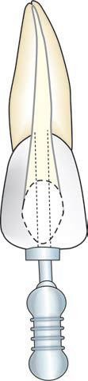
Figure 1.1: Use of sound reference point.

Management
If loss of working length is registered, treatment should be interrupted and an attempt made to identify the cause of the problem, most likely a ledge and/or apical accumulation of debris and/or tis-sue remnants. A radiograph can help to ascertain whether or not preparation still follows the original axis of the root canal. Copious irrigation with sodium hypochlorite and/or EDTA is necessary to dissolve tissue remnants or inorganic debris. Fine and ﬂexible pre-curved instruments are used to bypass a ledge and in order to stir up any accumulation of tissue or dentinal debris. Ultrasonic should be used extremely carefully in order to avoid ledging.( Hülsmann,2016)

Canal Blockage

A blockage is obstruction in a previously patent canal system that prevents access to the apical constriction or apical stop. (Garg& Garg ,2014)
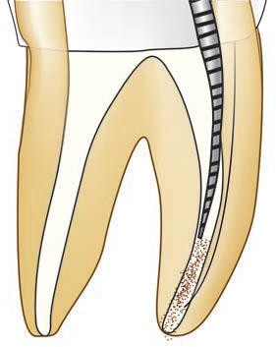
Figure 1.2: Accumulation of dentinal debris in apical third.

Can occur during canal enlargement. Stainless steel files are known to compact debris at the apex; even vital tissue can be compacted against the apical restriction. Suddenly, working length is shorter because the instruments are working against the packed mass at the apex. A radiograph will confirm this suspicion. Correction is made by recapitulation—starting with finer instruments used in a quarter-turn motion. Adding a chelating agent such as EDTA is helpful. However, one must be careful not to produce a ledge or perforation. On the other hand, sterile dentin chips at the apex, formed during preparation, help to block the foramen and prevent over-compaction, and dentin chips have been shown to stimulate cementum formation at the apex. Infected chips, on the other hand contribute to further inflammation. (Ingle, 2009).

Management

When a blockage occurs, place a small amount of EDTA lubricant on a fine instrument and introduce into the canal. Use a gentle watch winding motion along with copious irrigation of the canal to remove the dentin chips or tissue debris

If this does not solve the problem, endosonics may be used to dislodge the dentin chips by the action of acoustic streaming.

Whatever happens, do not force the instrument into the blockage as it may further pack the dentinal debris and worsen the condition. Moreover, forcing instruments may cause perforation of the canal. (Garg&Garg,2019)

1.2.2 Ledging
By definition, a ledge has been created when the working length can no longer be negotiated and the original patency of the canal is lost. The major causes of ledge formation include
- Inadequate straight-line access into the canal,
- Inadequate irrigation or lubrication,
- Excessive enlargement of a curved canal with files
- Packing of debris in the apical portion of the canal. (Torabinejad & Johnson, 2015).

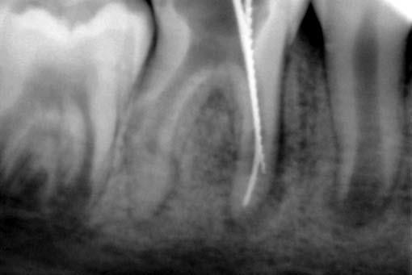
Figure 1.3: Ledge formation due to use of straight files in curved canal.

Newer instruments with noncutting tips have materially reduced this problem like Flex-O-File as the tip of this instrument is non cutting so no apical ledge formation is possible. there’s also the Flex-R-file in which the design of the tip of this instrument eliminates the possibility of ledge formation by removing the cutting surface of the tip's leading edge, this guides the instrument in the canal rather than cut. The rounded tip does not cut into the wall but slips by it. Curved roots are another impediment in canal preparation. This is especially true near the apex of maxillary lateral incisors and the palatal root of maxillary first molars. Small, flexible instruments with noncutting tips negotiate these curves, but larger, stiffer instruments start a ledge that can develop into a perforation. If the instrument can no longer be inserted into the canal to full working length, one should suspect that a ledge has been formed.
There also is a change in tactile sensation, a feeling that the instrument is no longer engaging the walls. To correct the ledge, return to a much smaller stainless file and curve the tip so that the file clings to the inner wall, away from the curve. Slip the file by the curve to the full working length, then file back against the ledge to remove the knick in the wall. Repeat the filing with the next size curved file, and so on, until the ledge is removed and larger instruments slip by the ledge area.
Be sure to use plenty of lubrication and irrigation to remove the dentin chips that tend to pack at the apex. Do not use ethylene diamine tetra-acetic acid (EDTA) for chelation because it tends to intensify the ledge.
Failure to maintain apical canal curvature (which can occur because files cut to the outside of the apical curve) alters the canal morphology, leaves potentially infected debris in the canal system, and makes obturation more difficult. (Ingle, 2009).

Management
To negotiate a ledge, choose a smaller number file, usually No. 10 or 15
Give a small bend at tip of the instrument (and penetrate the file carefully into the canal.
Once the tip of the file is apical to ledge, it is moved in and out of the canal utilizing ultrashort push–pull movements with emphasis on staying apical to the defect.
When file moves freely, it may be turned clockwise upon withdrawal to rasp, reduce, smooth, or eliminate the ledge. When ledge is bypassed, then efforts are directed towards establishing the apical patency with a No. 10 file. (Garg&Garg,2019)

1.2.3 Missed Canal
Sometimes endodontic failure can occur because of untreated missed canals which are store house of tissue, bacteria and other irritants (Garg & Garg, 2014).
Additional canals in the mesial roots of maxillary molars and the distal roots of mandibular molars are the most frequently missed. Second canals in lower incisors, and second canals and bifurcated canals in lower premolars, as well as third canals in upper premolars are also missed. One must be diligent and prepare adequate occlusal access! Always expect there will be an extra canal. Magnification with either telescopic lenses or a surgical microscope is indispensable (Ingle, 2009).
Missed canals can be located by:
- Taking radiographs such as CBCT and CT scan.
- Use of magnifying glasses or endomicroscope
- Accurate access cavity preparation
- Use of ultrasonics
- Use of dyes such as methylene blue
- Use of sodium hypochlorite: After thorough cleaning and shaping, pulp chamber is filled with sodium hypochlorite. If bubbles appear in, it indicates either there is residual tissue present in a missed canal or residual chelator in the prepared canal. This is called Champagne test.
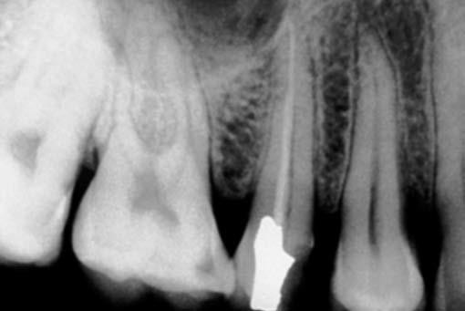
Figure 1.4: Radiograph showing missed canal in maxillary second premolar.

Significance of missed canal
Missed canal can contribute to endodontic failure because it holds the tissue debris, bacteria and other irritants. The tooth should be retreated first conservatively if endodontic failure exists, before going for endodontic surgery procedure. (Garg & Garg, 2014)
Prevention of Missed Canal
- Good radiographs taken at different horizontal angulations
- Good illumination and magnification
- Adequate access cavity preparation
- Clinician should always look for an additional canal in every tooth being treated. (Garg&Garg,2019)

1.2.4 INSTRUMENT SEPARATION
Instrument breakage is a common and frustrating problem in endodontic treatment which occurs by improper or overuse of instruments especially while working in curved, narrow or tortuous canals. (Garg& Garg, 2014).
Since the advent of nickel-titanium rotary instruments, breakage (euphemistically called “separation”) has increased. Because these new instruments are so flexible, unrealistic strains are placed upon them, especially in severely curved canals and at higher rotary speeds.
The first caveat is prevention. Do not force any endodontic instrument, especially in a twisting or rotary motion. Advancement down the canal by a “pecking” or “watch-winding” motion, rather than a forceful advance, is de rigueur. (Ingle, 2009).
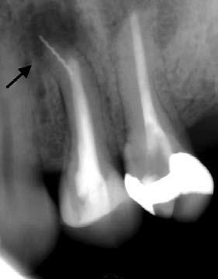
Figure 1.5: Curved, narrow and tortuous canals are more prone for instrument fracture.

The prognosis is best when separation of a large instrument occurs in the later stages of canal instrumentation close to the working length. The prognosis is poor for teeth with undebrided canals in which a small instrument is separated short of the apex or beyond the apical foramen early in instrumentation, because the prognosis depends on the extent of undebrided infected canal space apical to the separated instrument. (Torabinejad and Lemon, 2002).

Management
Removal attempts preferably should not be under-taken immediately following the fracture in an excited or frustrated mental state. The ﬁrst steps should be interruption of treatment, informing the patient on the incidence and taking a radiograph, which is important for medicolegal reasons (documentation of the incident) as well as for planning further treatment. The access cavity is temporized and closed. Treatment is continued in a new appointment. If removal of the broken instrument is necessary, all of the other root canals should be blocked (cotton or gutta-percha) to prevent the loosened fragment from falling into another root canal. Subsequently the access cavity has to be controlled or modiﬁed in order to gain straight-line access to the top of the fragment. When the top of the fragment cannot be visualized, removal attempts should be stopped because of the enormous risk of root perforation. If visualization is possible, some space should be prepared around the top of the fragment, so that the ultra-sonic tips can be placed alongside the fragment. Loosening and removal using ﬁne ultrasonic tips, loop or braiding techniques or special devices (e.g. IRS [Dentsply, Konstanz, Germany] and EndoRes-cue [Komet, Lemgo, Germany]). A ﬁnal radiograph is taken to document complete removal, however, even intermediate radiographs may become necessary to control the progress of removal attempts and to ensure that all instruments are still in the long axis of the root. (Hülsmann,2016)

1.2.5 Zipping
Zipping is defined as the apical transportation of a curved canal caused due to improper shaping technique causes are
- Failure to precurve the files.
- Forcing instruments in curved canal.
- Use of large, stiff instruments to bore out a curve canal
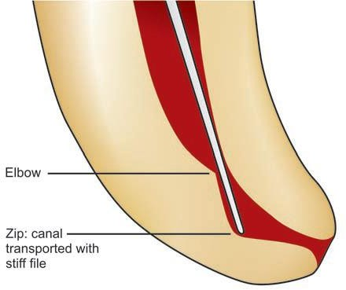
Figure 1.6: Zippping.

- In zipping, apical foramen tends to become a tear drop shape or elliptical is transported from the curve of the canal.
- File placed in curved canal cuts more on the outer portion of the canal wall at its apical extent, thus causing movement of the canal away from the curve and its natural path. In contrast, the coronal third of the flutes remove more on the inner most aspect of the canal wall causing an uneven reduction of the dentin in the coronal third.
- When a file is rotated in a curved canal a biomechanical defect known as an elbow is formed coronal to the elliptically shaped apical seat. This is the narrowest portion of the canal .
- In many cases the obturating material terminates at the elbow leaving an unfilled zipped canal apical to elbow. This is the common occurrence with laterally compacted gutta-percha technique.

Treatment
Use of warm vertical compaction of gutta-percha or thermoplastisized gutta-percha is ideal in these cases as the material becomes soft and easily adaptive to the shape of the canal so we can compact a solid core material into the apical preparation without using excessive amount of sealer. (Garg& Garg, 2014).

1.2.6 Stripping or Lateral Wall Perforation
“Stripping” is a lateral perforation caused by over instrumentation through a thin wall in the root and is most likely to happen on the inside or concave wall of a curved canal such as distal wall of mesial roots in mandibular first molars. Stripping is easily detected by sudden appearance of hemorrhage in a previously dry canal or by a sudden complaint by patient.
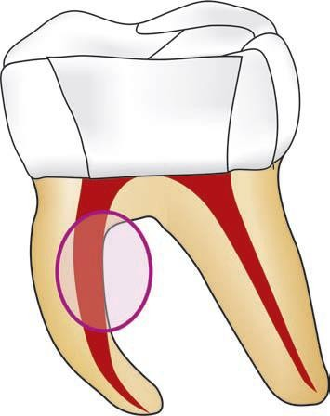
Figure 1.7: Strip perforation occurs more commonly on inner side of curve.

Management
Successful repair of a stripping or perforation relies on the adequacy of the seal established by repair material. Access to mid root perforation is most often difficult and repair is not predictable. Mineral trioxide aggregate (MTA) or Calcium hydroxide can be used as a biological barrier against which filling material is packed.(Garg& Garg, 2014)
If the defect is located at or above the height of crestal bone, the prognosis for perforation repair is favorable (Lemon , 1992).
Teeth with perforations below the crestal bone in the coronal third of the root generally have the poorest prognosis. Attachment often recedes, and a periodontal pocket forms, with attachment loss extending apically to at least the depth of the defect.
Success depends partially on the remaining amount of undebrided and unobturated canal. Obturation is difficult because of lack of a stop (matrix), and gutta-percha tends to be extruded during condensation. Teeth with perforations close to the apex after complete or partial debridement of the canal have a better prognosis than those with perforations that occur earlier. In addition to the length of uncleaned and unfilled portions of the canal, the size and surgical accessibility of perforations are important. In general, small perforations are easier to seal than large ones. Based on surgical accessibility, perforations toward the facial aspect are more easily repaired; therefore, these teeth have a better prognosis than those with perforations in other areas. (Torabinejad & Johnson, 2015).

1.2.7 Canal Transportation
“Apical canal transportation is moving the position of canal’s normal anatomic foramen to a new location on external root surface”.
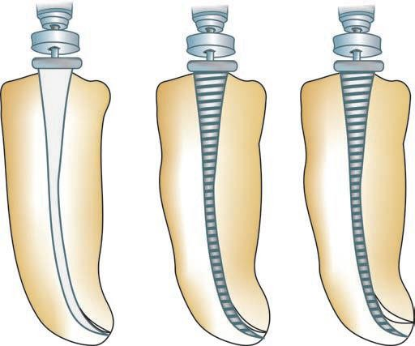
Figure 1.8: Type I, II and III canal transportation

Classification
Type I: It is minor movement of physiologic foramen. In such cases, if sufficient residual dentin can be maintained, one can try to create positive apical canal architecture to improve the prognosis of the tooth.
Type II: Apical transportations of Type II show moderate movement of the physiologic foramen to a new location. Such cases compromise the prognosis and are difficult to treat. Biocompatible materials like MTA can be used to provide barrier against which obturation material can be packed.
Type III: Apical transportation of Type III shows severe movement of physiological foramen. In Type III prognosis is poorest when compared to Type I and Type II. A three dimensional obturation is difficult in this case. This requires surgical intervention for correction otherwise tooth is indicated for extraction. Garg&Garg, 2014).

1.2.8 Over instrumentation
Excessive instrumentation beyond the apical constriction violates the periodontal ligament and alveolar bone. Loss of apical constriction creates an open apex with an increased risk of overfilling, lack of an adequate apical seal , pain and discomfort for the patient. Over instrumentation is recognized when hemorrhage is evident in the apical portion of canal with or without patient discomfort and when tactile resistance of the boundaries of canal space is lost. It can be confirmed by taking a radiograph and by inserting paper point in the canal. Instrumentation beyond apical foramen causes decrease in the prognosis of endodontic treatment because of trauma to periodontal ligament and the alveolar bone . Whereas when instrumentation of the root canal system remains within the confines of root canals, the chances of success of endodontic therapy are more. (Garg &Garg, 2014).

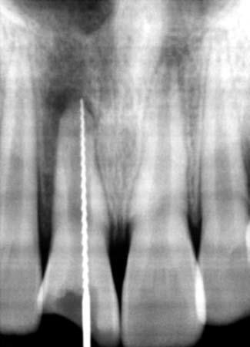
Figure 1.9: Radiograph showing instrument going beyond periapex.

Management
Re-establish the working length and carefully obturate the canal so as to prevent extrusion of the filling beyond apex
Another technique to prevent over extrusion of the filling is developing an apical barrier. Materials used for this include dentin chips, calcium hydroxide powder, hydroxyapatite (HA) and MTA. (Garg&Garg,2019)
1.2.9 PERFORATION

The mechanical or pathological communication between the root canal system and the external tooth surface.

Perforation
According to glossary of endodontic terms (by AAE), perforation is defined as “the mechanical or pathological communication between root canal system and the external tooth surface.” It can be cervical, mid-root, or apical levels depending upon site of the perforation.
Coronal perforation occurs during access cavity preparation (If the perforation is above the periodontal attachment, leakage of saliva into cavity or sodium hypochlorite in mouth is the main sign. But if perforation occurs into the periodontal ligament, bleeding is the hallmark feature.
Root canal perforation can occur at three levels:
1. Cervical canal perforation: It commonly occurs while locating the canal orifice and flaring of the coronal third
Perforation caused during access cavity preparation.
of the root canal. Sudden appearance of blood from
canal is the first sign of perforation
2. Mid-root perforation: It commonly occurs due to over-
instrumentation and over-preparation of thin wall of root or concave side of the curved canals. Sudden appearance of bleeding is the pathognomonic feature
3. Apical root perforation: It occurs if when instrument goes beyond the confines of the root canal and by overuse of chelating agents along with straight and stiffer large-sized instruments to negotiate ledge, canal blockage, or zipping, etc. (Garg&Garg,2019)
Management
Occurrence of a perforation can be recognized by:
- Placing an instrument into the opening and taking a radiograph
- Using paper point
- Sudden appearance of bleeding
- Complain of pain by patient when instrument touches periodontal tissue.
- Management of the Coronal Third Perforations
Anterior teeth where esthetics is the main concern, calcium sulfate barrier along with composites, glass ionomer cements and white MTA can be used for perforations repair.
Posterior teeth where esthetics is not the main criteria, super EBA, amalgam, MTA can be tried.

Management of Perforation in Mid-Root Level
In these cases, success of perforation repair depends on hemostasis, accessibility, visibility, and selection of material for repair.
If the defect is small and hemostasis can be achieved, perforation can be sealed and repaired during three dimensional obturation of the root canal. But in case the perforation defect is large and moisture control is difficult, then one should prepare the canal before going for perforation repair.
Lemon in 1992 gave the internal matrix concept for the repair of inaccessible strip perforations using microsurgical technique. Rationale behind this concept was that a matrix (HA) controls the material and prevents overfilling of repair material into the periradicular tissues. Material to be used as matrix should be biocompatible and able to stimulate osteogenesis amalgam, MTA can be tried.
Management of Perforation in Apical Third of the Root Canal
These types of perforations can be repaired both surgically as well as non-surgically. But one should attempt nonsurgical repair before going for surgery. MTA is a choice of material for perforation repair. (Garg& Garg, 2019)

1.2.10 Post space Perforation
Iatrogenic perforations during post space preparations can severely impair the prognosis of the tooth. They are usually caused by poor clinical judgment and improper orientation of the post preparing drills. Perforation can be recognized by sudden appearance of blood in the canal or radiographically. (Garg& Garg, 2014).
the prognosis for teeth with a root perforation that occurs during post space preparation depends on the root size, the location of the perforation relative to the epithelial attachment, and the accessibility for repair. Management of the post perforation generally is surgical if the post cannot be removed. If the post can be removed, nonsurgical repair is preferred (Hassan et al., 2009).
Teeth with small root perforations in the apical region that are accessible for surgical repair have a better prognosis than do teeth that have large perforations or perforations that are close to the gingival sulcus or inaccessible. (Torabinejad & Johnson, 2015).
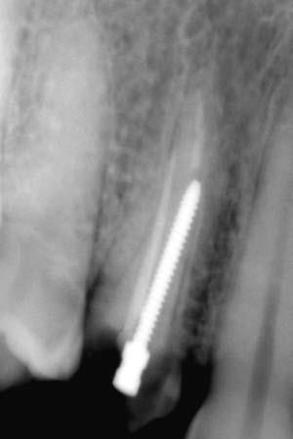
Figure 1.10: Improper postplacement due to improper direction of drill.

Management
Management of postspace perforation involves the same principles as for repair of other perforations. Materials like dental amalgam, calcium hydroxide, glass ionomer, composite resins, freeze–dried bone and tricalcium phosphate are used to repair the perforation. (Garg&Garg,2019)

1.2.11 Under Filling/Incompletely Filled Root Canals
Under filling, i.e. more than 2 mm short of radiographic apex occurs commonly because of procedural errors like ledge formation, blockage or incomplete instrumentation of the root canal "under instrumentation". (Garg & Garg, 2014).
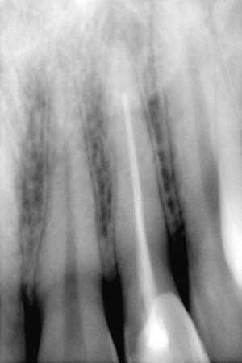
Figure 1.11: Radiograph showing incomplete obturation (short of the apex).

A 1-mm loss in working length increased the chance of treatment failure by 14 percent in teeth with apical periodontitis. However, if the unfilled canal does not contain irritants, such as bacteria or contaminated necrotic tissue, underfilling by itself would not cause periradicular inflammation. in teeth with a diseased periapex in which the filling density of the root canal was fair (that is, only a few voids) or poor (many voids), 20 percent more treatment failures occurred than when the filling density was better (no voids). (Chugal et al., 2003)
Underfilling does not have a direct effect on the outcome of endodontic therapy; rather, it is the remaining infected necrotic tissue in the inadequately instrumented and incompletely filled canal that causes continuing irritation to the periradicular tissues. (LIN, 2005).
Management
In the case of incomplete obturation, i.e. termination of the obturation material more than 2 mm from the radiographic apex (or radiographically, there are visible voids inside or empty spaces lateral to the ﬁlling material)
immediate removal of the ﬁlling material would be the optimal treatment, as the setting of the sealer will still not be completed. Taking a new radiograph for length determination can clarify or reassure the correct endodontic working length and can help to prevent repeated obturation failure. Depending on the time available, immediate reobturation is possible, otherwise medication is recommended. (Hülsmann,2016)

1.2.12 Overfilling of the Root Canals
Overfilling of the root canals is filling more than 2 mm beyondthe radiographic apex. (Garg& Garg, 2014).
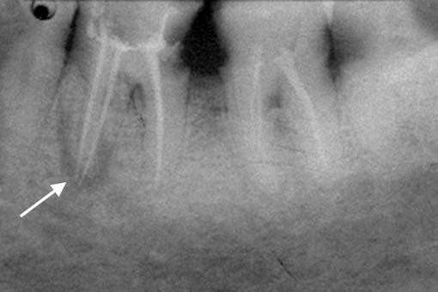
Figure 1.12: Radiograph showing over-extended gutta-percha in 36.

The long-term prognosis is dictated by the quality of the apical seal, the amount and biocompatibility of extruded material, host response, and toxicity and sealing ability of the root-end filling material. (Torabinejad& Johnson, 2015).

Filling materials might act as a foreign body, causing irritation of the periradicular tissues
Not all overfilled teeth are doomed to treatment failure, because approximately 76 percent of overfilled teeth heal satisfactorily after proper endodontic therapy.
The response of the periradicular tissues to root canal filling materials depends on the complex interaction between the properties of materials (that is, cytotoxicity, antigeneity and quantity) and the host’s immune defenses (innate and adapted). ( LIN, 2005).
Endodontic treatment failures associated with overfilled teeth usually are caused by concomitant intraradicular infection, extraradicular infection, or both.
Overfilling is not encouraged, because the filling material may cause foreign-body giant cell reaction, or may act as a foreign body that supports the formation of biofilms. .(Siqueira , 2001).

Management
If overextension of obturation material occurs, orthograde removal should be attempted for over-extended gutta-percha, which frequently can be removed with Hedström ﬁles carefully screwed into the gutta-percha. The apical part of the gutta percha can be removed using a ﬁle similar to a cork-screwer. If only sealer has been extruded, a conservative approach is recommended with radiographic controls in short intervals as long as no clinical or radiographical symptoms indicating periradicular inﬂammation are present. Depending on the type of extruded sealer, resorption can be observed over time. In case of new or persisting apical inﬂammation, surgical removal will be indicated. (Hülsmann, 2016)

1.2.13 VERTICAL ROOT FRACTURE.
Vertical root fracture can occur at any phase of root canal treatment that is during biochemical preparation, obturation or during postplacement. This fracture results from wedging forces within the canal. These excessive forces exceed the binding strength of existing dentin causing fatigue and fracture. (Garg& Garg ,2014).
This may take place during compaction, more often during lateral than vertical compaction. Sometimes vertical fractures, called “silent fractures,” can happen months or years later. It is suspected that stresses built up during compaction are relieved later, following additional stress from mastication or clenching. This is especially true when over enlargement and thinning of the dentin walls has occurred. Seating of posts, especially tapered posts, is another cause of vertical fractures.
There is no treatment if the fracture extends down the root. Prevention, then, is the only alternative. Prognosis of teeth with vertical root fracture is poorer than horizontal fractures (Ingle, 2009).
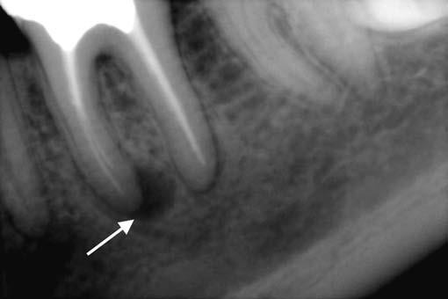
Figure 1.13: Radiograph showing J-shaped radiolucency around mesial root of mandibular molar with vertical root fracture.
Management
Vertical root fracture involves extraction in most of the cases. In multirooted teeth root resection or hemisection can be tried. (Garg & Garg, 2019)
1.2.14 Sodium Hypochlorite aspiration
The majority of reported NaOCl complication appears to be due to an inaccurate working length, iatrogenic widening of radicular foramen, lateral perforation of the root, or widening of the irrigation needle.
Management
Treatment protocols are impractical and are predicated on cause and severity. Antibiotics are usually prescribed and their administration commensurate with the severity of hard and soft tissue distruction and necrosis.
The use of corticosteroids is equivocal; the control of the spreading edema must be balanced with the increased risk of infection. The patient should be monitored closely; a marked increase in the size or extent of the swelling or signs of impending airway obstruction mandate immediate referral to the hospital or a maxillofacial surgeon for more aggressive treatment and management. Lastly, reassuring patients that recovery.
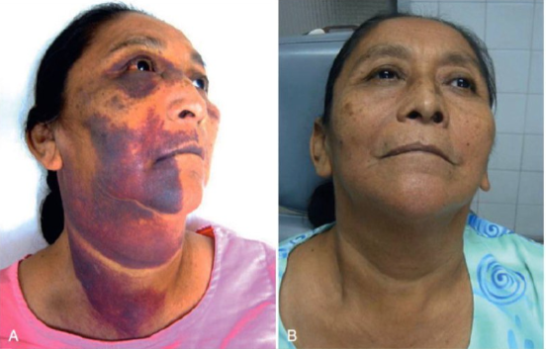
Figure 1.14: A. Sodium hypochlorite accident. B. After treatment of sodium hypochlorite accident

Chapter two
Conclusion

Conclusion

Endodontic treatment presents a great challenge to a clinician owing to difficult and variable root canal anatomy. Endodontic mishap can occur at any stage of the treatment which can be avoided with thorough knowledge of com- plications, variations in root canal anatomy, good clinical skills and excellent training. The advent of magnification and contemporary instruments decreases the frequency of procedural accidents. Our ethical obligation towards the patient is met if we can provide treatment to prevent the loss of the tooth.

References

C
- Chugal NM, Clive JM, Spangberg LS. Endodontic infection: some biologic and treatment factors associated with outcome. Oral Surg Oral Med Oral Pathol Oral Radiol Endod 2003;96(1):81-90.
- Chugal, N., Lin, L. M., & Kahler, B. Introduction: Endodontic Prognosis and Outcome. Endodontic Prognosis,2016; 1–12.

E
- Estrela C, Leles CR, Hollanda ACB, Moura MS, Pécora JD. Prevalence and risk factors of apical periodontitis in endodontically treated teeth in a selected population of Brazilian adults. Braz Dent J 2008;19:34-39.

F
- Friedman S. Treatment outcome and prognosis of endodontic therapy. In: Ørstavik D, Pitt Ford TR, editors. Essential endodontology. Oxford: Blackwell Science Ltd; 1998. p. 367–401. Chapter 15.
- Frisk F, Hugoson A, Hakeberg M. Technical quality of root fillings and periapical status in root filled teeth in Jonkoping, Sweden. Int Endod J. 2008;41:958–68.
- Frank, R.J.: Ingle’s Endodontics, 5th ed. Hamilton: B.C. Decker, 2002.

G
- Green TL, Walton RE, Taylor JK. Radiographic and histologic periapical findings of root canal treated teeth in cadaver. Oral Surg Oral Med Oral Pathol Oral Radiol Endod 1997;83:707-11.
- Gopikrishna, V. (2021) Grossman’s Endodontic Practice 14th Edition. Wolters Kluwer Health . India.
- Garg, N. & Garg, A. (2019) Textbook Of Endodontics. Fourth Edition. Jaypee Brothers Medical Publishers. India.
- Garg, N. & Garg, A. (2008) Review of Endodontics and Operative Dentistry. Jaypee Brothers Medical Publishers. India.
- Garg, N. & Garg, A. (2014) Textbook Of Endodontics. Third Edition. Jaypee Brothers Medical Publishers. India.

H
- Hassan B, Metska ME, Ozok AR, et al: Detection of vertical root fractures in endodontically treated teeth by a cone beam computed tomography scan, J Endod 35:719, 2009.
- Hülsmann, Michael. (2016). Prevention and management of problems during root canal treatment – A problem-based approach to root canal treatment. Part II. ENDO (Lond Engl). 10. 141-151.

J
- John I. Ingle. PDQ ENDODONTICS. Second edition. Canada. 2009.

L
- Lemon RR: Nonsurgical repair of perforation defects: internal matrix concept, Dent Clin North Am 36:439, 1992.
- Lin LM. Do procedural errors cause endodontic treatment failure? American Dental Association. 2005.

M
- M. V. Motta, M. A. L. Chaves Mendonca, C. G. Stirton, and H. F. Cardozo, "Accidental injection with sodium hypochlorite: report of a case," International Endodontic Journal, vol. 42, no. 2, pp. 175– 182, 2009.
- M. Hülsmann and W. Hahn, "Complications during root canal irrigation literature review and case reports," International Endodontic Journal, vol. 33, no. 3, pp. 186 193, 2000.

N
- Ng Y-L, Mann V, Gulabivala K. A prospective study of the factors affecting outcomes of nonsurgical root canal treatment: Part 2: tooth survival. Int Endod J. 2011;44:610–25.

S
- Siqueira JF Jr. Aetiology of root canal treatment failure: why well treated teeth can fail. Int Endod J 2001;34(1):1-10.

T
- Torabinejad M, Lemon RR. Procedural accidents. In: Walton R, Torabinejad M, eds. Principles and practice of endodontics. 3rd ed. Philadelphia: Saunders; 2002:310-30.
- Torabinejad M, Walton RE. Endodontic principle and practice 4th editions. 2007;21:377-379.
- Torabinejad M,. Johnson JD.. ENDODONTICS: PRINCIPLES AND PRACTICE. 2015. Fifth edition.

