Republic of Iraq
Ministry of Higher Education and
Scientific Research
University of Baghdad
Department of Dentistry

Endodontic Retreatment System

A project Submitted to
The college of dentistry, university of Baghdad, Department of Restorative and Aesthetic Dentistry in partial fulfilment for the bachelor degree of dental surgery

Done by:
Ula Abd Alkareem Makki Ahmed

Supervised by:
Assistant professor Dr. Samar Abd Al-hameed

April 2021-2022
Certification of the supervisor

l certify that this project entitled "Endodontic Retreatment System" was prepared by the fifth-year student "Ula abd alkareem maki " under my supervision at the college of dentistry / University of Baghdad in partial fulfillment of the graduation requirements for the bachelor degree in dentistry.

Dr.Samar Abd Al-Hameed
Date:

Dedication

I dedicate my graduation to my parents. Especially to my mother who accompanied me throughout my school years , she is my first supporter in all my decisions in study and work , and in the end ,l achieved her dreams .
I also dedicate this to my sisters (Athraa , Zaineb) who have supported me throughout the process , who made my difficult days pass peacefully.
I also dedicate this to all my friends l met during the 18 years of school.

Acknowledgment

Firstly, I would like to express my sincere gratitude to my supervisor
Dr. Samar for the continuous support and advice. His guidance helped me in all the time of research. Besides our supervisor, I would like to thank the rest of our committee for their insightful comments and help.
My thanks to UOB college of dentistry. I’m feeling proud of being one of its students. It's helped me to improve my educational level as well as improve my skills.
Lastly, I like to thank my supporter parents and friends

List of contents
Topic | Page No.
Introduction | 1
Causes of endodontic treatment failure | 2
Aim of endodontic retreatment | 4
Classifications of endodontic retreatment | 5
Treatment plan | 5
Nonsurgical endodontic retreatment | 6
Coronal access | 8
Missed canals | 11
Removal of gutta percha | 12
Removal of fractured instruments | 19
Treatment of root perforation | 24
Conclusion | 27
References | 28

List of Figures
Fig. No. | Description | Page No.
1 | Endodontic treatment (persistent periapical radiolucency ) | 2
2 | coronal access in nonsurgical endodontic retreatment | 9
3 | previous root canal therapy | 11
4 | Gutta percha removal under continuous motion | 13
5 | Gutta percha removal | 15
6 | Radiograph of gutta percha removal | 15
7 | Gutta percha removal | 18
8 | Removal of separated file | 21
9 | Removal of separated instrument | 21
10 | A new size 30 Hedstrom file | 22
11 | The 0.6 C+ file and The 0.6 K-file | 22
12 | Steps removal of fracture instrument | 23
13 | Fractured instrument removed | 23

Abstract
Endodontic retreatment is defined in the glossary of the American Association of Endodontists (AAE) as the “procedure to remove root canal filling materials from the tooth, followed by cleaning, shaping, and obturating the canals.” This procedure is indicated in teeth where previous endodontic treatment seems inadequate or has failed, or in cases of long-term exposure of root canal filling material to the oral environment leading to apical pathology related to coronal leakage. failures do occur in a large number of cases and most of the time can be attributed to the already stated causes. Inappropriate mechanical debridement, persistence of bacteria in the canals and apex, poor obturation quality, over and under extension of the root canal filling, and coronal leakage are some of the commonly attributable causes of failure. The aim of retreatment is to perform an endodontic treatment that can render the treated tooth functional and comfortable again, allowing complete repair of the supporting structures. Gutta percha is a thermoplastic material; therefore, there are different techniques for its removal. The traditional technique uses K files or H files, along with chemical solvents such as xylol or chloroform to soften the gutta percha component of the obturation material, allowing further penetration of the file deeper into the canal.

Introduction
Endodontics has been the flag-bearer of dentistry for a very long time. There has been a tremendous improvement in the field of endodontics in the recent past, which did not slow down the pace yet. This included better diag- nosis of periapical lesions and improving the prognosis of the endodontically treated teeth. But then, there have been incidences of root canal failures, though minimal, which did not fade away (Raj et al., 2018).
Endodontic retreatment is defined in the glossary of the American Association of Endodontists (AAE) as the “procedure to remove root canal filling materials from the tooth, followed by cleaning, shaping, and obturating the canals.” This procedure is indicated in teeth where previous endodontic treatment seems inadequate or has failed, or in cases of long-term exposure of root canal filling material to the oral environment leading to apical pathology related to coronal leakage (American Association of Endodontists, 2016).
The main cause of initial treatment failure is bacterial persistence within the root canal, or coronal penetration and/or leakage after treatment (Ricucci et al., 2009).
There are multiple reasons for the failure of root canal which include insufficient cleaning which results in persistence of bacteria leading to infection, inadequate obturation, overextension of the GP points, and improper seal. This resulted in the increase in research in the endodontic retreatment, which is gaining light currently by the removal of old GP. Removal of GP can be accomplished by various methods that include H-files, GP solvent, Gates-Glidden (GG) drills, heated pluggers, ultrasonic technique, and lasers (Viduci et al., 2003) .
Recently introduced specifically designed nickel titanium (NiTi) retreatment rotary files have proven to be efficient and require less time when compared with hand instrumentation (Rodig et al., 2012; Kumar et al., 2012).
Dentists and/ or endodontists should evaluate whether retreatment is viable from a pathological point of view and also consider whether the dental element will be structurally suitable for adequate restoration and fully functional in the oral environment after endodontic therapy. As part of this diagnosis process, the tooth needs to be evaluated to rule out any vertical root fracture (VRF) that may be contributing to the endodontic failure that has presented (AAE and AAOMR, 2015).
Previous studies have shown that, regardless of the instrumentation technique and instruments/irrigants used, chemomechanical procedures are unable to promote an optimal disinfection of the root canal systems. Additionally,the limited efficacy of hand and rotary instrumentation for removing root-filling material from endodontically treated teeth is also demonstrated (Martinho et al., 2015).

Chapter one - Review of literature

1.1. Causes of endodontic Treatment failure
Despite the high success rate of endodontic treatment, failures do occur in a large number of cases and most of the time can be attributed to the already stated causes. Inappropriate mechanical debridement, persistence of bacteria in the canals and apex, poor obturation quality, over and under extension of the root canal filling, and coronal leakage are some of the commonly attributable causes of failure (Tabassum and Khan, 2016)
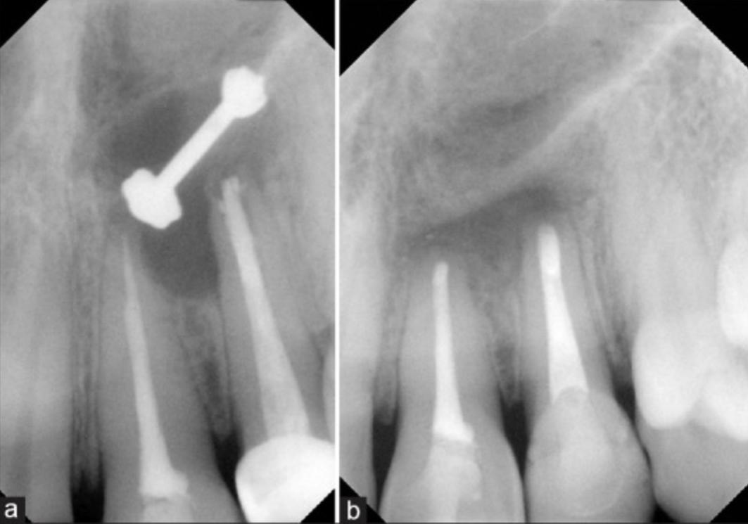
Fig.1 : A. Endodontic treatment in this patient failed due to a leaky apical seal which resulted in a persistent periapical radiolucency. B. Retrograde endodontic treatment was done to seal the apices so a favorable environment can occur for the healing of the infection (Tabassum and Khan, 2016).

Root canal system anatomy plays a significant role in endodontic success and failure. It contains branches that communicate with the periodontal attachment apparatus vertically and laterally, and often terminate apically into multiple portals of exit. Therefore, any opening from the root canal system (RCS) to the periodontal ligament space should be thought of as a portal of exit (POE) through which potential endodontic breakdown products may pass. There can be various causes for endodontic failures such as:
- Missed canals
- Pathological or iatrogenic perforations
- Inadequate obturations
- Inadequacies in shaping, cleaning and obturation, iatrogenic events, or reinfection of the RCS when the coronal seal is lost after completion of root canal treatment .
Regardless of all the causative factors, the final cause for failure is leakage and bacterial contamination due to inadequate debridement, disinfection or sealing of the RCS (Ruddle, 2004).

1.2. Aim of endodontic retreatment
Retreatment is a nonsurgical therapeutic option for an endodontic failure. Nonsurgical endodontic retreatment is performed to remove material from the root canal space in order to correct deficiencies or repair pathological or iatrogenic defects, followed by cleaning, shaping and three-dimensional obturation. Nonsurgical endodontic retreatment is necessary when microbial infection persists for initial treatments with deficient preparation, untreated canals, underfilling, crown filtration due to lack of marginal seal, deficient irrigation protocols,
altered biosafety circuits, among other causes (Mushtaq et al.,2012; Altunbas et al.,2016).
The aim of retreatment is to perform an endodontic treatment that can render the treated tooth functional and comfortable again, allowing complete repair of the supporting structures. Before starting the retreatment, it is profoundly important to consider all interdisciplinary treatment options in terms of time, cost, prognosis and potential for patient satisfaction. It is important to evaluate the endodontic failures so a decision can be made among non-surgical retreatment, surgical retreatment or extraction(Altunbas et al.,2016).

1.3. Classifications of endodontic retreatment
Retreatment is classified into two major groups (Zuolo et al., 2014):
- Non-surgical or conventional retreatment: the retreatment procedure is done through the root canals. Used in cases where the initial treatment is incomplete or presence of inadequate treat- ments diagnosed as failures.
- Surgical retreatment: the treatment procedure is carried out after surgical exposure of the apical portion of the tooth.

1.4. Treatment Plan
There are essentially four options for treatment of a tooth that has post treatment disease: do nothing, extraction, nonsurgical retreatment, and surgical treatment (Hargreaves and Berman,2015).
Avoiding treatment may result in the progression of disease and continued destruction of supporting tissues as well as possible acute exacerbation of systemic side effects such as cellulitis and/or lymphadenopathy. In most cases, these options are unacceptable. Extraction and replacement is a viable option, but replacements for missing teeth rarely are better than an otherwise restorable natural tooth (Iqbal and Kim, 2007).
Before commencing with any treatment, it is profoundly important to consider all interdisciplinary treatment options in terms of time, cost, prognosis and potential for patient satisfaction. Endodontic failures must be evaluated so a decision can be made among four basic options for treatment :
- Do nothing
- Extract the tooth
- Nonsurgical retreatment
- Surgical retreatment

1.5. Nonsurgical endodontic retreatment
Nonsurgical retreatment is indicated in cases of failed endodontic treatment. The effective removal of filling material from the root canal system is essential to ensure a successful outcome of the retreatment procedure(Rios et al., 2014).
Several methods have been used to remove root canal filling material, including the use of rotary systems specifically developed for this purpose. One of these systems is the ProTaper Universal retreatment system (Dentsply Maillefer, Ballaigues, Switzerland) . This system consists of 3 instruments: D1 (30/.09), D2 (25/.08), and D3 (20/.07) (Rios et al., 2014).
Recently, a new reciprocating motion approach was introduced for instru- mentation using nickel-titanium instruments with M-Wire alloy, which is considered more resistant than conventional alloys .
Two systems, Reciproc (VDW, Munich, Germany) and WaveOne (Dentsply Maillefer), are based on this motion(Rios et al., 2014).

The Reciproc system consists of 3 single-use files: R25 (25/.08 in the first milli- meters), R40 (40/.06 in the first millimeters), and R50 (50/.05 in the first millimeters). The WaveOne system consists of 3 single-use files: small (21/.06), primary (25/.08 in the first millimeters), and large (40/.08 in the first millimeters) (Rios et al., 2014).
The goals of nonsurgical retreatment are to remove materials from the root canal space and if present, address deficiencies or repair defects that are pathologic or iatrogenic in origin. Additionally, nonsurgical retreatment procedures confirm mechanical failures, previously missed canals or radicular subcrestal fractures. The procedures for endodontic nonsurgical retreatment can be grouped into disassembly, repair of existing perforations, access to missed anatomy, shaping and disinfection of the canal system, and obturation (Roda and Gettleman, 2015).
Primary goal is regain access to the periapical area (endo treated tooth)

Principles of endodontic therapy followed completion of case:
- Coronal access needs to be completed
- All previous root-filling materials need to be removed
- Canal obstructions must be managed
- Impediments to achieving full working length must be overcome
- Cleaning and shaping procedures : for effective obturation and case completion

1.5.1. Coronal access
Clinicians typically access the pulp chamber through an existing restoration if it is judged to be functionally designed, well-fitting and aesthetically pleasing(Utneja et al., 2012). If the restoration is deemed inadequate and/or additional access is required, then it should be sacrificed. However, on specific occasions,it may be desirable to remove the restoration intact so it can be re-cemented following endodontic treatment(Ruddle, 2002).
Several important technologies exist which facilitate the safe removal of a restorative. Coronal disassembly improves access, vision and the retreatment efforts. The safe dislodgement of a restoration is dependent on several factors such as the type of preparation, the restorative design and strength, the restorative material(s), the cementing agent and knowing how to use the best removal devices(Machtou, 1993).
There are several important removal devices which may be divided into three categories:
- Grasping instruments: This class of hand instruments works by applying inward pressure on two opposing handles. Increasing the handle pressure proportionally increases the instrument's ability to grip a restoration. These grasping instruments are best used in removing provisionalize dentistry such as K.Y. Pliers (GC America) and Wynman Crown Gripper (Miltex Instrument Company).

- Percussive instruments: This method involves using a selected and controlled percussive removal force. This family of instruments delivers an impact either directly to another securely engaged prosthetic removal device. Caution must be exercised when considering the disassembly of tooth colored restoratives like Ultrasonic Energy (Dentsply Tulsa Dental, Tulsa, Okla.), the Peerless Crown-a-Matic (Henry Schein) and the Coronaflex (KaVo America). All of which are used to remove provisionalized and potentially definitively cemented dentistry.

- Passive-active instruments: Instruments which are part of this category actively engage the restoration, enabling its specific dislodgement force that lifts off the prosthesis. These devices require a small occlusal window to be cut through the restoration to facilitate the mechanical action of the instrument. In this method of removal, the slight disadvantage of making and repairing the occlusal hole is significantly offset by the advantage of saving the patient's existing restorative dentistry such as the Metalift (Classic Practice Resources), the Kline Crown Remover (Brasseler) and the Higa Bridge Remover (Higa Manufacturing).

Clinicians must clearly define the risk versus benefit with patients before commencing with the safe and intact removal of an existing restorative
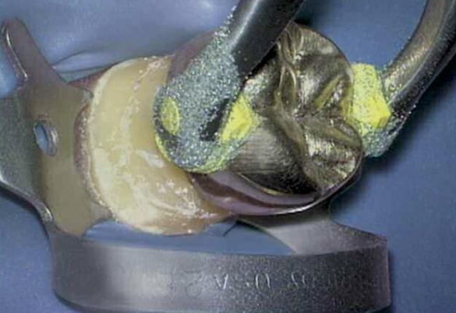

Fig. 2A. :A photograph demonstrates removal of a crown utilizing the K.Y. Pliers. Note the grasping pads have been dipped in emery powder to reduce slippage(Ruddle, 2004).

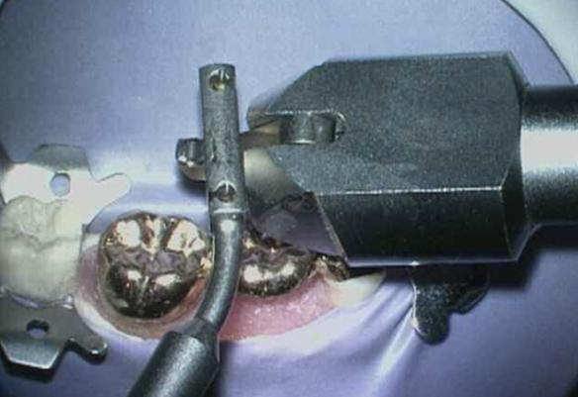

Fig. 2B: A photograph demonstrates bridge removal utilizing the Coronaflex. The air driven hammer generates the removal force against various prosthetic attachment devices(Ruddle, 2004).
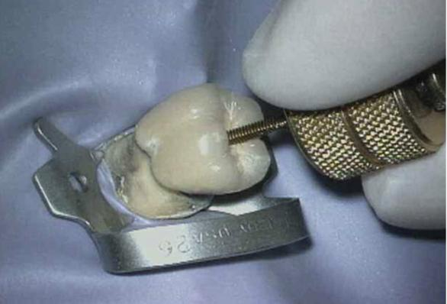

Fig. 2C: A photograph demonstrates the removal of a PFM crown utilizing the Metalift. This system applies a force between the crown and the tooth(Ruddle, 2004).

1.5.2. Missed canals
Missed canals hold tissue, and at times bacteria and related irritants that inevitably contribute to clinical symptoms and lesions of endodontic origin.9 Oftentimes, surgical treatment has been directed towards “corking” the end of the canal with the hopes that the retrograde material will incarcerate biological irritants within the root canal system over the life of the patient. Although this clinical scenario occurs anecdotally, it is not as predictable as nonsurgical retreatment. Endodontic prognosis is maximized in teeth whose root canals are shaped and root canal systems cleaned and packed in all their dimensions(Ruddle, 2004).
There are multiple concepts, armamentarium and techniques that are useful to locate canals. The most reliable method for locating canals is to have knowledge regarding root canal system anatomy and appreciation for the range of variation commonly associated with each type of tooth(He et al.,2017).
Frequently used methods for identifying canals include: radiographic analysis, magnification and lighting (microscopes), complete access, firm explorer pressure, ultrasonics, Micro-Openers (Dentsply Tulsa Dental), dyes, sodium hypochlorite, color and texture, removing restorations, and probing the sulcus(He et al.,2017).
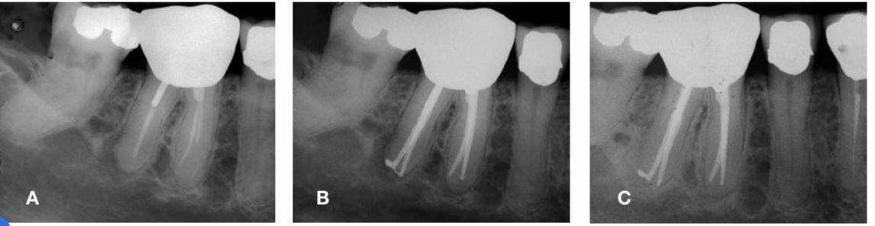
Fig.3 : Previous root canal therapy (A) with symptomatic apical periodontitis due to a missed distal canal and short fills of the mesial canals. Successful nonsurgical retreatment (B) results in complete healing and an asymptomatic patient at the 19-month re-evaluation (C)(He et al.,2017).

1.5.3. Removal of gutta percha
Gutta-percha (GP) has been used in endodontic therapy as filling material for over 100 years and remains the material of choice today. Gutta-percha is biocompatible and has dimensional stability; its properties have made it the gold standard of endodontic fillings. The procedures to remove gutta percha require additional mechanical preparation and therefore could modify the anatomy of the root canal. Dividing the root into thirds, gutta percha may be initially removed from the canal in the coronal one-third, then the middle one-third, and finally eliminated from the apical one-third. At times, single cones in larger and straighter canals can be removed with one instrument(Mushtaq et al.,2012).
Gutta percha is a thermoplastic material; therefore, there are different techniques for its removal. The traditional technique uses K files or H files, along with chemical solvents such as xylol or chloroform to soften the gutta percha component of the obturation material, allowing further penetration of the file deeper into the canal. The procedure begins from the crown to the apex, using copious irrigation with a physiological solution and/or sodium hypochlorite along with the removal. Gates burs can be used for the coronal and middle thirds in root canals with very compact fillings. Later, together with mechanized endodontics, different brands of gutta-percha removal systems have emerged. All function in the same way, generally using rotational movement(Colaco and Pai, 2015)(Figure 4B).
WaveOne® (Dentsply Maillefer, Switzerland) and Reciproc® (VDW, Germany) instruments, of reciprocating motion, have also been suggested to remove gutta percha with very good results (Figure 4C). In any case, and considering these varied possibilities, a recommended technique would be to use mechanized systems to remove most root filling material without solvent, and then finish the apical portion or curvatures manually with solvent if necessary.
Although the use of solvents facilitates the procedure by soft- ening the gutta percha, on the other hand, gutta-percha sticks to the root canal walls, hindering its complete elimination at times.
Residual solvents may hamper contact of the new obturation material (sealer and gutta percha) potentially creating a poten- tial leakage avenue over time. Therefore, its use is recommended only when essential. Currently, the use of ultrasound under magni- fication is proposed for removing remnants of filling material within the canal and optimizing its cleaning (Figure 4D)(Colaco and Pai, 2015).
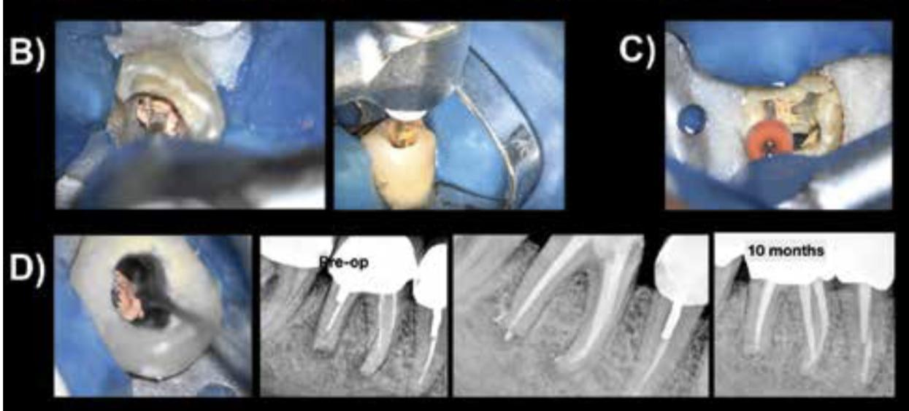
Fig.4: 4B. Gutta-percha removal under continuous motion ProTaper Retreatment System. 4C. Reciprocation motion WaveOne system. 4D. Ultrasonic removal of gutta-percha(Colaco and Pai, 2015).

Removal of GP can be accomplished by various methods, that include H-files, GP solvent, Gates-Glidden (GG) drills, heated pluggers, ultrasonic technique, and lasers. Recently introduced specifically designed nickel–titanium (NiTi) retreatment rotary files have proven to be efficient and require less time when com- pared with hand instrumentation(Rios et al., 2014).
D-RaCe has been introduced which is especially designed for retreatment procedures. It consists of two retreatment files, namely DR1 and DR2, whereas PTUR consists of three files: D1, D2, and D3(Rios et al., 2014).
The Single-file systems are an example of a modified instrument that has been designed to shape the root canal completely from start to finish with one single file. Particularly, the Reciproc (VDW) and WaveOne (Dentsply Maillefer) systems, are 2-M-wire reciprocating systems that increase instrument flexibility and improves its resistance to cyclic fatigue . Recently, the effectiveness of reciprocating systems i.e., WaveOne and Reciproc in removing gutta-percha and sealer during endodontic retreatment has been demonstrated(Rios et al., 2014).
Of these options, the best technique(s) for a specific case is selected based on preoperative radiographs, clinically assessing the available diameter of the orifices after re-entering the pulp chamber, and clinical experience. Certainly, a combination of methods are generally required and, in concert, provide safe, efficient and potentially complete elimination of gutta percha and sealer from the internal anatomy of the root canal system(Ruddle., 2004).
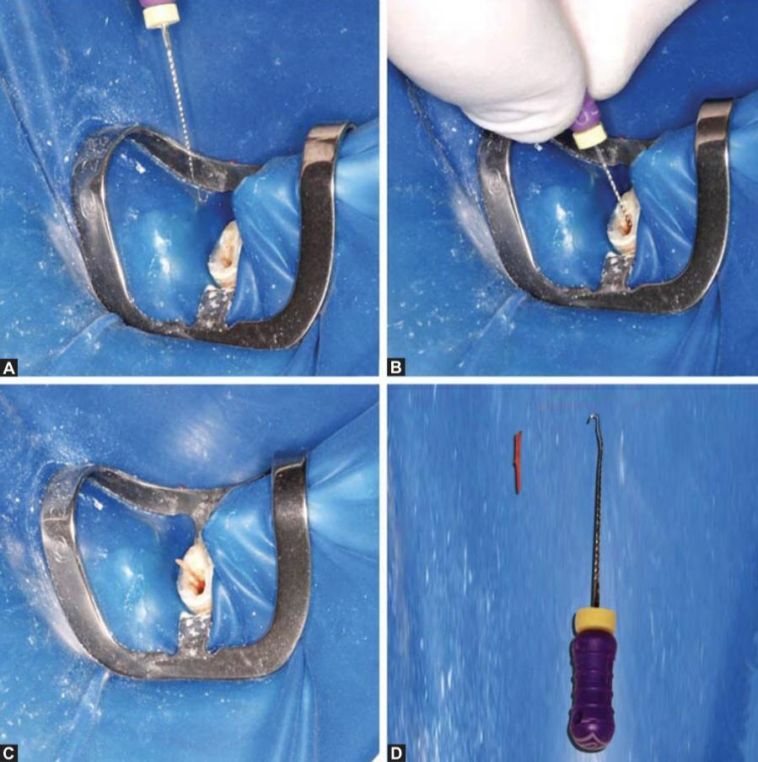
Fig.5 : (A) The apical 2 to 3 mm of a 10 K-file was curved; (B) the file was then inserted into the canal; and (C and D) using careful movements the gutta-percha was pierced and pulled out of the canal(Silva et al., 2012).
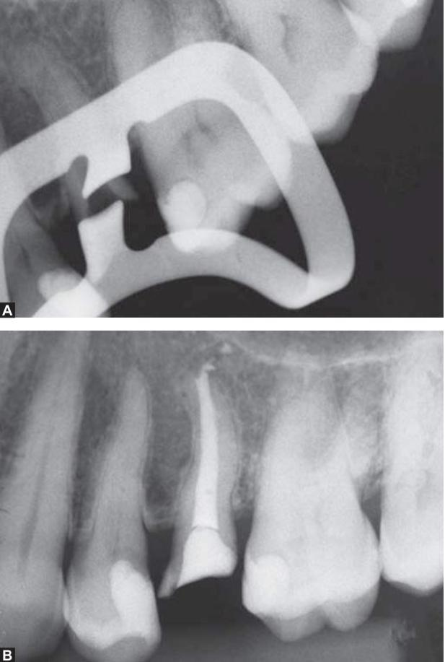

Fig.6 : (A) Periapical radiograph confirming the gutta- percha removal, and (B) further root canal obturation(Silva et al., 2012).

There are various methods or techniques for the retrieval of gutta-percha like manual, Rotary, laser etc. The selection of each technique depends on the patient factors, the complexity of the root canal anatomy and ultimately the clinician operative skills and experience.
Gutta-percha can be removed by using:
- Hand instruments
- Rotary instruments
- Ultrasonics
- Lasers
- Solvents
- Microdebriders

- Rotary Instruments for removal of gutta- percha
The advent of rotary nickel–titanium (NiTi) files has provided another means of removing single cones or poorly condensed gutta percha (Kanaparthy et al., 2016) . NiTi files of suitable size are selected so that the cutting flutes will engage the root filling but not to the canal walls. When the rotary NiTi files are activated, the flutes will engage to the gutta-percha and propel the filling out of the canal. The disadvantage of using rotary files in the removal in gutta-percha is the danger of fracture of the files. This may be reduced by applying less apical pressure and keeping the speed and torque in recommended values of the file systems. The recent published studies on the removal of gutta-percha root canal fillings have focused on the use of rotary instruments with or without using organic solvents, comparing their performance with hand instru- ments. Prasad et al. did a study using Protaper retreatment files D1,D2,D3 (Dentsply) and Mtwo files (VDW, Munich, Germa- ny) for GuttaPercha removal. The teeth were subjected to Cone beam computed tomography analysis and it was concluded that both the instruments retrieved Guttapercha but left some residual sealer material (Prasad et al., 2018).
Another study done by Fatima et al. using 48 single rooted premolars and Protaper retreatment files D1,D2,D3 (Dentsply) and Wave One primary files, concluded that Wave One group required more time in retrieving and resulting in incom- plete GP removal (Fatima et al., 2018). De Mello Junior et al. did a study to evaluate the effect of Microscope and Ultrasonics on GuttaPercha retrieval on forty teeth with straight root canals and found that Ultrasonic use in combination with the microscope resulted in significantly cleaner canals in straight roots (de Mello et al., 2009).
Rotary instruments have been recommended for their speed, higher efficiency and safety. The heat generated by rotary instru- ments also helps in softening and displacement of gutta percha from the root canal. Furthermore, Passive ultrasonic irrigation along with rotary instrumentation during retreatment improves the efficiency of the retreatment system and the acoustic stream- ing produced by the ultrasonic tip promotes removal of obtura- tion material from the canal walls (Bedier and Roshdy, 2018). The Rotary instruments are also associated with the greater risk of Guttapercha extrusion during the retreatment procedure. So the dentist should take ut- most care while performing the retreatment procedure with rotary files.

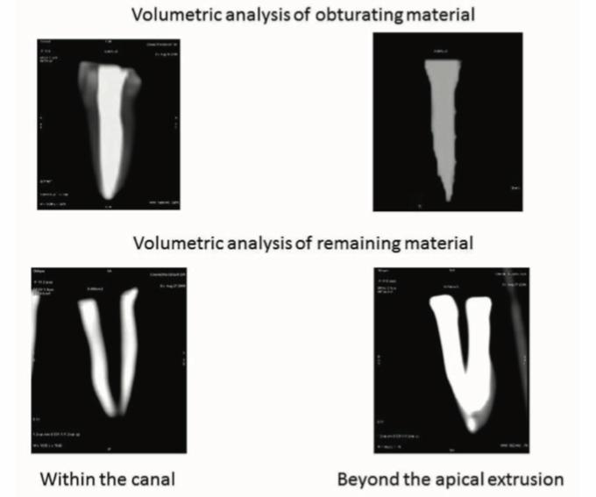

Fig. 7: Gutta percha removal and apical debris extrusion with ProTaper Retreament files (Chandrasekar et al., 2014).

1.6. Fractured instruments
Instrument fractures within the root canal during root canal treatment are an unwanted and frustrating complication. Fracture often results from incorrect use or overuse of an endodontic instrument, and seems to occur most commonly in the apical third of a root canal (Rahimi and Parashos, 2009).
Fractured endodontic instruments may include endodontic files, Gates-Glidden burs, lateral or finger spreaders or spiral fillers manufactured from stainless steel, NiTi or carbon steel. According to a limited number of studies, the fracture incidence of rotary NiTi files ranges from 0.4 to 5%, with the higher percentage representing fractures in molar teeth only. In a majority of cases instrument fracture results from incorrect use or overuse, occurring most frequently in the apical third of the root canal (Spili et al., 2005).
Rotary NiTi files are known to fracture without any visible signs of deformation and potential fracture, compared to the evident warning signs seen in traditional stainless steel files (Al-Fouzan, 2003).
The fracture of endodontic rotary instruments can be broadly classified into two types: fractures due to cyclic fatigue and fractures due to torsional fatigue. Fatigue has been implicated as one of the key reasons for endodontic instrument fracture (Sattapan et al., 2000).

1.6.1. Removal of fractured instruments
In cases of non-surgical retreatment, one of the most complex situations to solve is the removal of fractured instruments from within the canal. Numerous techniques have been described, from the use of hand files to trap and remove the fragments to countless devices made for this purpose (Terauchi et al., 2007). Regarding the use of these specific kits, it is interesting to note that each operator should choose the one considered most appropriate to his/her training.
A universal technique is the use of thin ultrasonic tips under magnification, preferably an operating microscope. The first thing we should achieve is straight access to the instrument to be removed. The technique consists of exposing the instrument from 1 mm to 3 mm in its most coronal portion to be able to perform ultrasonic vibration in that place, thus unlocking the fragment and removing it. The exposed length will also depend on the length of the fragment. This procedure takes time and has to be performed carefully because the space generated to dislodge the fragment is at the expense of dental tissue, structurally weak- ening the root. This situation can also lead to accidents such as perforations, in the case of not having good vision and fine and precise motion. Therefore, this maneuver should be as conservative as possible(Terauchi et al., 2006). Some factors will determine whether to remove the fractured fragment. First, its position in the root canal is essential, considering that the more apical the fragment, the more difficult its removal. Additionally, if the instrument is beyond the curvature of the canal or is not visible, the possibilities decrease from few to none, increasing the risk of complications (Souter and Messer, 2005).
If there is a separated file in the canal, and it is positioned coronal to the canal curvature, many times it can be removed successfully, but this requires very specialized techniques and armamentarium including the dental operating microscope. Frequently, removal of tooth structure deep in the canal is required to access and remove the separated instrument. This can result in perforation of the root or weakening of the tooth structure increasing chances of fracture in the future(Gencoglu and Helvacioglu, 2009).
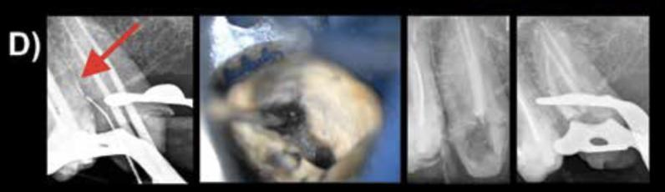
Fig. 8 : D. Separated file removal from canal with ultrasonic thin tip and under operative microscope

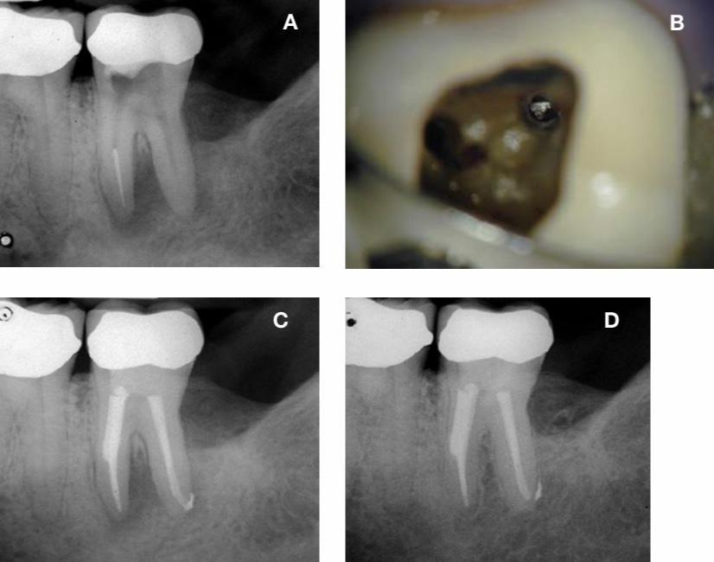
Fig. 9: Removal of a separated instrument from a lower molar (A). The separated instrument is seen in the canal (B) but the enlargement needed to remove it has weakened the root (C). Despite the good healing evident on the two-year re- evaluation (D), the longer-term prognosis is questionable.
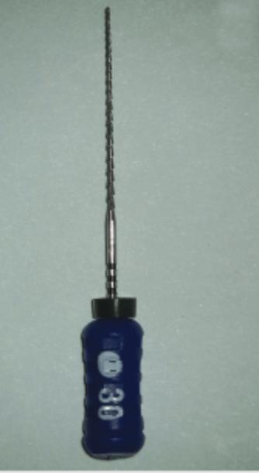

Fig. 10: A new size 30 Hedstrom file used to engage the fragment after the initial path of insertion was created to a size 30 K-file(Casper and Carel, 2018).
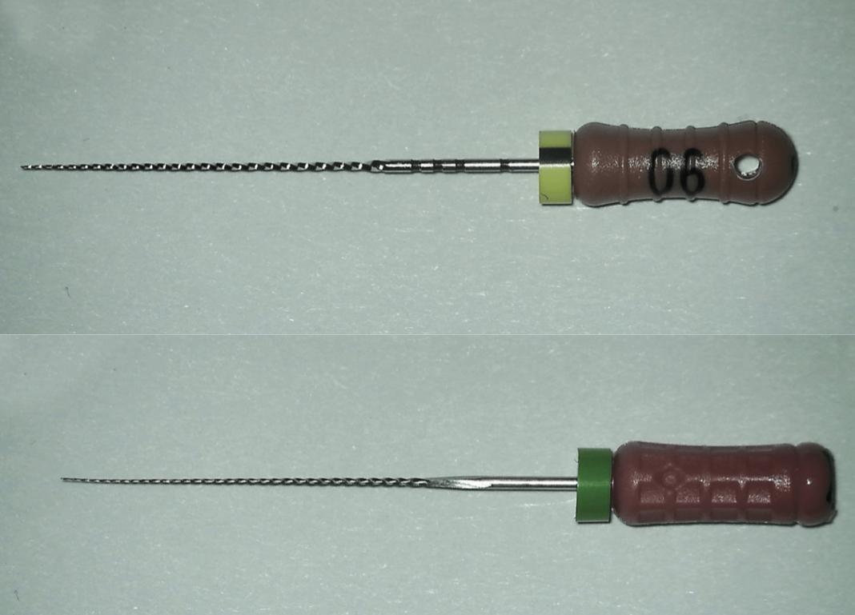
Fig. 11: 3A and 3B: 3A.The 0.6 C+ file used with viscous 15% EDTA paste to locate a portal of entry for the size 0.6 K-file to follow. 3B. The 0.6 K-file used in a watch-winding motion with viscous 15% EDTA paste after the initial penetration of the 0.6 C+ file (Casper and Carel, 2018).
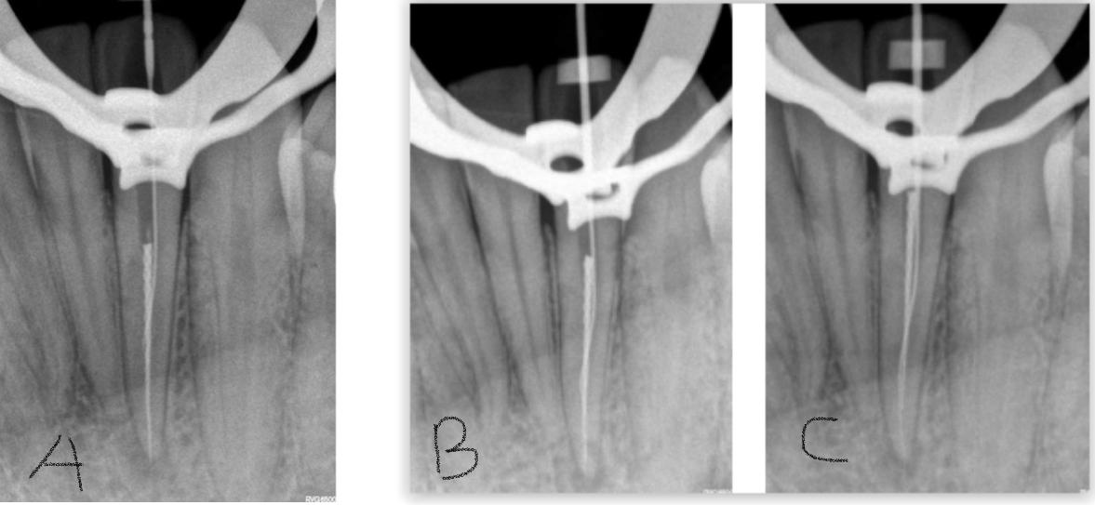
Fig.12:A.The 0.6 K-file engaged in the pathway created by the 0.6 C+ file
B.The gentle pulling action on the 0.6 K-file with ultrasonic activation moving the fragment in a coronal direction.
C. Full working length reached with the 0.6 K-file and fragment moving coronally (Casper and Carel, 2018).
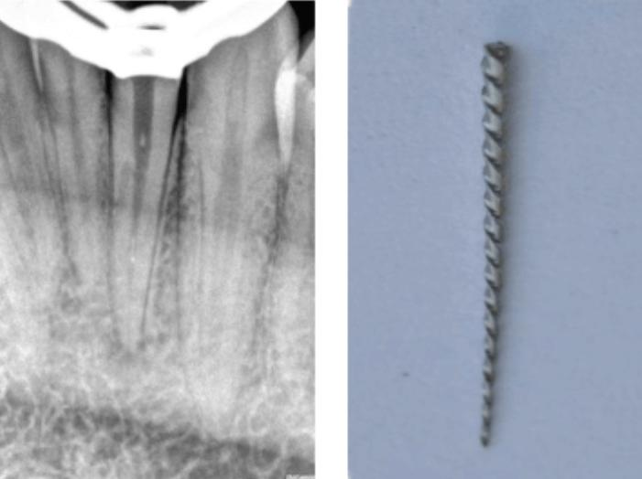

Fig.13: Fractured instrument removed with limited amount of destruction of tooth structure.A large segment of a fractured instrument viewed under magnification after removal from the root canal (Casper and Carel, 2018).
1.7. Treatment of root perforations
Root perforations are mistakes often made during endodontic treatment. Root perforations can occur at different levels, and we could classify them didactically according to their location as occurring in the apical third, middle third, coronal third, or chamber floor. In the apical third, perforations usually occur when there is a ledge, and we try to negotiate the canal; in that attempt, a hole is drilled in the canal, transporting the canal.
Perforations can also occur when trying to remove fractured instruments as described previously. In the middle third, the cause is usually due to deviations in post prepara- tion, or in some cases, as in the mesial roots of mandibular molars, it can also be due to excessive wear of the furcal wall during instrumentation-stripping related to the natural concavity on the distal aspect of the mesial root. In the coronal third, perforations usually occur during post preparation or due to errors when accessing the canal in the initial stages of endodontic treatment. The same happens with chamber floor perforations, generally related to a spatial disorientation by the operator when approaching the pulp chamber and searching for the canal opening, which is even greater in cases of very sclerotic pulp chambers due to secondary dentin formation. An impor- tant prognostic factor with respect to the perforation site is related to the level of the surrounding bone, whether it is above or below the crestal bone level. Perforation size is also important, being inversely related to the prognosis, and an additional impor- tant factor is if the perforation is recent or longstanding(Tsesis et al., 2010).
Regarding the perforation site, if perforations are above the level of the crestal bone, permanent sealing is more complex, considering that they are practically exposed to the oral environment. In these cases, the materials of choice are usually glass iono- mers or composite resins. On the other hand, in cases of perforations below the crestal bone or chamber floor levels, the material of choice is mineral trioxide aggregate (MTA), with many years of studies on this matter(Pontius et al., 2013).
The use of new bioceramics materials is also currently suggested. In the case of chamber floor perforations, which are usually the most common, it is important to consider at the time of diagnosis whether they are recent or longstanding. The difference if they are longstanding is that they usually have an associated osseous lesion. Treatment in these cases begins with curettage of the granulation tissue occupying the space of the osseous lesion with excavators or ideally with electrocautery/lasers. The edges of the perforation are then cleaned with ultrasound because they are probably contaminated. And finally, in these cases, before placing MTA into the perforation site, it is optional to place a collagen membrane or similar in the space of the lesion, as is the use of calcium hydroxide, in order to generate a barrier preventing extrusion of the MTA repair material.Use of the barrier membrane limits excess repair material from extruding into the space left by the osseous lesion and allow osseous healing with bone fill over time(Tsesis et al., 2010; Pontius et al., 2013).
Root perforations (iatrogenic or resorptive) can cause periradicular periodontitis in root-treated teeth and an assessment of whether the defect can be repaired is part of the treatment planning process. Ideally, the perforation should be repaired as soon as possible, and repair of perforations below the periodontal attachment must be done using bioceramic materials to enhance complete healing (Main et al.,2004).
Tooth-colored restoratives, such as a dual cured composite, require the placement of a barrier so the material is not contaminated during use. A barrier serves as a “hemostatic” and a “backstop” so a restorative material can be placed into a clean, dry preparation with control. Calcium sulfate is an excellent resorbable barrier material when using the principles of wet bonding because it is biocompatible, osteogenic, and following placement, sets brick-hard. When set, calcium sulfate is internally trimmed back to the cavo surface of the root. A dual cured, tooth- colored restorative can now be placed against the barrier and utilized to seal a root defect (Ruddle., 2004).

Conclusion
The persistence of bacteria within the root canal system is the primary cause of endodontic failure after initial root canal treatment. To reduce the bacterial loads during retreatment, it is important to remove the filling material and gain access to the apical foramen , which, in turn, facilitates adequate cleaning, shaping, and disinfection of the root canal system. Before commencing with any treatment, it is profoundly important to consider all interdisciplinary treatment options in terms of time, cost, prognosis and potential for patient satisfaction. Endodontic failures must be evaluated so a decision can be made among nonsurgical retreatment, surgical retreatment, or extraction.

References:
- AAE and AAOMR Joint Position Statement: Use of Cone Beam Computed Tomography in Endodontics 2015 Update. (2015). Journal of endodontics, 41(9), 1393–1396.
- Al-Fouzan K. S. (2003). Incidence of rotary ProFile instrument fracture and the potential for bypassing in vivo. International endodontic journal, 36(12), 864–867. https://doi.org/10.1111/j.1365-2591.2003.00733.x
- Altunbas, D., Kutuk, B., Toyoglu, M., Kutlu, G., Kustarci, A., & Er, K. (2016). Reciproc versus Twisted file for root canal filling removal: assessment of apically extruded debris. Journal of Istanbul University Faculty of Dentistry, 50(2), 31–37.
- American Association of Endodontists. Glossary of Endodontic Terms. 2016. http://www.aae.org/clinical-resources/aae-glossary-of-endodontic-terms.aspx. Accessed November 19, 2018.
- Casper H. Jonker, BChD, Dip Odont, Msc,(2018). runs the module of Endodontics, Department of Operative Dentistry, School of Oral Health Sciences, Sefako Makgatho Health Sciences University, Gauteng, South Africa.
- Chandrasekar, Ebenezar, A. V., Kumar, M., & Sivakumar, A. (2014). A comparative evaluation of gutta percha removal and extrusion of apical debris by rotary and hand files. Journal of clinical and diagnostic research : JCDR, 8(11), ZC110–ZC114. https://doi.org/10.7860/JCDR/2014/10203.5199
- Colaco, A. S., & Pai, V. A. (2015). Comparative Evaluation of the Efficiency of Manual and Rotary Gutta-percha Removal Techniques. Journal of endodontics, 41(11), 1871–1874.
- De Mello Junior, J. E., Cunha, R. S., Bueno, C. E., & Zuolo, M. L. (2009). Retreatment efficacy of gutta-percha removal using a clinical microscope and ultrasonic instruments: part I--an ex vivo study. Oral surgery, oral medicine, oral pathology, oral radiology, and endodontics, 108(1), e59–e62. https://doi.org/10.1016/j.tripleo.2009.03.027
- Fatima, K., Nair, R., Khasnis, S., Vallabhaneni, S., & Patil, J. D. (2018). Efficacy of rotary and reciprocating single-file systems on different access outlines for gutta-percha removal in retreatment: An in vitro study. Journal of conservative dentistry : JCD, 21(4), 354–358. https://doi.org/10.4103/JCD.JCD_339_17
- Gencoglu, N., & Helvacioglu, D. (2009). Comparison of the different techniques to remove fractured endodontic instruments from root canal systems. European journal of dentistry, 3(2), 90–95.
- Hargreaves K, Berman L, eds.(2015). Cohen’s Pathways of the Pulp. 11th ed.;St Louis;Elsevier:; 324-86.
- He, J., White, R. K., White, C. A., Schweitzer, J. L., & Woodmansey, K. F. (2017). Clinical and Patient-centered Outcomes of Nonsurgical Root Canal Retreatment in First Molars Using Contemporary Techniques. Journal of endodontics, 43(2), 231–237.
- Iqbal, M. K., & Kim, S. (2007). For teeth requiring endodontic treatment, what are the differences in outcomes of restored endodontically treated teeth compared to implant-supported restorations?. The International journal of oral & maxillofacial implants, 22 Suppl, 96–116.
- Kanaparthy, A., & Kanaparthy, R. (2016). The Comparative Efficacy of Different Files in The Removal of Different Sealers in Simulated Root Canal Retreatment- An In-vitro Study. Journal of clinical and diagnostic research : JCDR, 10(5), ZC130–ZC133. https://doi.org/10.7860/JCDR/2016/17731.7845
- Kumar, M. S., Sajjan, G. S., Satish, K., & Varma, K. M. (2012). A comparative evaluation of efficacy of protaper universal rotary retreatment system for gutta-percha removal with or without a solvent. Contemporary clinical dentistry, 3(Suppl 2), S160–S163.
- Machtou P: Ch. 8,(1993).La cavité d’accès. In Machtou P, editor: Endodontie - guide clinique, pp. 125-137, Editions CdP, Paris.
- Main C, Mirzayan N, Shabahang S, Torabinejad M. Repair of root perforations using mineral trioxide aggregate: a long-term study. J Endod 2004;30:80-3.
- Martinho, F. C., Freitas, L. F., Nascimento, G. G., Fernandes, A. M., Leite, F. R., Gomes, A. P., & Camões, I. C. (2015). Endodontic retreatment: clinical comparison of reciprocating systems versus rotary system in disinfecting root canals. Clinical oral investigations, 19(6), 1411–1417.
- Mushtaq, M., Farooq, R., Ibrahim, M., & Khan, F. Y. (2012). Dissolving efficacy of different organic solvents on gutta-percha and resilon root canal obturating materials at different immersion time intervals. Journal of conservative dentistry : JCD, 15(2), 141–145.
- Pontius V, Pontius O, Braun A, Frankenberger R, Roggen- dorf MJ. Retrospective evaluation of perforation repairs in 6 private practices. J Endod. 2013;39(11):1346-1358.
- Prasad A, Nair RS, Angelo JM, Mathai V, Vineet RV, Christopher SR. (2018). A comparative evaluation of retrievability of Guttapercha, Resilon and CPoints for retreatment, using two different rotary retrieval systems-An ex vivo study. Saudi Endod. J. 2018 May 1;8(2):87.
- Rahimi, M., & Parashos, P. (2009). A novel technique for the removal of fractured instruments in the apical third of curved root canals. International endodontic journal, 42(3), 264–270. https://doi.org/10.1111/j.1365-2591.2008.01464.x
- Raj, P., Mudrakola, D. P., Baby, D., Govindankutty, R. K., Davis, D., Sasikumar, T. P., & Ealla, K. (2018). Evaluation of Effectiveness of Two Different Endodontic Retreatment Systems in Removal of Gutta-percha: An in vitro Study. The journal of contemporary dental practice, 19(6), 726–731.
- Ricucci, D., Siqueira, J. F., Jr, Bate, A. L., & Pitt Ford, T. R. (2009). Histologic investigation of root canal-treated teeth with apical periodontitis: a retrospective study from twenty-four patients. Journal of endodontics, 35(4), 493–502.
- Rios, M., Villela, A. M., Cunha, R. S., Velasco, R. C., De Martin, A. S., Kato, A. S., & Bueno, C. E. (2014). Efficacy of 2 reciprocating systems compared with a rotary retreatment system for gutta-percha removal. Journal of endodontics, 40(4), 543–546.
- Roda R, Gettleman B. (2015). Non-surgical Retreatment. In: Hargreaves K, Berman L, eds. Cohen’s Pathways of the Pulp. 11th ed.;St Louis;Elsevier:; 324-86.
- Rödig, T., Hausdörfer, T., Konietschke, F., Dullin, C., Hahn, W., & Hülsmann, M. (2012). Efficacy of D-RaCe and ProTaper Universal Retreatment NiTi instruments and hand files in removing gutta-percha from curved root canals - a micro-computed tomography study. International endodontic journal, 45(6), 580–589.
- Ruddle C. J. (2004). Nonsurgical endodontic retreatment. Journal of the California Dental Association, 32(6), 474–484.
- Ruddle CJ: Ch. 25,(2002). Nonsurgical endodontic retreatment. In Cohen S, Burns RC, editors: Pathways of the Pulp, pp. 875-929, 8th ed., Mosby, St. Louis.
- Sattapan, B., Nervo, G. J., Palamara, J. E., & Messer, H. H. (2000). Defects in rotary nickel-titanium files after clinical use. Journal of endodontics, 26(3), 161–165. https://doi.org/10.1097/00004770-200003000-00008
- Silva, E. J., Herrera, D. R., Lima, T. F., & Zaia, A. A. (2012). A nonsurgical technique for the removal of overextended gutta-percha. The journal of contemporary dental practice, 13(2), 219–221.
- Souter NJ, Messer HH. Complications associated with frac- tured file removal using an ultrasonic technique. J Endod. 2005;31(6):450-452.
- Spili, P., Parashos, P., & Messer, H. H. (2005). The impact of instrument fracture on outcome of endodontic treatment. Journal of endodontics, 31(12), 845–850. https://doi.org/10.1097/01.don.0000164127.62864.7c
- Tabassum, S., & Khan, F. R. (2016). Failure of endodontic treatment: The usual suspects. European journal of dentistry, 10(1), 144–147.
- Terauchi Y, O’Leary L, Kikuchi I, et al. Evaluation of the efficiency of a new file removal system in comparison with two conventional systems. J Endod. 2007;33(5):585-588.
- Terauchi Y, O’Leary L, Suda H. Removal of separated files from root canals with a new file-removal system: case reports. J Endod. 2006;32(8):789-797.
- Tsesis I, Rosenberg E, Faivishevsky V, et al. Prevalence and associated periodontal status of teeth with root perforation: a retrospective study of 2,002 patients’ medical records. J Endod. 2010;36(5):797-800.
- Utneja, S., Garg, G., Arora, S., & Talwar, S. (2012). Nonsurgical endodontic retreatment of advanced inflammatory external root resorption using mineral trioxide aggregate obturation. Case reports in dentistry, 2012, 624792.
- Viducić, D., Jukić, S., Karlović, Z., Bozić, Z., Miletić, I., & Anić, I. (2003). Removal of gutta-percha from root canals using an Nd:YAG laser. International endodontic journal, 36(10), 670–673.
- Zuolo M, Kherlakian D, De Mello Jr J, Carvalho M. Fagundes M. (2014). Reintervention in Endodontics Quintessence Publishing, Batavia, IL.

