

Republic of Iraq Ministry of Higher Education and Scientific Research University of Baghdad College of Dentistry

**Diastema closure**

The College of Dentistry, University of Baghdad, Department of Operative dentistry in Partial Fulfillment for the Bachelor of Dental Surgery

By:

**Ali Hasan Khazal**

Supervised by:

**Assist. Prof. Dr. Samar Abd Alhameed**

BDS, MSc

**2022 1443**

**Certification of the Supervisor**

I certify that this project entitled “**Diastema closure**” was prepared by **Ali hasan** under my Supervision at the College of Dentistry/University of Baghdad in partial fulfilment of the graduation requirements for the Bachelor Degree in Dentistry.

**Supervisor’s name: Assist. Prof. Dr. Samar Abd Alhameed**

**Date: 1/4/2022**

**Dedication**

To my father for his support,

To my kind mother for her patience,

To my brothers and sisters and for their encouragement.

**Acknowledgment**

First, **"Alhamdulillah,"** for giving me the strength and patience to accomplish this work, and I pray that His blessings on me will last the rest of my life.

I would like to thank **Assist. Prof.** **Dr. Anas Falah**, Head of the Department of Operative Dentistry, for his support.

My sincere gratitude and most profound respect go to my supervisor **Assist Prof.** **Dr. Samar Abd Alhameed**, for her guidance, kindness, high ethics, support, and continuous helpful advice throughout my study.

**List of contents**

|  |  |
| --- | --- |
| Contents | Page NO. |
| Introduction | 1 |
| Prevalence | 2 |
| Midline diastema etiology | 4 |
| Physiological | 4 |
| Abnormal labial frenum | 5 |
| Missing maxillary lateral incisors | 6 |
| Ectopic maxillary canines | 7 |
| Tooth size or shape discrepancy | 8 |
| Development | 9 |
| Habits | 9 |
| Root divergence | 10 |
| Treatment options | 12 |
| Orthodontic Treatment | 13 |
| Using composite resins for diastema closure | 14 |
| Step by step approach to a diastema closure | 18 |
| Using indirect restorations for diastema closure | 20 |
| Conclusion | 24 |
| References | 25 |

**List of Figures**

|  |  |  |  |
| --- | --- | --- | --- |
| Figure | Name | | Page NO. |
| Figure 1 | | **Diastema with abnormal Frenum** | 6 |
| Figure 2 | | **Missing maxillary lateral incisors** | 7 |
| Figure 3 | | **Development of a Diastema as a result of ectopic maxillary canine** | 7 |
| Figure 4 | | **Diastema is associated shape discrepancies** | 8 |
| Figure 5 | | **black triangular space; Root divergence and mesially inclined incisors** | 11 |
| Figure 6 | | **concave mesial surfaces in maxillary incisors after leveling** | 11 |
| Figure 7 | | **the effect of the distance from the contact point to the crest of bone on the presence or absence of an interproximal dental papilla** | 12 |
| Figure 8 | | **diastema closure using silicone index** | 17 |
| Figure 9 | | **A step-by-step approach to a diastema closure - a dual-purpose technique that manages black triangles** | 19 |
| Figure 10 | | **Diastema closure with laminate veneers** | 22 |
| Figure 11 | | **Closing a large central diastema using a pressed ceramic** | 23 |

**List of Abbreviations**

|  |  |
| --- | --- |
| IPC | interproximal carver |

**Introduction**

Esthetic restorative treatments are highly demanded procedures of dentistry nowadays due to patients’ requests. Midline diastemas are commonly cited by patients as a primary esthetic concern **(Chu et al., 2011; Romero et al., 2017)**, and are defined as an interdental space greater than 0.5 mm within the maxillary central incisors. Also, diastemas can often be considered as esthetic or malocclusion problem, thus, closing them is commonplace in esthetic dentistry **(Lempel et al., 2017; Saratti et al., 2016)**. Once defined their etiology, different treat- ments can be performed, such as surgery, orthodontics, restorative procedures, or an association within them **(Romero et al., 2017)**.

Orthodontic treatments are frequently indicated, however, for some patients, diastemas remain even after the treatment is finished due to alterations in the dental proportions. Moreover, orthodontic treatments are expensive, time-consuming **(Saratti et al., 2016)**, and not all patients (mostly after adult age), agree to re/insert brackets. Faster treatments are related to restorative procedures; with the increase in technology and success rate of adhesive dentistry, treatments such as ceramic veneers and composite resins can be successfully performed **(Calamia and Pantzis, 2015)**.

Given the numerous treatment options, diastema closures decisions are based on factors such as etiology, economics, time availability, and the patients’ desires **(Barros de Campos et al., 2015)**. Although ceramics are highly esthetic materials, their treatment needs to be performed in multiple sessions and their cost is significantly superior when compared with composite resin due to the laboratory phase involved; moreover, it often needs intact enamel preparation **(Calamia and Pantzis, 2015)**. In the counterpart, with the fast develop- ment of adhesive technology, it became possible to add composites to tooth structures with little-to-no cavity preparation, in a minimally or non-invasive approach **(Ferracane, 2011; Frese et al., 2013)**.

In addition, composite resins are materials that can be used for restorations in a single session. However, the major drawback relates to its color stability and possible resin chipping, although different studies have demonstrated a high success rate up to 5-10 years **(Frese et al., 2013)**. Due to the material's properties, if the existing restoration is still clinical satisfactory, chipping can be repaired by adding new composite layers, and color changes sometimes can be fixed by composite resin polishing **(Lempel et al., 2017; Frese et al., 2013)**.

Closing a large diastema is reported to have two major difficulties: to close it without making the width of the central incisors out of pro- portion; and to avoid a ledge at the gingival aspect of the contact area that would be a plaque and food trap.8 Knowing these two reported major difficulties, the present clinical case describes a novel technique that helps the clinician to promote a diastema closure with appropriate width proportions based on a previous wax up, avoiding an excess of composite resin that could lead to possible inflammation of the gingiva.

**Prevalence**

Numerous studies have investigated the frequency/prevalence of diastema. Consequently, there was a wide range of findings from 1.6% to 25.4% in adults and an even greater range in groups of young people. Differences in epidemiological study findings may be attributed to the increased number of factors contributing to midline diastema, to the definitions used to explain its presence and to gender and race differences in the distribution of the hereditary feature in question **(Sullivan et al., 1996)**.

The incidence of midline diastema varies greatly with the age group, gender, population and race. This condition is very common in the paediatric age-group at the early stages of dental development. The diastema remains after the eruption of the permanent incisors and canine, such may not close on its own **(Azzaldeen and Muhamad, 2015)**. The aesthetic importance varies in relation to culture, age group and racial background. Influenced by such culture and social forms, individuals without a diastema may desire to have it created through cosmetic dentistry, while some others with diastema would rather want it closed or removed, because they find it aesthetically displeasing.

In Africa, maxillary midline diastema is regarded as an attractive dental feature, a sign of beauty, especially in the females, and is used as notable successful trademark **(Abdulgani et al., 2014)**. Meanwhile, a study by Oboro et al in 2008 reported that majority of patients interviewed did not support the artificial creation of midline diastema **(Oboro et al., 2008)**. The incidence of median diastema found in Kuwait (26.8%). A study among Turkish population showed that midline diastema was observed in (4.5%) of the patients and it was almost equally distributed between the females and males, 35 in females and 33 in males, whereas a study among Tanzanians found the incidence to be 26%, 11% and 8% for maxillary, mandibular, and both arches midline diastema respectively **(Athumani and Mugonzibwa, 2006)**. These figures were lower in these populations than in the current study. The percentage of median diastema 12.59 % is considerably higher in a study done in Pakistan **(HamedullahJan et al., 2010)** as compared to prevalence in United Kingdom 3.4 % of Caucasians and 1.6 % of South Indians.

The prevalence of the diastema in female was more than male **(Muhamad, 2021)**. This result disagre with **Al-Huwaizi, (2003)** which found that the prevalence of midline diastema in male more than female. Genetic factors most likely play a leading role in male-female differences. **Omotoso and Kadir (2010)** found that maxillary midline diastema occurs more frequently than mandibular midline diastema, and that females are more likely to have a maxillary midline diastema, while males are more likely to have a mandibular midline diastema. Diastema runs in families, and it is suggested that male children are more likely to inherit it.

**Midline diastema** **etiology**

Numerous etiological factors contributing to the development of midline diastema have been reported and discussed in the literature. There is no agreement on a single etiological factor **(Abu-Hussein et al., 2014)**. The prevailing view seems to consider its development as a multifactorial phenomenon **(Azzaldeen and Muhamad, 2015)**.

**Physiological**

Physiological diastemata in the definition are considered to be the manifestation of tooth replacement preparation of maxillae. Studies of the lack of physiological diastema in children and adolescents showed that this symptom may be an expression of inadequate physical development and requires further general diagnostics. Most maxillary midline diastemas in the mixed dentition appear as a consequence of the growth in width of the jaws in preparation for the eruption of the larger permanent teeth. The maxillary unerupted permanent canines lie superior and distal to the apices of the lateral incisor roots, and as they erupt they tend to force the lateral and central incisors towards the midline closing the space. In most cases a diastema of less than 2mm will close spontaneously unless the patient has generalised spacing of the dentition **(Abdulgani et al., 2014)**. The incidence of diastemas varies with the age group and the race studied. Richardson and colleagues found the incidence at age 14 to be 12 per cent in white girls, 17 per cent in white boys, 19 per cent in black girls and 26 per cent in black boys. Popovich and colleagues found that 83 per cent of patients with a diastema at nine years in the mixed dentition had no diastema at 16 years. Besides the physiological diastema incisors are usually fan-arranged – divergently, and because they do not look very aesthetic – this period, therefore, has been named as “ugly duckling stage‟‟. In typically developing bite conditions the median diastema is gradually being closed during the eruption of lateral incisors and permanent canines. Therefore, the incidence of physiological midline diastema at age of 6 years is 98%, then it decreases to 49% at age of 11, at age of 12–18 years incidence of space between the central incisors is 7% **(Abraham and Kamath, 2014)**.

**Abnormal labial frenum**

An abnormal fraenum might be defined as one exhibiting excessive thickness and alveolar attachment between the maxillary central incisors and apparent continuity with a large incisive papilla (Fig. 1). A large persistent fraenum has been traditionally associated with midline diastema but the relationship between the two may have been overstated in the past. Edwards found a strong correlation between an abnormal fraenum, together with vertical osseous cleft on x-ray and the presence of a midline diastema. Popovich and colleagues, however, found no such relationship **(Koora et al., 2007)**. Bergstrom and colleagues in a longitudinal evaluation of a group of nine-year olds with abnormal fraena revealed no difference in spontaneous closure whether or not a fraenectomy had been carried out. There appears to be broad consensus, however, that when there is a v-shaped radiolucency (“notch”) in the crestal bone, on x-ray combined with a largediastema (more than 2mm), and a thick fleshy fraenum, then a fraenectomy is indicated **(Bergstrom et al., 1973)**.

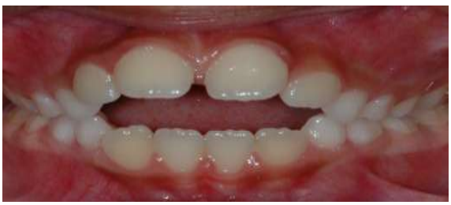

**Figure 1: Diastema with abnormal Frenum**

**Missing maxillary lateral incisors**

This can allow maxillary central incisors to drift distally. There are no physiological pressures placed on these teeth to close together as the canines erupt (Fig. 2a-c). The diastemas due to congenital absence of lateral incisors can be treated orthodontically with closure of the diastema and proper guidance of the canines to the position of the missing lateral incisors and of the posterior teeth mesially. In such cases, it is obligatory to achieve an Angle II occlusal relation. Selective grinding of the incisive and palatal canine cusps and of the palatal cusps of the first premolarsand restorations with resin composite must be performed in order to transform canines and first premolars into lateral incisors and canines, respectively. This is essential for satisfying patient‟s esthetic requirements, as well as properfunction of the stomatognathic system **(Azzaldeen and Muhamad, 2015)**. Alternative treatment options for the maxillary midline diastema caused by congenitally missing lateral incisors are to close the diastema and create the appropriate space for placing toothsupported restorations or single-tooth implants. The last options are of particular significance in cases of unilateral tooth absence, mainly because of the difficulties faced during orthodontic treatment, when trying to achieve dental arch symmetry. The selection of the appropriate treatment option in cases with congenitally missing lateral incisors, depends on the present malocclusion, on the anterior teeth relationship, on the specific needs concerning the available space, on the conditionof the adjacent teeth, on the tooth-size relationship and on the size and shape of the canine **(Miller, 1985)**.

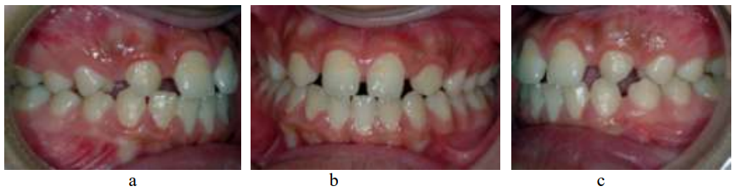

**Figure 2: Missing maxillary lateral incisors**

**Ectopic maxillary canines**

The absence of the canines from their normal position can facilitate distal drift and tilt of the incisors with space opening and there is the associated lack of the physiological pressures to upright the lateral and central roots that normally closes the diastema (Fig. 3) **(Muhamad, 2021)**.

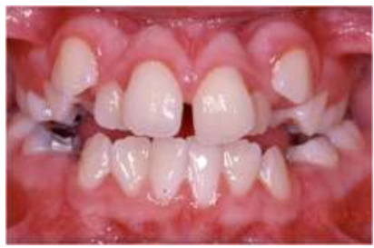

**Figure 3: Development of a Diastema as a result of ectopic maxillary canine**

**Tooth size or shape discrepancy**

The most commonly presenting of these are small lateral incisors. The Bolton Analysis may be used to compare tooth size discrepancies. This group are the most amenable to restorative and prosthetic solutions **(Azzaldeen and Muhamad, 2015)**. The associated shape discrepancies most frequently seen are central incisors that are excessively triangular or have mesial surfaces that are either concave or convex (Fig. 4).

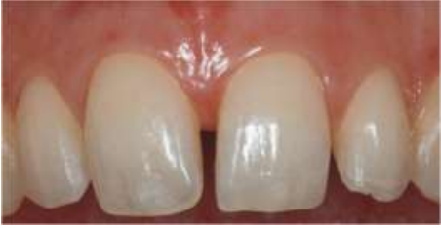

**Figure 4: Diastema is associated shape discrepancies**

The mesiodistal widths of the anterior teeth and the arch width should be measured. These measurements should be compared with the norms to determine whether it is contributed due to tooth size discrepancy, check whether all four incisor are small or only the lateral incisor are smaller with normal sized central incisors. Approximate mesiodistal widths of the anterior teeth and approximate arch widths, both in mm, are given in tables respectively. If only the lateral incisor is small, the Diastema should be closed orthodontically by moving the central incisor together reciprocally. Then the lateral incisor position can be corrected orthodontically and tooth size can be restored by composite build up or placement of crowns over lateral incisors **(Azzaldeen and Muhamad, 2015)**.

**Development**

A maxillary midline supernumary is a rare cause of midline diastemain children. Permanent maxillary central incisors can normally erupt with a diastema that will be reduced in size with the eruption of the lateral incisors and will completely disappear with the eruption of the canines. This happens because each permanent incisor and canine is 2-3 mm wider than its primary predecessor. Therefore, the maxillary midline diastema is frequently, not only physiologic, but necessary. If there is no pathological condition related to these specific teeth or major deviations from normal teeth size, spontaneous closure of the diastema should be considered certain in most cases. If, however, this does not happen, then intervention by the dentist may be necessary **(Bennet and McLaughlin, 1999)**.

**Habits**

The most frequently implicated habits are thumb, digit or soother sucking. These have a tendency to procline the maxillary labial segment, which may lead to spacing and diastema in some patients. Oral habits such as tongue thrusting and finger sucking can be other aetiological factors for the appearance of the midline diastema **(Gkantidis et al., 2008)**. According to Proffit and Fields, tongue position at rest may have a greater impact on tooth position than tongue pressure, as the tongue only briefly contacts the lingual surface of the anterior teeth during thrusting. The tongue pushes the anterior teeth to a forward position,increasing the circumference which results in spacing **(Proffit and Fields, 2003)**. An abnormal habit of the tongue can be detected by the tip of the tongue popping out through the anterior spacing when the patient is asked to swallow. In cases of anterior open bite, the tongue may be seen thrusting between incisal edges of the maxillary and mandibular incisors. Patients with tongue thrust often produce a snap sound on swallowing and also have hyperactivity of the orbicularis oris muscle.

An abnormal tongue size is a severe problem which may create difficulties in retaining the orthodontically corrected midline diastema. Macroglossia can be detected by simple observations **(Gkantidis et al., 2008; Azzaldeen and Muhamad, 2015).** The patient can be asked to touch the tip of the nose with his tongue and, if he/she is able to do that, it is an indication of an extended tongue. In the same way, if tooth indentations are seen on the lateral borders of the tongue, it can be an indication of an enlarged tongue In such cases, surgical trimming may have to be considered in order to attain stability in the dental occlusion. Deleterious habits have to be corrected by using habit-breaking appliances and by psychological approaches. The use of fixed tongue cribs are found to be effective in breaking the tongue-thrusting habit **(Azzaldeen and Muhamad, 2015)**.

**Root divergence**

Mesially inclined incisors can result in a coronally positioned contact point and a diastema, which is more gingivally placed. This is often referred to as the black triangle and is associated with reduced papilla infill, so that in effect it is a diastema that is closed off at its incisal aspect by contact of adjacent teeth. Burke and colleagues **(Abraham and Kamath, 2014)** in a study found that 40 per cent of crowded maxillary incisors can be expected to produce a black triangular space at the midline after fixed appliance treatment unless something is done to close this space before appliances are removed and the case considered finished (Fig. 5). There is a high incidence of concave mesial surfaces in crowded maxillary incisors, which becomes more apparent as the teeth are decrowded orthodontically (Fig. 6).

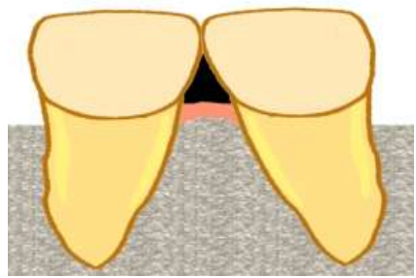

**Figure 5: black triangular space; Root divergence and mesially inclined incisors**

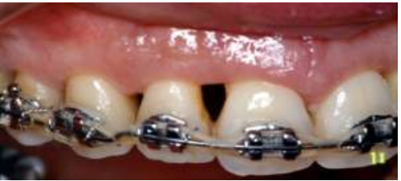

**Figure 6: concave mesial surfaces in maxillary incisors after leveling**

The effect of the distance from the contact point to the crest of bone on the presence or absence of an interproximal dental papilla **(Muhamad, 2021)**:

• when the distance was 5mm or less the papilla was usually present (Fig. 7a)

• when the distance was 6mm the papilla was present 56 per cent of the time (Fig. 7b)

• when the distance was 7mmor more the papilla was present 27per cent of the time or less (Fig. 7c).

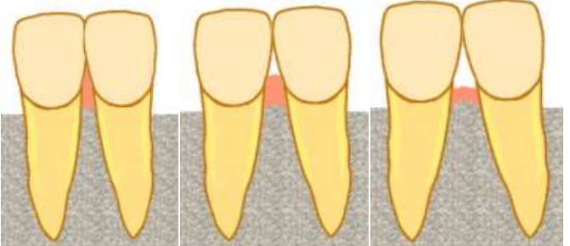

(a) (b) (c)

**Figure 7: the effect of the distance from the contact point to the crest of bone on the presence or absence of an interproximal dental papilla**

**Treatment options**

Before the practitioner can determine the optimal treatment, he or she must consider the contributing factors. These include normal growth and development, toothsize discrepancies, excessive incisor vertical overlap of different causes, mesiodistal and labiolingual incisor angulation, generalized spacing and pathological conditions. A carefully developed differential diagnosis allows the practitioner to choose the most effective orthodontic and/or restorative treatment. Diastemas based on tooth-size discrepancy are most amenable to restorative and prosthetic solutions. The most appropriate treatment often requires orthodontically closing the midline diastema. Treatment of diastema varies and it requires correct diagnosis of its etiology, and early intervention relevant to the specific etiology **(Chu et al., 2010)**.

Correct diagnoses include radiological and clinical examinations and possibly tooth size evaluation **(Abraham and Kamath, 2014)**

• No treatment is usually done, if the diastema is physiological/transient as it spontaneously closes after the eruption of permanent maxillary canines. Spontaneous correction of a childhood diastema is most likely when its width is not more than 2mm.

• Pathological causes like supernumerary teeth, midline soft tissue anomalies can be removed surgically and spaces are closed orthodontically. Oral habits such as thumb sucking and tongue thrusting should be corrected before closure of the space.

**Orthodontic Treatment**

It is an error to surgically remove the frenum at an early age and then delay orthodontic treatment in the hope that the diastema will close spontaneously. If the frenum is removed, while there is still a space between the central incisors, scar tissue forms between the teeth as healing progresses, and a long delay may result in a space that is more difficult to close than it was previously **(Van Gastel et al., 2011)**.

It is better to align the teeth before frenectomy. Sliding them together along an arch wire is usually better than using a closing loop, because loop with any vertical height will touch and irritate the frenum. If the diastema is small, it is usually possible to bring the central incisors completely together before surgery. If the space is large and frenal attachment is thick, it may not possible to completely close the space before surgical intervention. The space should be closed at least partially and the orthodontic movement to bring the teeth together should be resumed immediately after the frenectomy, so that the teeth are brought together quickly after the procedure. When this is done, healing occurs with the teeth together and the inevitable post-surgical scar tissue stabilizes the teeth instead of creating obstacles to final closure of the space **(Azzaldeen and Muhamad, 2015)**.

**Using composite resins for diastema closure**

Highly esthetic restorations made of composite resins are now possible due to constant improvements in techniques, materials, and technology **(Ferracane, 2011)**. One important aspect of composite resins is their capacity of mimic dental enamel, with overall survival rate higher than 88% up to 10 years. On the other hand, the major causes of failure are chipping and color mismatch, which can many times be solved by repairing and polishing **(Lempel et al., 2017)**.

Recently, alternative techniques have been described for performing diastema closures. The use of posterior stainless-steel matrix has been described in order to facilitate the building of the proximal anatomy **(Goyal et al., 2016)**; and although it helps on creating the incisors proximal angles, again, it does not help on assuring an adequate width for the incisors themselves.

Another technique described on the literature relies on using a Teflon band to isolate the adjacent tooth **(Korkut et al., 2016)**, which has the single benefit of preventing the adhesion of proximal walls of the adjacent teeth. Despite of this positive aspect, it presents the disadvantage of not allowing a clear view of the tooth adjacent to the working area, and in some occasions, it can be dispensable.

Also, the use of a mylar strip and flowable composite has been used to obtain emergence profile **(Saratti et al., 2016)**, which advantages regard creating an anatomically correct interproximal emergence profile, and avoiding black triangles, although those two cited techniques do not ensure width central proportion.

Among the different diastema closure techniques, the most typical one relies on creating a wax-up restoration, in order to simulate the diastema closure, and building a silicone index to guide the final composite resin restoration **(De Araujo et al., 2009)**. This technique is extremely useful because it makes it easy to reproduce the previously created anatomy of the teeth by the wax up. It was the technique that inspired the one used in this article. However, a modification was applied in order to promote a better guidance for the clinician to assure teeth width proportions.

Despite being highly effective on diastema closure treatment, none of the previously mentioned techniques took into account the reported difficulty on achieving a pleasant dental width proportion. This novel technique for diastema closure enables the clinician to promote a physical “stop” in the first tooth restoration by aims of a previous wax up and modified silicone indexes. By doing so, it avoids the invasion of the space from the second upper central incisor to be restored and assures a pleasant proportion of the teeth involved in the diastema closure (Figure 8).

The use of rubber dam is important not only because it helps to avoid moisture contamination, but also to obtain a good gingival retraction, providing better access to the cervical area and enabling composite addition in areas previously occupied by gingival tissue, thus, avoiding the non-esthetic black triangle **(Barros de Campos et al., 2015)**.

In patients with large midline diastemas, it is frequently observed an absence of interdental papilla, as the distance between the interdental contact point of these teeth and the alveolar bone crest has significant influence in interdental papilla presence. A previous study concluded that when the measurement from the contact point to the crest of bone is 5 mm or less, the papilla was present almost in 100% of the cases, however, when this distance increases, chances of the presence of papilla decreases. A rubber dam was used as previously reported **(Barros de Campos et al., 2015)**, in order to obtain enough gingival retraction and help on building the restorations.

In order to achieve clinical success with the presented technique, an important aspect is to promote enough thickness of the index made with both putty and light PVS materials. Sufficient index thickness reflects in an efficient barrier or “stop” for making the restoration of the first tooth, avoiding an invasion of the space available for the second tooth to be restored or the gingival tissue space, and thus, not jeopardizing the width of the restorations or provoking gingival inflammation. In the presented technique, clinicians can also follow the principles of the golden proportion when performing the wax up from the teeth, previous to the restoration procedure itself, which has been suggested as a possible mathematical approach to development of ideal size and shape for maxillary teeth **(Saratti et al., 2016)**, and can be used to determine the width of the teeth as they relate to each other.

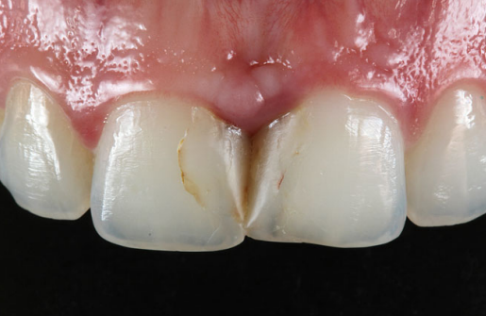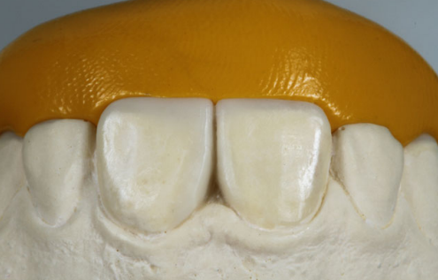

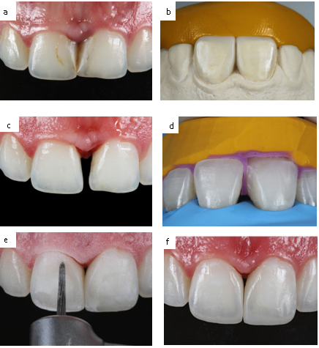

a

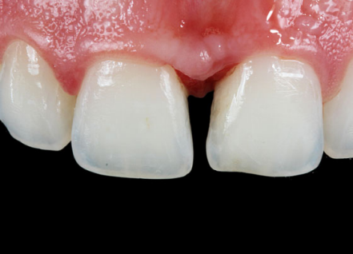 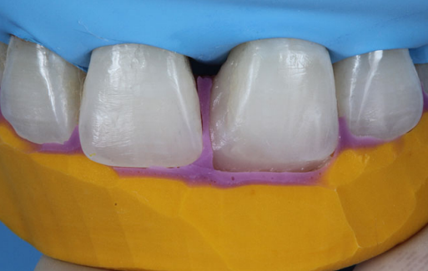  
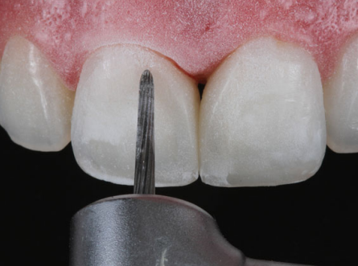



c

d

**Figure 8: a. Frontal view from the upper central incisors with previous restorations. Note the inflammation observed in the periodontal tissue b. Silicone index made with putty material consistency over the wax up c. Removal of previous restorations d. After rubber dam installing, the index with putty and light materials was positioned and the first tooth was built with composite resin (upper left central incisor) e. Finishing and polishing procedures made with burs after the performance of the upper right central incisor with the putty material silicone index f. Immediate photo taken after finishing the procedure.**

**Step by step approach to a diastema closure (Vargas, 2011)**

**Step 1.** A small increment of the appropriately shaded composite resin that corresponds to the facial half of each diastema is placed over the mesiofacial aspect of each tooth. These increments are placed simultaneously and contoured to ensure optimal con-tour and identical width for both central incisors. Attention should be given to blending the increments over the facial surface.

**Step 2.** Using a thin-bladed interproximal carver (IPC) instrument, contour the increments to match each other’s profile and ensure adequate gingival embrasure and emergence profile

**Step 3.** A metal matrix is sometimes utilized to produce a small separation between the two increments. A small brush is used to smooth the composite resin surface and approximate the increments. Light-cure the increments.

**Step 4.** Place a matrix against one of the central incisors and layer the lingual half of the diastema between the tooth and the matrix. Push this increment facially, close the matrix against the tooth, and pull it through toward the facial to ensure proper lingual contour. If excess composite remains in the gingival embrasure, remove it prior to light-curing.

**Step 5.** Light-cure the direct resin buildup and repeat Step 4 for the other central incisor.

**Step 6.** Using a #12 blade, remove any excess material gingivally to the contact point. Sof-Lex disks and a coarse polishing cup were used to contour the facial surface of the restorations. Create surface characteristics with a diamond bur, without water irrigation. Proximal polishing was achieved by sequentially using polishing strips. Polishing cups were used to create the restoration’s final luster and surface anatomy.

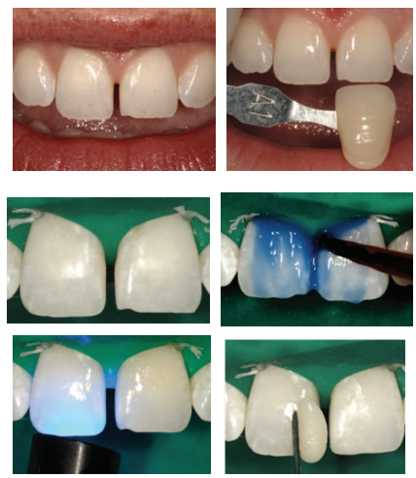

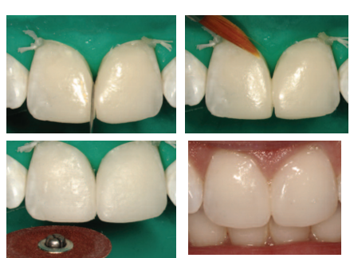

**Figure 9: A step-by-step approach to a diastema closure - a dual-purpose technique that manages black triangles**

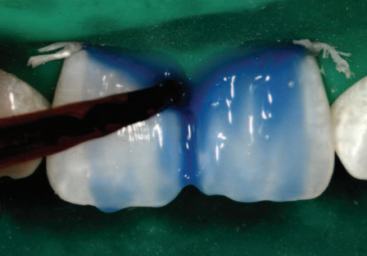   
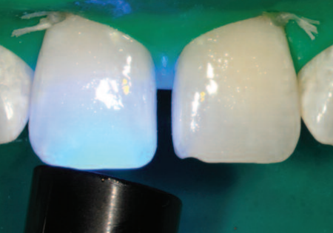

**Using indirect restorations for diastema closure**

Indirect restorations have excellent biocompatibility and are most similar to the normal tooth appearance, in shape, color, and brightness, because they have excellent optical characteristics when compared to direct restorations. Color stability is not guaranteed in resins as much as in ceramics, and resins are more susceptible to fractures **(Vaz et al., 2018)**. However, some contraindications should be taken into account for the use of ceramics: bruxism to a severe degree, decreased interocclusal distance, parafunctional activities, overjet, and greatly increased overbite. Additionally, the success of indirect restorations depends directly on a suitable sequence of steps, which include a correct treatment plan, and choosing the type of ceramic indicated for the specific case and technique, especially in the tooth preparation and cementation of the ceramics **(Faus-Matoses et al., 2017)**.

Ceramic laminates have gained considerable importance with the increase of aesthetic demand and often offer a treatment option with minimal preparation of dental structure. However, the prevention of micro infiltrations is a very important factor for the longevity of the restoration. An in vitro study by **Celik et al. (2017)** showed that preparation and polymerization techniques have demonstrated different effects on microleakage in ceramic laminates. Restorations that involve problems in sealing margins can allow for bacterial penetration and as a result may cause marginal staining, postoperative sensitivity, and recurrent caries.

Considering the various factors involved in the longevity of ceramics, studies have shown that patients who have good hygiene and yearly follow up have an excellent rate of indirect restoration permanence. According to **Olley et al. (2017)**, in a follow-up of 50 years of clinical cases, the survival rate of indirect restorations in anterior teeth made in feldspathic ceramics is better than in posterior teeth (95%). Both feldspathic ceramics and glassinfiltrated ceramics have similar survival rates of 96% to 98% when evaluated at 5 years. When compared to other materials (for example, use of the technique in direct composite resin), the success rate of the ceramics was higher (94%) than of the lower composite resin (74%).

It is noteworthy that the possibilities of treatment with composite resin or ceramic laminates, as well as their advantages and limitations, should be evaluated together with the patient. The ceramic laminates are made of lithium disilicate because this material, compared to others (for example, leucite-enhanced ceramics), has higher biaxial strength and fracture resistance **(Della Bona, 2009)**. Despite the minimally invasive approach of composite resin, this type of restoration would suffer from limited longevity because the material remains susceptible to discoloration, wear and marginal fractures, which would reduce the success of the aesthetic result in the long term **(Peumans et al., 2004)**. Therefore, ceramic laminates are proposed as an excellent treatment option due to their durability, in addition to superior aesthetics. This type of restoration can be implemented using strictly enamel sintering ceramics on a dentinal core-type framework (cut-back technique) only where little space is available **(Edelhoff et al., 2018)**. The complete crystallization of lithium metasilicate is achieved during burning and is associated with the final strength of the ceramics **(Silva et al., 2017)**.

To ensure minimally invasive dentistry requires a complete understanding of smile aesthetics and function. All clinicians, as well as the patient, were involved in the decision-making process and followed the steps correctly, which made it possible to achieve an aesthetic result by ensuring the minimum dental structure was removed **(Chai et al., 2018)**.

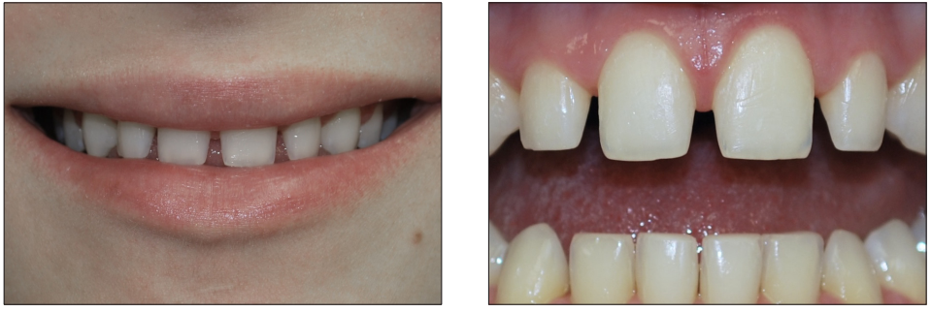

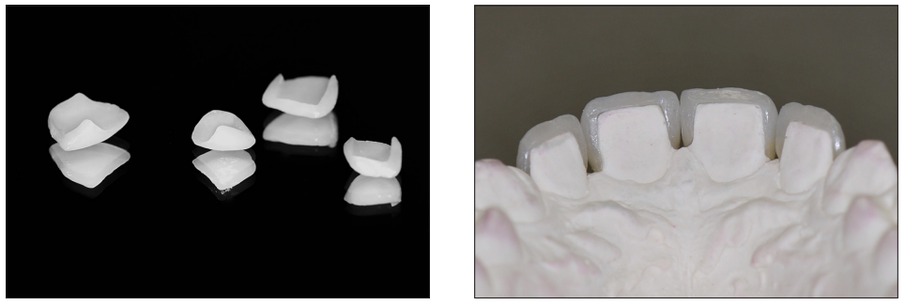

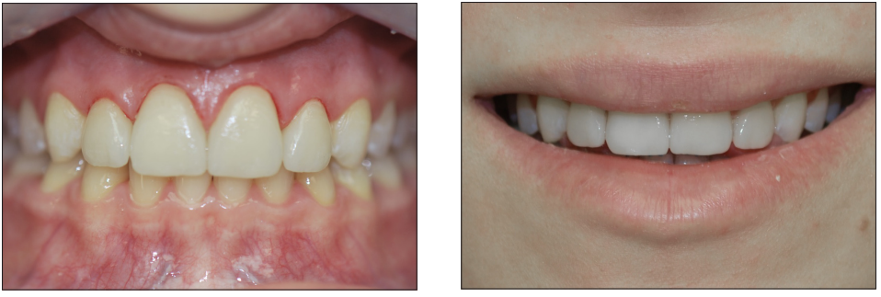

**Figure 10: Diastema closure with laminate veneers**

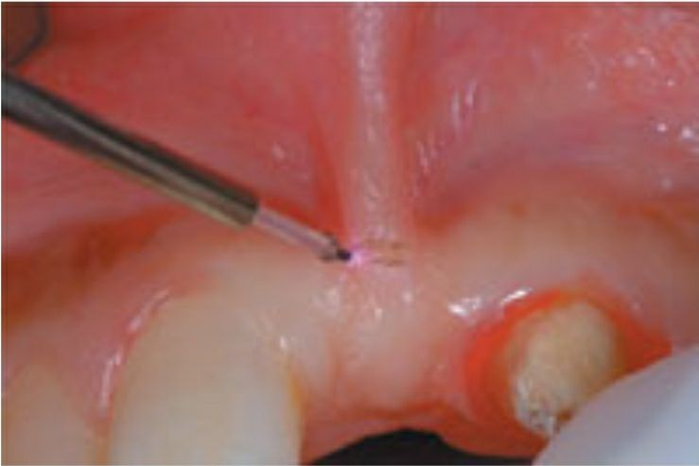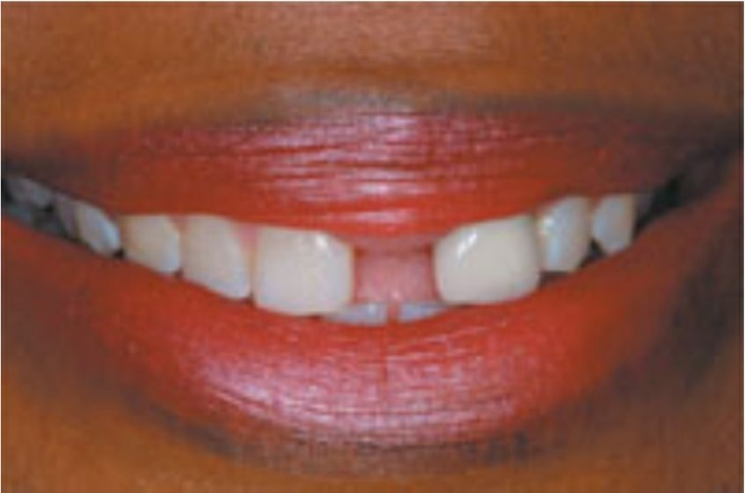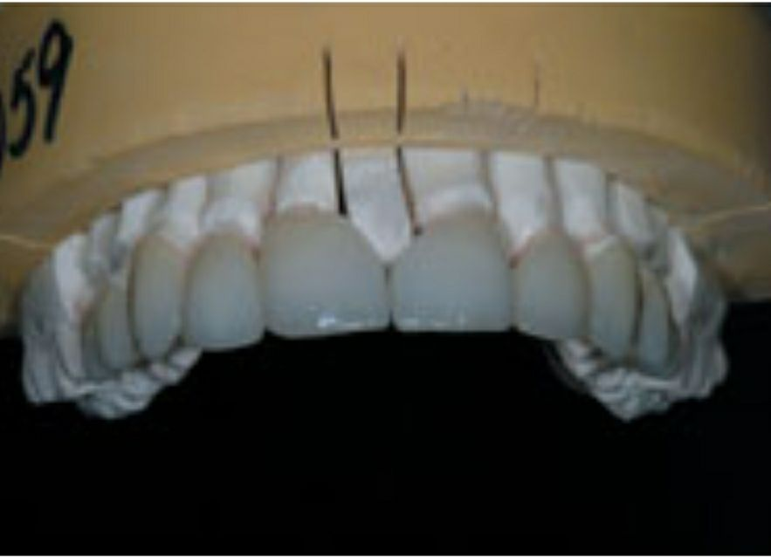

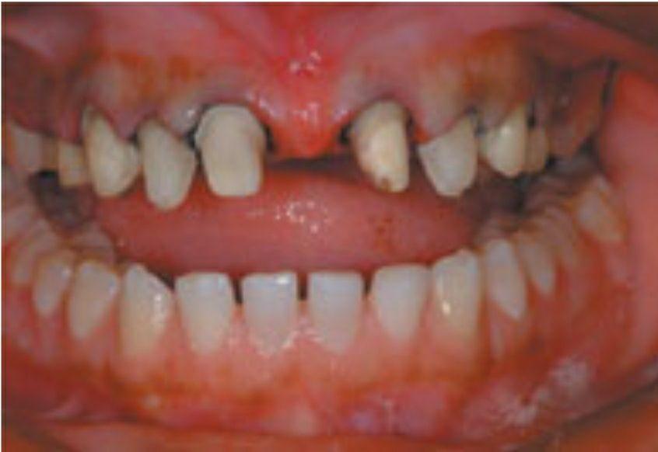

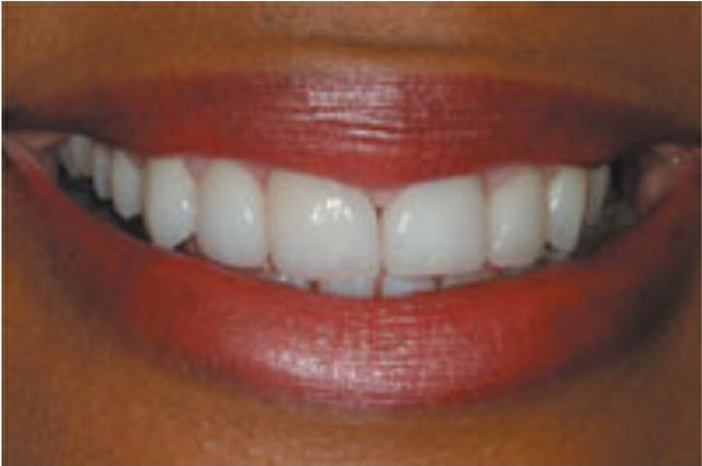

**Figure 11: Closing a large central diastema using a pressed ceramic**

**Conclusion**

The etiology of midline diastema is a very important factor that has to be taken into consideration before starting any orthodontic correction. Environmental factors as well genetic influences together plays a vital role in the etiology of midline diastema hence the orthodontist role to evaluate the various important factors and predict the risk of a developing midline diastema in future generation is valuable for patient diagnosis, treatment and retention. However, if the diastema is more than 1.8 mm, even after the eruption of lateral incisors, an orthodontic intervention will be necessary. A radiographic examination of the site will be beneficial to rule out any multifactorial aetiology. To achieve an aesthetic and stable result, it is important to establish the underlying cause for the midline diastema. Retention protocol should depend on the size and the aetiology of the midline diastema.

**The references**

- Abdulgani A, Watted N, Abu-Hussein M. (2014) DIRECT BONDING IN DIASTEMA CLOSURE HIGH DRAMA, IMMEDIATE RESOLUTION: A CASE REPORT.IJDHS.1(4);430-435.

- Abraham, R., & Kamath, G. (2014). Midline diastema and its aetiology--a review. *Dental update*, *41*(5), 457–464.

- Abraham, R., & Kamath, G. (2014). Midline diastema and its aetiology--a review. *Dental update*, *41*(5), 457–464.

- Abu-Hussein M., Watted N., Abdulgani A., and Bajali M.; (2014) Treatment of Patients With Congenitally Missing Lateral Incisors: Is an Interdisciplinary Task, RRJDS 2(4),53-68.

- Al-Huwaizi AF, Al-Alousi WS, Al-Mulla AA. (2003) The dental midline at 13- year of age. J Coll Dentistry 15: 1-7.

- Athumani AP and Mugonzibwa EA. (2006) Perception on diastema medialle among dental patients attending Muhimbili National Hospital. Tanzania Dental Journal 12 (2)50-57.

- Azzaldeen A, Muhamad AH. (2015) Diastema Closure with Direct Composite: Architectural Gingival Contouring. J Adv Med Dent Scie Res 3(1):134-139.

- Azzaldeen A, Muhamad AH. Diastema Closure with Direct Composite: Architectural Gingival Contouring. J Adv Med Dent Scie Res 2015;3(1):134-139

- Barros de Campos PR, Maia RR, Rodrigues de Menezes L, et al. (2015) Rubber dam isolation–key to success in diastema closure technique with direct composite resin. Int J Esthet Dent. 10(4): 564-574.

- Barros de Campos PR, Maia RR, Rodrigues de Menezes L, et al. (2015) Rubber dam isolation–key to success in diastema closure technique with direct composite resin. Int J Esthet Dent. 10(4): 564-574.

- Bennet J.C., McLaughlin R.P.: (1999) Fixed appliances. Orthodontic treatment with straight-wire technique. Czelej, Lublin p. 77.

- Bergstrom K, Jensen R, Martensson B. (1973) The effect of superior labial frenectomy in cases with midline diastema. Am J Orthod 63:633-8.

- Burke S, Burch JG, Tetz JA. (1994) Incidence and size of pretreatment overlap and posttreatment gingival embrasure space between maxillary central incisors. Am.J.Orthod. Dentofacial Orthop. 105(5): 506-511.

- Calamia V, Pantzis A. (2015) Simple case treatment planning: diastema closure. Dent Clin North Am. 2015;59(3):655-664.

- Celik N, Yapar MI, Ta pınar N, Seven N. (2017) The Effect of Polymerization and Preparation Techniques on the Microleakage of Composite Laminate Veneers. Contemp Clin Dent. Jul-Sep;8(3):400-4.

- Chai SY, Bennani V, Aarts JM, Lyons K. (2018) Incisal preparation design for ceramic veneers: A critical review. J Am Dent Assoc. Jan;149(1):25-37.

- Chalifoux PR. (2007) Perception esthetics: Factors that affect smile design. *J Esthet Rest Dent*. 2007;8(4):189-192.

- Chu CH, Zhang CF, Jin LJ. (2011) Treating a maxillary midline diastema in adult patients: a general dentist's perspective. J Am Dent Assoc. 142(11):1258-1264.

- Chu FC, Siu AS, Newsome PR, Wei SH. (2010) Management of median diastema. Gen Dent. 49(3):282-7.

- De Araujo EM, Jr, Fortkamp S, Baratieri LN. (2009) Closure of diastema and gingival recontouring using direct adhesive restorations: a case report. J Esthet Restor Dent. 21(4):229-240.

- Della Bona A. (2009) Bonding to ceramics: Scientific evidences for clinical dentistry. São Paulo: Artes Médicas: 252p.

- Edelhoff D, Prandtner O, Saeidi Pour R, Liebermann A, Stimmelmayr M, Güth JF. (2018) Anterior restorations: The performance of ceramic veneers. Quintessence Int. 49(2):89-101.

- Faus-Matoses V, Faus-Matoses I, Jorques-Zafrilla A, Faus-Llácer VJ. (2017) Orthodontics and veneers to restore the anterior guidance. A minimally invasive approach. J Clin Exp Dent. Nov 1;9(11): e1375-e1378.

- Ferracane JL. (2011) Resin composite—state of the art. Dent Mater. 27(1):29-38.

- Ferracane JL. (2011) Resin composite—state of the art. Dent Mater. 27(1):29-38.

- Frese C, Schiller P, Staehle HJ, Wolff D. (2013) Recontouring teeth and closing diastemas with direct composite buildups: a 5-year follow-up. J Dent. 2013;41(11):979-985.

- Gkantidis N, Kolokithao,Topouzelis N. (2008) Management of maxillary midline diastema with emphasis on etiology. Pediatr Dent. 32(4): 265272.

- Goyal A, Nikhil V, Singh R. (2016) Diastema closure in anterior teeth using a posterior matrix. Case Rep Dent. 2016:2538526.

- HamedullahJan, Sadia Naureen, AyeshaAnwar: (2010) Frequency and etiology of midline diastema in orthodontic patients reporting to armed forces institute of dentistry Rawalpindi Pakistan: Armed Force Medical Journal 1,4-10.

- Koora K, Mutthu MS, Rathna PR. Spontaneous closure of midline diastema following frenectomy. J Indian Soc Pedod Prev Dent 2007; 25: 23−26.

- Korkut B, Yanikoglu F, Tagtekin D. (2016) Direct midline diastema closure with composite layering technique: a one-year follow-up. Case Rep Dent. 2016:6810984.

- Lempel E, Lovász BV, Meszarics R, et al. (2017) Direct resin composite restorations for fractured maxillary teeth and diastema closure: a 7 years retrospective evaluation of survival and influencing factors. Dent Mater. 33(4):467-476.

- Lempel E, Lovász BV, Meszarics R, et al. (2017) Direct resin composite restorations for fractured maxillary teeth and diastema closure: a 7 years retrospective evaluation of survival and influencing factors. Dent Mater. 33(4):467-476.

- Miller PD Jr. (1985) The frenectomy combined with a laterally positioned pedicle graft. Functional and esthetic considerations. J Periodontol, 56: 102–106.

- Muhamad, Abu-Hussein. (2021). The midline diastema: a review of its etiology and treatment.

- Oboro HO, Umanah AU, Chukwumah NM, Sede M. (2008) Creation of artificial midline maxillary diastema: opinion of Nigerian dentists. (online) (cited 2009 Nov 16).

- Olley RC, Andiappan M, Frost P. (2018) An up to 50-year follow-up of crown and veneer survival in a dental practice. J Prosthet Dent. Jun;119(6):935-41.

- Omotoso GO, Kadir E. (2010) Midline Diastema Amongst South-Western Nigerians. The Internet J Dental Science. 8(2).432- 339

- Omotoso GO, Kadir E.: (2010) Midline Diastema Amongst South-Western Nigerians. The Internet J Dental Science. 8(2).432- 339.

- Peumans M, De Munck J, Fieuws S, Lambrechts P, Vanherle G, Van Meerbeek B. (2004) A prospective ten-year clinical trial of porcelain veneers. J Adhes Dent. Spring;6(1):65-76.

- Popovich F, Thompson GW, Main PA. (1977a) The maxillary interincisal diastema and its relationship to the superior labial frenum and intermaxillary suture. Angle Orthod 47:265-71.

- Proffit WR, Fields HW. (2003) Contemporary Orthodontics 2nd edn. St Louis: Mosby Yearbook, 467.

- Romero MF, Babb CS, Brenes C, Haddock FJ. (2017) A multidisciplinary approach to the management of a maxillary midline diastema: a clinical report. J Prosthet Dent. 119:502-505.

- Saratti CM, Krejci I, Rocca GT. (2016) Multiple diastema closure in periodontally compromised teeth: how to achieve an enamel-like emergence profile. J Prosthet Dent. 116(5):642-646.

- Saratti CM, Krejci I, Rocca GT. (2016) Multiple diastema closure in periodontally compromised teeth: how to achieve an enamel-like emergence profile. J Prosthet Dent. 116(5):642-646.

- Silva LHD, Lima E, Miranda RBP, Favero SS, Lohbauer U, Cesar PF. (2017) Dental ceramics: a review of new materials and processing methods. Braz Oral Res. Aug 28;31(suppl 1): e58.

- Van Gastel J, Quirynen M, Teughels W, Coucke W, Carels C. (2011) Longitudinal changes in microbiology and clinical periodontal parameters after removal of fixed orthodontic appliances. Eur J Orthod 33:15-21.

- Vargas, M. A. (2011). Step-by-step approach to a diastema closure-a dual-purpose technique that manages black triangles. *J. Cosmetic Dent*, *26*(3), 40-5.

- Vaz EC, Vaz MM, de Torres ÉM, de Souza JB, Barata TJE, Lopes LG. (2018) Resin Cement: Correspondence with Try-In Paste and Influence on the Immediate Final Color of Veneers. J Prosthodont. Jan 3.