Republic of Iraq
Ministry of Higher Education
and Scientific Research
University of Baghdad
College of Dentistry

Impression Technique for Indirect Restoration

A Project Submitted to
The College of Dentistry, University of Baghdad, Department of
Conservative in Partial Fulfillment for the Bachelor of Dental
Surgery

By:
Karar Basim Jemia

Supervised By:
Dr. Mohamed T. Mohamed
B.D.S., M.Sc ., (Conservative Dentistry)
Baghdad-Iraq

2022 A.D. 1443 A.H

Certification of the Supervisor
I certify that this project entitled "Impression Technique For Indirect Restoration " was prepared by the fifth-year student Karar Basim Jemia under my supervision at the College of Dentistry/University of Baghdad in partial fulfilment of the graduation requirements for the Bachelor Degree in Dentistry.

Supervisor’s name:
Assist. Lec. Mohamed T. Mohamed

Date;

Dedication

I would like to dedicate my family , God bless them …. To my father & my mother & my sister and brother . I wish that I will make you happy with success ….. With all love …..

Acknowledgement

I would like to thank my first and only support in this life, I own all my success to ALLAH, for now and ever I will not stop fighting while ALLAH by my side.
I would like to thank my lovely family for their support and encouragement.
I would like to thank my supervisor Dr. Mohamed T. Mohamed
for his support and Motivation .....

بسم الله الرحمن الرحيم
( و قل رَبِّ زِدْنِي عِلْماً )

صدق الله العلي العظيم
سورة طه : من الآية ١١٤

List of Contents
Subject | Page No.
Certification of the Supervisor | 1
Dedication | II
Acknowledgement | III
Table of content | V
List of figures | VI
List of tables | VII
1.Introduction | 1
2. REVIEW OF LITERATURE | 3
2.1 Impression material | 3
2.1.1 Non elastomeric impression material | 3
2.1.2 Elastomeric impression material | 4
2.2 Impression Technique | 7
2.2.1 Conventional Impression Technique | 7
2.2.2 Digital impression technique | 15
3. Conclusion | 22
References |  | 23

List of Figures
N. of Figure | Title | Page No.
Fig. 1.1 | Final impression showing supragingival finishing line | 2
Fig. 1.2 | Vinyl Polyether addition silicon | 6
Fig. 1.3 | Completed custom tray with relief over preparation area | 10
Fig. 1.4 | Adhesive placed on tray and extended over borders | 11
Fig. 1.5 | Proportions measured out on pad , (B) Mix begun with spreading motion, not whipping | 11
Fig. 1.6 | Loading tray without incorporating or trapping air , (B) Completed impression | 12
Fig. 1.7 | The tray must be rigid. It must feature internal retention bars (i.e., “rim-locks”) and provide a clearance of 3 to 6 mm | 13
Fig. 1.8 | In view of the excellent dimensional fidelity of contemporary impression materials, in most situations, a stock tray will suffice to carry the impression material. (a) The ideal tray leaves a 3 to 6 mm clearance between the tray and the teeth. (b) Whenever the shape of the dental arch is such that no homogeneous fit is obtained, a custom tray should be fabricated | 14
Fig. 1.9 | Scanned Upper and lower dental arches | 16

List of Tables
No. of Table | Title | Page Number
Table 1 | Stock Trays Versus Custom Tray | 12
Table 2 | Advantages and Disadvantages of Convention Impression Technique | 14
Table 3 | Advantages and Disadvantages of Digital Impression Technique | 19

1_INTRODUCTION
The indirect restorations can be extracoronal restorations (which cover the crown completely or partially, the retention and resistance form is gained from the external walls of the tooth and the overall surface area. Or intracoronal restorations (which are within the confines of the coronal portion of the tooth, the retention and resistance form is gained from the intimate fit of the restoration with the opposing walls). Both fabricated in dental laboratory by the competent person (Sikri , 2017).
Indirect restorations that satisfy biological, mechanical and aesthetic requirements can only be made if there is an exact transfer of both the three dimensional geometry of the entire preparation and surrounding intra-oral tissue from the patient's mouth to a definitive cast through accurate final. Using the correct impression material and appropriate techniques are mandatory to have fine details of preparation, especially at the margins. Preparation margins must be fully visible in the final impression, in addition to an intact and uninterrupted cuff of impression material present 0.5-1 mm beyond every margin, to facilitate precise die trimming in the resultant working cast (Farah , 2016).
Several techniques can be used for impression making, regardless of the system used, an acceptable impression must accurately capture all aspects of the prepared tooth. This means it must include sufficient unprepared tooth structure immediately adjacent to the margins so that the dentist and laboratory technician can identify the contour of the tooth and all prepared surfaces. The contour of the unprepared tooth structure cervical to the preparation margin is crucial information that must be available when the restoration is fabricated in the dental laboratory. If the impression does not reproduce this critical area where tooth and future restoration meet, fabricating the restoration with proper contours is not possible (barring some lucky guesswork). All teeth in the arch and the soft tissues immediately surrounding the tooth preparation must also be reproduced in the impression (Fujimoto et al., 2016).

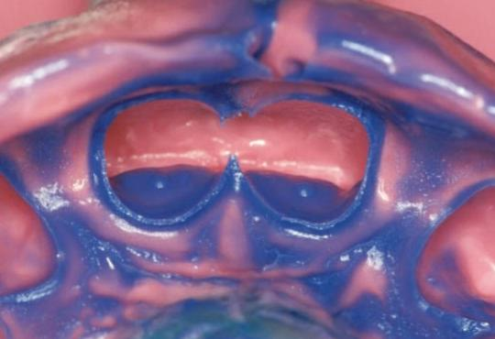
(Fig. 1.1) Final impression showing supragingival finishing line (Kern, 2017).

Several impression materials are available broadly divided into non-elastic and elastic materials. Non-elastic impression materials generally not used for obtaining impressions of crown preparations because of their inability to accurately record undercuts. The elastic impression materials can be divided into two groups: the hydrocolloids and the synthetic elastomers are commonly used (Wassell et al., 2002).

2.Review of literature
2.1 Impression Materials
Impression materials are used to record intraoral structures for the fabrication of definitive restorations. Accurate impressions are necessary for construction of any dental prosthesis. They must accurately reproduce the relationship between static and mobile oral structures for an optimum cast. Materials used without adequate knowledge of their characteristics can impair a successful outcome (Rubel , 2007).
There are two main classes of impression materials: Non-Elastomeric (hydrocolloid impression materials) and Elastomeric impression materials
    - Non-Elastomeric impression materials
- Irreversible Impression Materials
Irreversible impression materials such as alginate has been the staple of most dental practices for many years. The general use of irreversible hydrocolloid impression materials far exceeds that of any impression material, because of their various advantages such as hydrophilicity, pleasant taste and odor, non-staining, inexpensive and ease of mixing. However they have low tear strength and dimensional stability. As with any hydrocolloid, alginates are prone to distortion caused by expansion associated with imbibition (absorption of moisture) or shrinkage due to moisture loss by evaporation, or continued reaction (syneresis). Casts produced from alginate impressions must be generated immediately or within 3 hours after the impressions are removed from the patient’s mouth (Danasory et al., 2016).
- Reversible Impression Materials
Reversible hydrocolloid was introduced to the dental profession in 1925 by Alphons Poller as impression material. It has dimensional changes as a result of synergists or evaporation of water when exposed to air. This material does not readily flow into areas in which the tray does not extend. If distortion occurs, it cannot be corrected. (Madhavan , 2015)
    - Elastomeric Impression Materials
Elastomeric impression materials are in common use. The impression taken should be highly precise, thus, requiring specific care when manipulating these materials. There are 4 groups of elastomers; polysulfide, condensation silicone, addition silicone and polyether; each differ in their setting mechanism and their physical and chemical properties (Levartovsky et al., 2011).
- Polyether Impression Material
Polyether materials, when applies correctly, provide perfectly fine detail and accuracy in crown-and-bridge impressions. The advantages are also the ability to do multiple pours and have a longer set time and long-term stability. Nevertheless, they are rigid and compared to PVS harder to remove from oral cavity especially when there are restorations or undercuts, however, contemporary polyether impression materials are slightly more flexible than the older products, which facilitates their removal from the oral cavity. In addition, many patients object to their taste, though it was improved over the recent years. Due to its water absorption property, impression should not be immersed into water, as it will result in distortion. So, it is recommended to carry out ten-minute sterilization with glutaraldehyde afterwards it maintains its dimensional stability up to 7 days when under the dry conditions (Heboyan et al., 2019).
- Polysulfide Impression Material
Polysulfide materials had better dimensional stability and tear strength than hydrocolloid. They must be poured as soon as possible after impression making, delays of over an hour resulted in clinically significant dimensional change, and it has improved dimensional stability over hydrocolloid (inferior to polyether and addition silicone). Polysulfides have a long working and setting time, which is an advantage when impressions are being taken of multiple preparations, but a disadvantage when only one or two teeth have been prepared. Its disadvantage of a long setting time in the mouth induces poor patient acceptance (especially in view of its unpleasant sulfide odor) (Pratten et al., 1990).
- Addition reaction silicones; (poly(vinylsiloxanes), vinyl(polysiloxanes)
Addition curing silicones have the least amount of shrinkage on setting making them the most accurate class of rubber impression material. The poly (vinyl siloxane) are characterized by excellent dimensional accuracy and long-term dimensional stability. Their great stability means that accurate dies can be poured for up to a week after they have been removed from the mouth. In addition, silicone impression materials have a polymerization shrinkage lower than condensation silicon impression materials. It is similar in many respects to condensation silicone except that it has much greater dimensional stability (equivalent to poly-ether polymer) ( Keyf, 1994).
In addition silicone impression has become the impression material of choice in many clinical situations. They possess excellent physical properties and handling characteristics. Although they are the most expensive materials, they are used in wide variety of clinical situations (Pande, 2013).
- Condensation silicones impression material ( polysilixone)
The conventional silicone impression materials are also known as condensation reaction silicones. The main disadvantage of silicone, its poor wetting characteristics. The prepared teeth and gingival sulci must be completely free of moisture for a defect-free impression. The condensation silicones have more shrinkage on the setting than other rubber impression materials (Malone , 1989).
Its dimensional stability is less than that of polysulfide although greater than that of reversible hydrocolloid. Condensation silicone and polysulfide have a dimensional instability that is due to their mode of polymerization (Malone , 1989).
- Vinyl polyether addition silicone
Vinyl polyether silicone is a formulation that combines properties of the addition silicones and the polyethers. It was commercially introduced in 2009. The material has dimensional properties similar to those of the addition silicones and polyethers which include excellent dimensional stability (Fujimoto J , 2016).
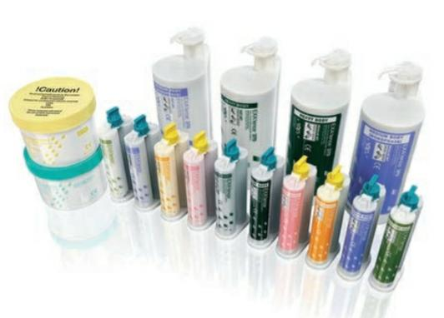
(Fig. 1.2) Vinyl Polyether addition silicon (Fujimoto J , 2016).

2.2 Impression Techniques
2.2.1 Conventional Impression Technique
2.2.1.1 One Step Technique
The impression material used in this technique is Polyvinyl siloxane. One step technique can be single mix or double mix technique
  - Single Mix Technique
In this technique proper stock tray with the correct border extensions, and tray shape and size is selected depending on the patient’s arch shape and size. Then apply tray adhesive on the inside and rim of the stock tray. After that mix the high-viscosity putty impression material and roll putty into elongated cylinder ant then place the putty in the stock tray and cover with polyethylene sheet. The insertion and seating of the tray should be with a rocking type motion (Annamma , 2006).
The Seating of the tray in the mouth without movement till initial set occurs (approximately 2 minutes). For stock tray (putty wash) single mixing technique, the unset high-viscosity impression material should already be in the tray, and the preparations syringed with low-viscosity impression material. After setting being completed, remove the impression from mouth with minimal sideward movement and ensure the material is set using a fingernail test. (Material rebounds completely). After removing the spacer, the excess impression material is removed with a sharp knife (Annamma , 2006).
  - Double Mix Technique
In this technique medium and heavy-bodied elastomers can be done. After a stock tray is selected, tray adhesive is applied; the impression putty is mixed and placed in the tray. A polyethylene sheet is used to cover the putty material and impression is seated in the patient’s mouth. After the complete set of the impression is ensured by fingernail testing, the tray is removed. After measuring the arch length of tray, the tip of the syringe carrying the low-viscosity elastomer is trimmed and then low viscosity material is dispensed. For the final impression (Annamma , 2006).
A mixing pad, (6 by 8 inches) or an automatic gun dispensing system is used. The low-viscosity impression material is mixed with a circular motion combining the two strands, then a figure-eight motion to blend and flatten the mixture onto the mixing pad (Approximate mixing timeless than l minute). After that loading the impression material. The syringe is loaded by holding it at a slight angle while scraping the pad of the external borders. The tray should not be moved while the material is set. After the final set is over, the tray is removed and the impression is rinsed with water, and dried with compressed air (Annamma , 2006).
2.2.1.2 Two Step Impression Technique
Two-step, putty-wash technique In principle, the technique consists in taking two consecutive impressions of the same arch. The first impression is produced using a putty material. For the second impression, light-flowing material is syringed onto the preparations and coated into the putty impression. This assembly is then seated onto the arch again. Due to the excess of fluid impression paste, the material escapes from underneath the putty – hence the term wash (i.e., it is “washed away”). To provide room for the fluid material, the putty impression must be seated after the teeth have been covered with a spacer (usually a sheet of polyethylene) (Wang et al., 1995).
Technically though, the sheet is not placed on the teeth but on the surface of the impression-filled tray. Both the tray material and the spacer are then seated onto the dental arch. After setting, the spacer is removed from the putty and the putty-tray assembly is ready for the wash impression (Wiskott , 2011).
The proponents of this technique emphasize its in- creased accuracy since the thickness of setting material is reduced. While this argument is mainly theoretical, the putty-wash technique presents an advantage regarding applicability. Indeed, the technique can be performed by one clinician and a single assistant or even, with some training, by one dentist working alone. On the downside, the technique requires that the initial tray positioning be accurately duplicated during the second impression to avoid local zones of compression (and subsequent distortion) of the putty material (Wiskott , 2011).
2.2.1.3. Custom Tray Fabrication
The tray is constructed of autopolymerizing tray resin adapted to a cast of the patient’s teeth. A spacer of two sheets of base plate wax (2 mm) is first adapted to the cast. The wax spacer provides the necessary space within the tray being formed to allow the optimum thickness of impression material during the subsequent impression procedure. To assure bonding of the impression mixture to the tray, the inner surface and periphery of the tray are coated with a suitable adhesive (Rhoads et al., 1986).
Proper proportions of the impression material are placed upon a mixing pad and mixed to a uniform consistency which exhibits no streaking of the different colored constituents. The mixed material is carefully inserted into the tray, avoiding entrapment of air masses within the viscous material . The remaining material is carefully loaded into the injection syringe (Rhoads et al., 1986).
Impression material is carefully placed into the critical areas to avoid entrap-ment of air or other innacuracy associated with the application of the material. The tray is placed over the teeth and seated with light uniform pressure to assure proper orientation. The tray should he maintained in its position with light finger pressure until polymerization has occurred. Care should be exercised that movement of the tray does not occur during the setting period. After removal of the impression from the mouth , the cast material should be introduced (Rhoads et al., 1986).
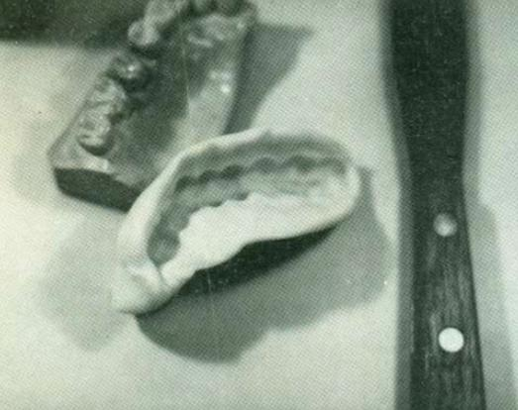
(Fig. 1.3) Completed custom tray with relief over preparation area (Rhoads et al., 1986).

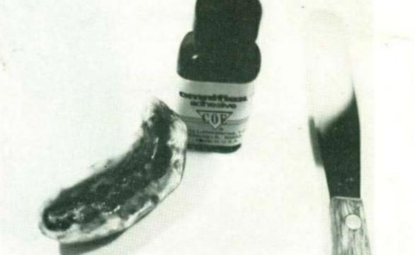
Fig. 1.4) Adhesive placed on tray and extended over borders (Rhoads et al., 1986).
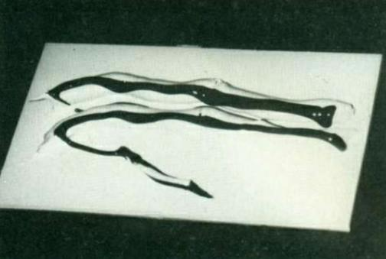
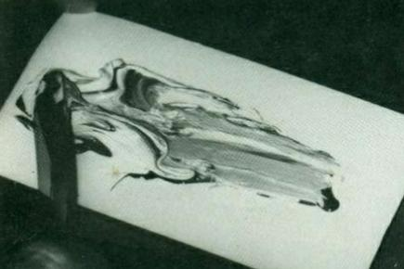
(A) (B)

(Fig. 1.5) (A) Proportions measured out on pad , (B) Mix begun with spreading motion, not whipping (Rhoads et al., 1986).
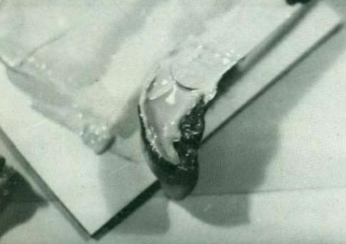
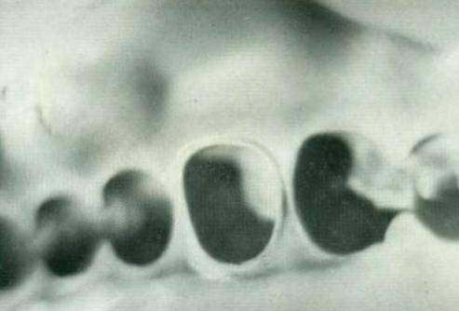
A B
(Fig. 1.6) (A) Loading tray without incorporating or trapping air , (B) Completed impression (Rhoads et al., 1986).

Table 1 : Stock Trays Versus Custom Tray (Wiskott , 2011).
Stock Tray | Custom Tray
Stock trays are sized according to the average curvature of a dental arch. Manufacturers typically provide them in sizes ranging from small to large (or extra-large). | A custom-made tray is one in which a preliminary model is made first. Then a laboratory technician fabricates a resin tray off this model.
The advantages of stock Tray it is less time required for it's fabrication. | The advantage of custom-  made trays lies in their clearance which is set during fabrication. As a consequence, the layer of impression material surrounding the teeth is fairly even. Due to a  more uniform shrinkage, it is postulated that a superior accuracy would be obtained in the resulting model.
The disadvantages of stock Tray it require high thickness of impression material. | The disadvantages of such trays lie in the additional laboratory procedures and costs. Further, their actual purpose needs to be investigated more closely.

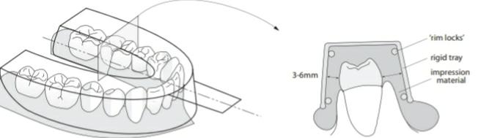
(Fig. 1.7) The tray must be rigid. It must feature internal retention bars (i.e., “rim-locks”) and provide a clearance of 3 to 6 mm (Rueda et al., 1996).

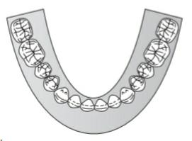
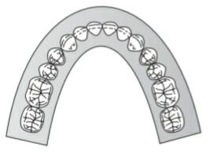
a b
(Fig.1.8) In view of the excellent dimensional fidelity of contemporary impression materials, in most situations, a stock tray will suffice to carry the impression material. (a) The ideal tray leaves a 3 to 6 mm clearance between the tray and the teeth. (b) Whenever the shape of the dental arch is such that no homogeneous fit is obtained, a custom tray should be fabricated (Rueda et al., 1996).

Table 2 : Advantages and Disadvantages of Convention Impression Technique. (Sethi et al., 2022)
Advantages | Disadvantage
The technique is well known and acceptable | Creates mess  Discomfort for the patient  Air bubbles or debris cause inaccuracies  Stocking the materials and trays
Simple equipment needed | Discomfort for the patient
Cost ranges from low-to-moderate4. Known accuracy | Air bubbles or debris cause inaccuracies
Relatively simple and predictable clinical technique | Stocking the materials and trays

2.2.1.4. Accuracy of single-step versus two step technique
Single-step technique, in which both materials polymerize simultaneously, reduces chairside time and saves impression material. Although time is a limiting factor since the professional has to accommodate both low- and high-consistency materials simultaneously before setting occurs, this technique yields accurate impressions independently of the curing kinetics of the syringed material alone . According to the literature, the single-step technique with vinyl polysiloxanes or polyether’s leads to very accurate impressions.
In the 2-step technique, a high-viscosity material is used for a preliminary impression, while the final impression is performed with a lower-viscosity material. Even though the 2-step technique has been widely adopted and can offer good accuracy , some problems may be experimented with this technique, such as dimensional alterations, extra chairside time, and extra material needed. ( Cardash , 2011)
2.2.2 Digital Impression Technique
Digital dental scanners are classified into intraoral and extraoral scanners . Extraoral scanners are used for scanning physical dental impressions or stone casts so conventional impression procedure is still mandatory . That’s why intraoral scanners are more preferred over extraoral scanners in the dental procedures.
Intraoral scanners are used for scanning prepared teeth, implant scan bodies and gingival tissues directly from the patient’s mouth . They eliminate the use of conventional impression material reducing the occurrence of patient’s vomiting reflux, discomfort and the unfavorable taste (Aly et.al, 2020).

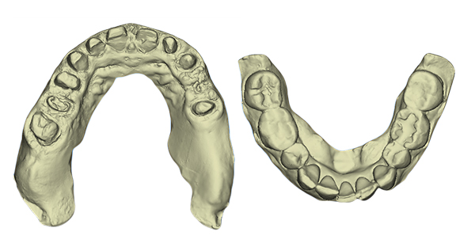
(Fig.1.9) Scanned Upper and lower dental arches (Aly et al , 2020).

2.2.2.1 The factors that may affecting scanning accuracy (Aly et al., 2020) :-
- Type of scanner (3shape and Dental Wings intraoral scanners).
- Tooth (canines, premolars or molars)
- Measurement direction (BL or MD).
2.2.2.2 Principles Behind 3D Surface Imaging
3D surface scanners are devices that create a digital map of the surface of an object and collect data on its three-dimensional shape and size. The raw data are usually obtained in the form of a point cloud, representing the 3D coordinates of the digitized surface. In practice, there are two main categories of 3D surface scanners: contact and non-contact scanners (Schweiger , 2008).
- Contact Scanners
Many contact scanners are coordinate measuring machines which are mechanical systems designed to move a measuring probe over a surface and to determine the coordinates of the points comprising the surface. They have four main components (Birnbaum , 2008) :
The measuring probe: The mechanical measuring probe performs a linear or radial scan of the desired surface and, as it does so, the position of the stylus tip in the x, y, and z planes is sampled at regular intervals. Example of a contact probe scanner in use in dentistry is the Incise system probe has a ceramic shaft on the end of which is a ruby ball (Sethi et al., 2022).
- The control or computing system
- The machine which moves the probe
- Measuring software

- Non Contact Optical Scanners
Many 3D laser scanners employ the principle of triangulation to obtain 3D surface images. A laser beam is incident on the surface of the object to be scanned and a camera-like device, such as a charge-coupled device or position-sensitive detector, is used to record the location of the point at which the laser beam strikes the object. Since the positions of both the laser and camera and the angle between them is known, the position of the surface can be calculated using simple triangulation (Sethi et al., 2022).
Laser scans can either be created from a point which is progressively scanned over the object surface, or more rapidly by imaging the object with a series of laser lines or profile. Photogrammetry also employs the principles of triangulation, but instead of a laser beam, it uses a series of photographs of the object of interest. (Sethi et al., 2022).
The major drawback of this technique is that it is not possible to obtain the dense point clouds required for freeform surface modeling and accurate CAD surface reconstruction. Reconstruction of the acquired image can also be time-consuming. Interferometric techniques may use laser or white light. Interferometry uses the principle that waves will interact with one another causing interference. If waves are perfectly in phase they reinforce each other, but if they are perfectly out of phase they will cancel each other out (Bhuvaneswaran , 2018).
In interferometric shape measurement, light of different wavelengths is projected along a single beam onto a surface. The interference between the wavelengths depends on the distance between the source and the surface, thus fringes of dark and light are formed on the object which relates to the topography of the surface. The advantages of interferometry include high resolution, a long range, and they are also relatively insensitive to mechanical vibrations (Giordano , 2006).
The main advantages of this method of 3D optical scanning are the high speed, low cost, and high accuracy. It is used in the 3dMd facial imaging system. However, the technique is not without its problems as issues such as shading and surface holes or crevices will present problems with image projection and subsequent cap (Giordano , 2006).

Table 3: Advantages and Disadvantages of Digital Impression Technique (Priyanka et al., 2020).
Advantages | Disadvantages
- Minimizes discomfort: Digital impressions minimizes the transient discomfort by the placement of impression materials and trays in the patient mouth. It terminates the use of impression trays, materials, etc. | - Sub-gingival margin detection: There was a problem of detection of deeply placed gingival margins
- Time-saving: Through the scanning of the patient’s soft and hard tissues chairside time is reduced. Time-consuming: procedures like pouring the casts etc. are eliminated. | - Cannot displace the soft tissue margins and cannot register dynamic tissue relationships
- Easier workﬂow: Procedure of impression is simpliﬁed for complex cases for example severe undercuts, multiple implants which enable conventional impression procedure difﬁcult, and the procedure for repeating the impression is easier without remaking the entire procedure. | - Cost-sensitive: The initial purchase costs of IOS are very high, even after the release of many new models into the market.
- Communication with Laboratory Personnel: Digital impression technique enables the clinician to communicate with the laboratory personnel instantaneously after the scan, if the laboratory personnel is not satisﬁed clinician can make an instant remake of the scan without a second appointment for the patient.

2.3.2.3 Digital impression versus conventional impression for fabrication of crowns and FDPs
(Anadioti et al ., 2014) conducted an in vitro study to evaluate the 3D and 2D marginal fit of pressed and CAD/CAM lithium desilicated crowns. Crowns were made based on digital and conventional impressions using the following combinations: conventional impression/pressed crown, conventional impression/CAD/CAM crown, digital impression/press crown, and digital impression/CAD/CAM crown. Two points on the margin and at 0.75 mm above the margin were measured for the 2D measurements; 3D marginal fit measurements showed the average marginal fit of the selected area. Measurements revealed that the polyvinyl siloxane (PVS) impression/IPS emax press group produced the most accurate marginal fit, whereas no significant differences in marginal fit were found between the other groups (Seelbach et al., 2103). conducted an in vitro experiment to evaluate the precision of crowns fabricated by using conventional and digital impressions, measuring the accessible marginal inaccuracy and the internal fit. They concluded that the accuracy of crowns fabricated by using digital impressions was at the same level as conventional impressions (Ahlholm et al., 2016).
2.3.2.4 Precision Between Digital And Conventional Impression
Marginal and internal fitness are important criteria for the success of FDPs like ceramic restorations. To obtain a precise restoration, a high level of impression accuracy is important. Syrek et al conducted an in vivo experiment to compare the fitness of zirconia single crowns made from an intraoral digital impression with that from a conventional silicone impression. The study concluded that ceramic crowns fabricated from a digital impression had a better fit than conventional impressions. (Ruthwal et al., 2017).
The interproximal contact was better for digital impressions than for the conventional impressions. Ender and Mehl conducted an in vitro experiment on full arch scanning to evaluate the precision of conventional and digital impressions, and determined the values to be 30.9 μm for CEREC Bluecam, 60.1 μm for Lava C.O.S., and 61.3 μm for a conventional impression. Few authors concluded that the accuracy of digital impressions was similar to that of conventional impressions, potentially due to a powder coat spraying, which was applied before both Lava C.O.S. and CEREC scanning (Ruthwal et al., 2017).

3.Conclusion :
In fixed prosthodontics, the intraoral digital impression technique aids the CAD/CAM process introduce as a relatively new technique, dental products fabricated with intraoral digital impressions have presented high accuracy as compared with conventional impressions.
Although conventional impression materials like poly (vinyl siloxane) and polyether are well developed and present great accuracy and excellent properties in many prostheses, the intraoral digital impression technique has a distinct superiority in work efficiency and saving of materials and patient's comfort. The further improvement of the intraoral digital impression technique will lead to its wide use in dentistry.

References
(A)
Ahlholm P et al., 2016 , Journal of Prosthodontics , Digital Versus Conventional Impressions in Fixed Prosthodontics , 27: 35-41 .

Aly et al , 2020 , Alexandria Dental Journal , Evaluation of the accuracy of digital models obtained from intraoral scanners with different CAD/CAM scanning technologies , 45(3) , 118-538 .

Anadioti et al., 2014 : Journal of Prosthodontic , 3D and 2D marginal fit of pressed and CAD/CAM lithium desilicated crowns made from digital and conventional impressions , 23;610-617 .

Annamma , 2006 , Review of Fixed Partial Dentures , Jaypee Brothers Medical Publishers (P) Ltd .
(B)
Barker D , Crowns and other extra-coronal restoration British , Dental Journal ,192(2): 679–69.

Bhuvaneswaran , 2018 , Journal of operative dentistry and Endodontic, digital imaging in dental impression, 3:63-70 .

Birnbaum , 2008 , Journal of compendium of continuing education in Dentistry
, dental impression using 3D digital scanners , 29:494-505.

(C)
Cardash S , 2011, International Scholarly Research Notices Journal , Accuracy of Single-Step versus 2-Step Double-Mix Impression Technique , 10; 341-546.
(D)

Danasory , 2016 , Alexandria Dental Journal , Dimensional Stability of Three Extended-storage Irreversible Hydrocolloid , 41:146-149.

(F)
Farah RI., Modified impression technique for tooth - supported cemented indirect restoration , International Journal of Dental and Health Sciences, 2016; 3(1): 1305-1310 .

Fujimoto et al., 2016 , Contemporary fixed prosthodontics , Library of Congress Cataloguing-in-Publication Data.

)G)

Giordano , 2006 , Journal of American Dental Association , Materials for Chairside CAD/CAM-produced restoration , 137:14S-21S .

(H)
Heboyan , 2019 , International Academy Journal Web of Scholar , Impression material selection and soft tissue management in contemporary fixed prosthodontic , 5(35): 2518-167.

(K)
Kern , 2017 , Prostheses Resin-Bonded Fixed Dental , Quintessence Publishing Co. Ltd .

(L)
Levartovsky et al., 2011, Journal of National Library of Medicine , Elastomeric impression materials , 28(2):54-64.

(M)
Madhavan , 2015 , Journal of Pharmaceutical Science and Research, A Review on Hydrocolloids-Agar and Alginate , 7(9):704-707.

Malone , 1989 , Tylman's Theory and practice of Fixed Prosthodontics. Eighth Ed, copyright.

(P)
Pande et al ., 2013 , Journal of Indian Prosthodontic Society , An Evaluation of Dimensional Accuracy of One-Step and Two-Step Impression Technique Using Addition Silicone Impression Material: An In Vitro Study , 13(3):254–259.

Polido , 2010 , Dental Press Journal of Orthodontic , Digital impressions and handling of digital models: The future of Dentistry , 15(5):18-22.

Pratten et al., 1990 , Journal of Prosthetic Dentistry , Effect of disinfec-tant solutions on the Wettability of elastomeric impression materials , 63:223-227.

Priyanka et al., 2020 , IP Annals of Prosthodontics and Restorative Dentistry , Digital impression in prosthodontic, 6(2):66-70 .

(R)

Rhoads et al., 1986 , Dental Laboratory Procedures (Fixed Partial Dentures) , Library of Congress Cataloguing in Publication Data.

Ruthwal et al., 2017 , Journal of dental and medical sciences , Digital Impressions: A New Era in Prosthodontics , 16(6);2279-0861.

Rubel S , 2007 , Journal of dental clinics of north America , Impression materials : comparative review of impression materials most commonly used in operative dentistry , 51(3):629-642 .

Rueda et al., 1996, International Journal of Prosthodontic , The effect of using custom or stock trays on the accuracy of gypsum casts ;9:367–373.

(S)
Schweiger , 2008 , J , overview of recent developments for CAD/CAM generated restoration , 204:505-11.

Seelbach P et al ., 2013 , Journal of Clinical Oral Investigation , Accuracy of digital and conventional impression techniques and workflow ,17:1759-1764.

Sethi , 2022 , Asian Pacific Journal of Health Sciences , Digital Impression in Dentistry , 9(2); 2349-0659.

Sikr. K , 2017 , Indirect Restorations in Dental Practice , Corporate Office .

)W)
Wang et al., 1995 , Journal of Prosthetic dentistry , The effect of tray material and surface condition on the shear bond strength of impression ma-terials;74:449–454.

Wassell et al., 2002 , British Dental Journal , Crowns and other extra-coronal restorations: Impression materials and technique ; 192:679–690.

Wiskott A , 2011 , Fixed Prosthodontic Principles and Clinics , British Library Cataloguing in Publication Data .

